**Egyptian E-Learning University**

Faculty of Computers & Information Technology

Project title

**Career Guidance**

**By**

|  |  |
| --- | --- |
| **Abdelrahman Maged Abdeldayem Abdelfattah** | **2100274** |
| **Abdelrahman Rezk Mohamed Rezk** | **2101966** |
| **Mohamed Khaled Abdeltawwab Radwan** | **2101228** |
| **Nourhan Khaled Shipa Ahmed** | **2102123** |
| **Rania Rabea Sayed Esmael** | **2101901** |
| **Shrouk Ahmed Rashad Abdelaal** | **2101636** |
| **Ziad Alamir Mohamed Mahmoud** | **2101913** |

Supervised by

Dr. manal shaaban

Assistant

Eng. AHMED GOMAA

[Fayoum]-2025

Abstract

The Career Guidance project is a comprehensive web-based platform aimed at revolutionizing programming education for learners of all levels from beginners to advanced professionals. The core objective is to provide clear, structured learning roadmaps that guide users through mastering various programming languages and specializations. These roadmaps are carefully designed to follow industry standards, ensuring that foundational concepts are understood before moving to advanced topics.

The methodology involves combining theoretical learning with task-based, practical exercises and real-world projects. Users engage with interactive content and hands-on tasks to build both technical knowledge and applied skills. An integrated interview simulation module allows learners to practice technical and behavioral interview scenarios, receive feedback, and prepare effectively for professional challenges.

Beyond the educational aspect, the platform serves as a bridge to the job market. Strategic partnerships with tech companies enable direct access to job opportunities, while additional features support resume building and interview preparation. The system architecture leverages modern technologies such as React for the frontend and .NET Core for scalable backend APIs, ensuring a seamless and secure user experience.

Ultimately, the project addresses key challenges in traditional programming education fragmented resources, lack of guidance, and insufficient career transition support by offering a holistic solution that empowers learners to achieve professional success.

Acknowledgments

I would like to express my sincere gratitude to everyone who contributed to the completion of this project. First, I extend my appreciation to my academic supervisor for his valuable guidance and continuous support throughout the development of this project.

I also acknowledge the programming community and open educational resources that have helped me gain knowledge and expand my perspective in this field. The exchange of knowledge within this community has played a fundamental role in shaping my vision for this project.

Finally, I would like to thank everyone who aspires to learn programming despite the challenges they may face. You are the true motivation behind this work, and I hope this project serves as a stepping stone in your journey toward success in the tech industry.

Contents

Chapter 1 5

Introduction 5

1.1 Introduction 6

1.2 Background and motivation for the project 7

1.3 Importance of the problem being addressed 8

1.4 Problem Statement 9

1.5 Objectives 10

1.6 Brief Overview of the Proposed Solution 12

Chapter 2 14

Literature Review / Related Work 14

2.1 Summary of Existing Research and Technologies Related to the Project 15

2.2 Gaps in Current Solutions That the Project Aims to Fill 16

2.3 Summary 18

Chapter 3 19

Proposed system 19

3.1 Approach Used to Solve the Problem 20

3.1 System architecture 23

3.**1.1** User Story 23

3.1.2 Use Case 30

3.1.3 ERD Diagram 38

4. Class Diagram 42

5. Sequence Diagram 44

4. Data Flow Diagram 65

3.3 Algorithms or frameworks used. 66

Chapter 4 69

Implementation 69

4.1 Technologies, Tools, and Programming Languages Used 70

4.2 Key Components/Modules of the System 72

4.3 Database Implementation 74

4.4 GUI Implementation Design 80

Chapter 5 104

Testing & Evaluation 104

5.1 Testing Strategies 105

5.2 Performance Metrics 106

5.3 Comparison with Existing Solutions 107

Chapter 6 108

Results & Discussion 108

6.1 Introduction 109

6.2 Summary of Findings 110

6.3 Interpretation of Results 111

6.4 Limitations of the Proposed Solution 112

Chapter 7 113

Conclusion & Future Work 113

7.1 Summary of Contributions 114

7.2 Possible Improvements or Extensions for Future Work 115

References 116

# Chapter 1

# Introduction

## 1.1 Introduction

The continuous evolution of the technology sector has led to a growing demand for skilled programmers across diverse industries. However, the path to acquiring programming expertise is often fragmented, unstructured, and overwhelming especially for beginners or individuals seeking to transition into the tech field. Many aspiring learners struggle with choosing the right learning path, identifying high-quality resources, and gaining practical experience aligned with real-world job requirements.

Career Guidance is a comprehensive web-based educational platform designed to address these challenges by offering an integrated and structured learning experience in programming. The platform caters to learners of all levels, from beginners to advanced professionals, providing them with clearly defined learning roadmaps tailored to various programming languages and specializations.

A key feature of the platform is its holistic approach to education and career development. Users follow guided learning paths that combine theoretical lessons with practical tasks, coding challenges, and real-world projects. Additionally, the platform offers interview preparation modules, including mock interviews and behavioral training, ensuring that learners are well-prepared for the job market. Strategic partnerships with tech companies further bridge the gap between education and employment, enabling users to access internship and job opportunities directly through the platform.

By providing an all-in-one solution comprising structured content, practical experience, career support, and an engaging user interface, Career Guidance empowers learners to progress efficiently, build confidence, and achieve their professional aspirations in the dynamic world of technology.

## 1.2 Background and motivation for the project

The technology industry today is evolving at a rapid pace, leading to an ever-growing demand for skilled programmers across various sectors. However, the path to becoming a proficient programmer is often unclear and filled with challenges especially for beginners and professionals seeking to transition into the field.

Traditionally, learning programming was an unstructured process, relying on scattered resources such as books, online articles, or personal recommendations. Learners were often left to navigate their own path, which led to inconsistent outcomes and frequent frustration. In many cases, learners asked more experienced programmers for guidance, only to receive roadmaps based on personal experiences that were not universally applicable. This approach resulted in confusion and inefficiency, as learners had to sift through an overwhelming number of resources and often missed critical foundational concepts.

The **primary motivation** behind this project is to address these prevalent challenges in programming education. Many aspiring developers face issues such as:

**Fragmented Learning Resources:** Learners often encounter disorganized materials that lead to confusion.

**Lack of Guidance:** Without a clear starting point, many potential programmers are overwhelmed by the vast amount of information available.

**Ineffective Course Selection:** Students sometimes enroll in courses that do not align with their career goals, resulting in a need to restart their learning journey.

**Lack of Practical Experience:** Many educational platforms focus on theoretical knowledge without providing sufficient opportunities for real-world application.

**Difficulty Transitioning to Employment:** Self-taught programmers often struggle with interview preparation and identifying relevant job opportunities.

The Career Guidance project was conceived to overcome these obstacles by offering a structured and integrated learning platform. It provides organized learning roadmaps tailored to each programming specialization, guiding learners step by step from basic to advanced levels. The platform combines theoretical learning with practical exercises, hands-on projects, and interview simulations to ensure learners gain both technical proficiency and professional readiness.

Moreover, Career Guidance bridges the gap between education and employment through partnerships with tech companies, offering users access to real jobs.

opportunities. By delivering a holistic and engaging learning experience, the platform empowers users to build the skills required for success in the modern tech industry

## 1.3 Importance of the problem being addressed

The problem addressed by the Career Guidance project is significant in today’s fast-evolving technology landscape. As programming skills become essential across nearly every industry, the number of individuals seeking to enter the field continues to grow. However, traditional learning approaches have not evolved at the same pace. Many learners encounter substantial obstacles in their journey to becoming proficient programmers.

One of the most critical issues is the lack of structured and cohesive learning pathways. Aspiring developers are often faced with fragmented, unorganized resources scattered across the internet, making it difficult to identify what to learn, in what order, and which resources are trustworthy. This problem is further compounded by the absence of clear guidance or mentorship, which leaves many learners overwhelmed and unsure of how to progress.

Moreover, ineffective course selection frequently results in wasted time and effort, as learners enroll in programs that do not align with their career goals or the current demands of the job market. Compounding these challenges is the lack of hands-on practice and real-world preparation, as many traditional educational systems focus heavily on theory without providing sufficient opportunities for applying skills in practical contexts.

Another major gap is the disconnect between learning and employment. Even after completing courses or self-study programs, learners often struggle with interview preparation, job search strategies, and building industry-relevant portfolios. This lack of support hinders their ability to transition successfully into professional roles.

Addressing these challenges is crucial not only for improving individual learning outcomes but also for meeting the broader demand for skilled programmers in the workforce. The Career Guidance platform tackles these problems holistically by offering structured learning roadmaps, practical tasks, mock interview simulations, and direct connections to job opportunities. By doing so, it aims to

empower learners, streamline their educational journey, and bridge the gap between education and employment, ultimately contributing to a more competent and job-ready tech workforce.

## 1.4 Problem Statement

**Definition of the Problem:**

Learning programming has traditionally been an unstructured and often overwhelming experience for many aspiring developers. With countless resources available online—ranging from books and tutorials to videos and blog posts—learners face significant difficulty in identifying high-quality, coherent, and logically structured learning pathways.

Without proper guidance, learners frequently encounter:

* **Fragmented learning resources** that lack cohesion and continuity.
* **Unclear starting points**, making it difficult to build foundational knowledge systematically.
* **Ineffective course selection**, leading to wasted time and misaligned learning outcomes.
* **Limited practical experience**, preventing learners from applying theoretical knowledge in real-world scenarios.
* **Lack of career transition support**, leaving self-taught programmers unprepared for technical interviews and disconnected from job opportunities.

As a result, many individuals either give up mid-way or enter the job market underprepared, contributing to a skills gap between educational outcomes and industry needs.

**Justification for Solving the Problem:**

Solving this problem is essential for both individual learners and the broader tech ecosystem. The global demand for skilled programmers continues to rise, yet **many educational platforms fail to provide the comprehensive, career-oriented learning experience required for professional success**.

Addressing this gap would:

* **Empower learners** to pursue programming education confidently and efficiently.
* **Improve educational outcomes** through structured learning roadmaps aligned with industry best practices.
* **Bridge the gap** between theoretical knowledge and practical application, enhancing job readiness.
* **Facilitate smoother career transitions** by integrating interview preparation, career support, and direct connections to employment opportunities.
* **Contribute to the tech industry** by producing more qualified, job-ready candidates who meet evolving market demands.

## 1.5 Objectives

Main Objective

The primary objective of the Career Guidance project is to develop a comprehensive web-based educational platform that provides structured, interactive, and career-focused programming education for learners at all levels. The platform aims to bridge the gap between learning and employment by offering clear learning roadmaps, practical tasks, real-world project experience, interview preparation, and direct access to job opportunities.

Specific Objectives

To achieve this main goal, the project focuses on the following specific objectives:

**Provide Simplified Learning Roadmaps**

* + Design and implement clear, step-by-step learning paths for various programming specializations (e.g., web development, data science, AI, cybersecurity).
  + Ensure these roadmaps are tailored to different learner levels (beginner, intermediate, advanced).
* **Create an Organized Learning Environment**
  + Develop an intuitive and user-friendly interface that enables seamless navigation through courses, tasks, progress tracking, and career support features.
* **Integrate Practical Experience**
  + Incorporate hands-on tasks, coding challenges, and real-world projects to help learners apply theoretical knowledge and build technical proficiency.
* **Support Career Transition**
  + Implement an interview simulation module, providing mock technical and behavioral interviews to prepare learners for real-world hiring processes.
  + **Offer Job Opportunities Portal**
  + Build partnerships with tech companies to provide learners with access to internships, freelance projects, and full-time job opportunities through an integrated job board.
* **Enable Progress Tracking**
  + Develop a dynamic progress tracking system, allowing learners to monitor their advancement through courses and receive personalized feedback.
* **Maintain Updated and Relevant Content**
  + Continuously update learning materials and roadmaps to align with evolving industry standards and emerging technologies.
* **Provide an Advanced Admin Dashboard**
  + Create a backend dashboard for administrators to manage users, courses, content updates, and monitor system performance.
* **Ensure Scalability and Security**
  + Implement robust architectural solutions to ensure the platform can handle large user volumes while maintaining high levels of security and performance.

## 1.6 Brief Overview of the Proposed Solution

The proposed solution, Career Guidance, is a comprehensive web-based educational platform designed to reshape the way programming is taught and learned. It delivers structured, interactive, and career-oriented learning experiences through well-defined roadmaps that guide users from beginner to professional levels across various programming fields and specializations.

At the heart of the platform is a step-by-step learning system that eliminates the confusion caused by fragmented and unverified online resources. Each roadmap is meticulously crafted to cover foundational concepts first, then gradually progress into advanced topics using a mix of educational articles, explanatory videos, hands-on coding tasks, and real-world projects.

One of the platform’s key innovations is its interview preparation module, which simulates real technical and behavioral interviews. This equips learners with essential soft and technical skills needed for actual hiring scenarios, enhancing their confidence and readiness for the job market.

To bridge the gap between learning and employment, the platform features a job opportunities portal, enabling users to explore and apply for internships and job postings from partnered tech companies. Additionally, learners receive personalized support from mentors and real-time feedback to ensure continuous improvement.

Technically, the system leverages modern technologies React for building a dynamic and responsive frontend, and .NET Core for a secure and high-performance backend. The platform also includes a robust admin dashboard for managing users, content, and system performance.

What sets Career Guidance apart from other educational platforms is its integration of all essential elements structured roadmaps, task-based learning, interview training, career support, and progress tracking into one cohesive and user-friendly environment. This holistic approach empowers learners not only to acquire knowledge but also to apply it effectively, build a professional profile, and secure real opportunities in the tech industry.

# Chapter 2

# Literature Review / Related Work

## 2.1 Summary of Existing Research and Technologies Related to the Project

In designing the Career Guidance platform, extensive research was conducted on existing educational platforms and technologies to identify industry best practices, uncover limitations, and discover opportunities for innovation. The goal was to develop a solution that not only provides technical learning but also bridges the gap between education and employment.

Existing Educational Platforms

A comparative analysis was made of both global and Arabic platforms:

* roadmap.sh offers structured learning paths for developers across various domains. However, it lacks interactivity, practical assessments, and career support mechanisms such as interview preparation or job connections.
* Educative.io provides interactive, browser-based coding courses with a focus on technical training, yet does not include features like progress tracking, mock interviews, or job application integration.
* Codecademy delivers gamified, hands-on programming lessons with real-time coding exercises. While it promotes engagement, it falls short in offering structured roadmaps aligned with career progression or direct job market links.
* Platforms like Coursera, Udemy, and edX feature high-quality academic courses from reputable institutions, but they often require learners to self-navigate, lacking unified, personalized roadmaps or real-world project guidance.
* Arabic platforms such as Rawaq, Hassoub Academy, and Edraak provide regionally tailored content in Arabic, but typically do not offer a fully integrated experience with hands-on projects, performance analytics, or employment support.

This evaluation exposed a clear gap in the educational ecosystem: no single platform combines structured learning, personalized support, hands-on application, interview simulation, and direct job opportunities in a unified environment.

Related Technologies

The Career Guidance platform is built upon modern web technologies to ensure scalability, performance, and user engagement:

* Frontend: Developed using React, enabling dynamic, responsive interfaces with a modular, component-based architecture.
* Backend: Powered by .NET Core, offering robust API services, security, and scalable business logic handling.
* RESTful APIs: Ensure efficient and standardized communication between the frontend and backend systems.
* Database: Utilizes SQL Server to manage user data, progress tracking, learning content, and system operations securely and reliably.
* Security: Implements industry-standard measures such as JWT-based authentication, SSL encryption, and Role-Based Access Control (RBAC) to ensure user data protection.
* Admin Dashboard: A powerful administrative interface for managing users, learning content, roadmap updates, and monitoring system performance.

## 2.2 Gaps in Current Solutions That the Project Aims to Fill

While numerous platforms offer online programming education, critical shortcomings continue to hinder learners from effectively transitioning into the tech workforce. Career Guidance is designed to directly address the following key gaps:

* **Lack of Personalized and Structured Learning Paths**

Most existing platforms provide generic or static content that does not adapt to individual learner goals or skill levels. Career Guidance offers dynamic, specialization-based roadmaps tailored to each learner’s background and progress.

* **Limited Real-World Application**

Many platforms emphasize theoretical content or simple coding exercises without exposing learners to industry-relevant projects. Career Guidance integrates hands-on tasks and project-based learning to help users gain applicable, job-ready experience.

* **Weak Support for Career Transition**

Few solutions provide tools that assist learners in moving from education to employment. Career Guidance fills this void with mock interviews, behavioral training, and a built-in job opportunities portal that connects users directly to hiring companies.

* **Fragmented Learning Ecosystem**

Learners often juggle multiple platforms for courses, exercises, tracking, and job search. Career Guidance unifies these elements into one cohesive platform, ensuring a focused and efficient learning journey.

* **Inadequate Progress Tracking and Feedback**

Many systems lack intelligent mechanisms for tracking user progress or offering actionable feedback. Career Guidance introduces progress dashboards and adaptive recommendations to keep learners engaged and informed.

* **Outdated or Static Content**

Several platforms fail to regularly update their material, leading to skills that may no longer match market demands. Career Guidance ensures ongoing updates to reflect current technologies and industry trends.

## 2.3 Summary

This chapter provided a comprehensive review of existing educational platforms and technologies relevant to programming education. Through the analysis of both global and regional solutions including roadmap.sh, Codecademy, Educative.io, Coursera, Udemy, edX, Rawaq, Edraak, and others it became evident that while these platforms offer valuable learning resources, they often fall short in providing a fully integrated and career-aligned experience.

Key limitations observed across these platforms include the absence of personalized learning paths, limited hands-on practice, lack of structured interview preparation, and weak integration with real-world job markets. Arabic platforms, while culturally and linguistically relevant, also tend to lack comprehensive progress tracking, performance analytics, and career transition tools.

To address these shortcomings, the Career Guidance platform proposes a unified, end-to-end solution that not only delivers structured and interactive learning paths but also includes real-world projects, mock interviews, intelligent progress tracking, and direct job opportunity access. The platform is powered by modern, scalable technologies such as React, .NET Core, RESTful APIs, and SQL Server, ensuring high performance, security, and user engagement.

In conclusion, the findings and comparisons presented in this chapter establish a clear need for an innovative platform like Career Guidance one that bridges the gap between technical education and professional success, particularly for learners in both global and Arabic-speaking communities.

# Chapter 3

# Proposed system

## 3.1 Approach Used to Solve the Problem

To effectively address the challenges of fragmented programming education and the gap between learning and employment, the Career Guidance project adopts a structured, user-centered, and technology-driven approach. The solution focuses on delivering an integrated learning experience through three key pillars: organized learning, practical experience, and career support—all within a unified web-based platform.

**User-Centered Design**

The project began with a thorough **requirement analysis phase** involving surveys, interviews, and workshops with students, instructors, and recruiters. This user-centered approach ensured that the platform addresses real learner needs, such as:

* The desire for **clear learning roadmaps**
* The need for **practical application opportunities**
* The importance of **career transition support**

**Structured Learning Roadmaps**

At the core of the solution is a system of **structured learning roadmaps**, which provide clear, step-by-step educational paths for various programming specializations. These roadmaps are designed based on:

* **Industry standards and best practices**
* **Continuous market analysis** to ensure relevance
* **Learner feedback** to adapt paths to individual needs

Each roadmap guides users logically from foundational concepts to advanced topics, reducing confusion and preventing the inefficiencies common in traditional learning approaches.

**Practical Experience and Skill Building**

To ensure that learners acquire not only theoretical knowledge but also real-world skills, the platform integrates:

* **Interactive coding lessons** and in-browser exercises
* **Real-world projects** that contribute to professional portfolios
* **Short quizzes** to reinforce understanding and track progress

This hands-on learning approach helps bridge the gap between classroom education and job market expectations.

**Integrated Career Support**

Recognizing that learning alone is not enough, the platform offers a dedicated **career support module**, which includes:

* **Mock interview simulations** (both technical and behavioral)
* **Career coaching** and soft skills training
* A **job opportunities portal** where learners can apply for internships and full-time positions with partner companies

This feature ensures that learners are fully prepared to transition from education to employment.

**Modern System Architecture**

The technical approach leverages modern web development technologies to ensure scalability, security, and performance:

* **Frontend:** Built with React for a dynamic and responsive user interface
* **Backend:** Developed using .NET Core to deliver robust RESTful APIs
* **Database:** SQL Server ensures reliable and secure data management
* **Authentication:** JWT-based authentication and role-based access control guarantee secure user interactions

**Continuous Improvement**

The platform is designed for **continuous evolution**. By incorporating **user feedback loops** and ongoing **market analysis**, the system continuously updates learning content, refines roadmaps, and introduces new features to maintain its relevance and effectiveness.

## 3.1 System architecture

### 3.1.1 User Story

Figure 3-0: Sign Up and Login

**Sign Up**: New users can create an account by entering personal details or via Google, with error handling for invalid inputs (e.g., "Invalid email/password").

**Login**: Users log in with email/username and password, featuring a "Remember Me" option and a "Forgot Password" flow to reset credentials via email.

**Redirect**: Successful login redirects students to the Home page and admins to the Admin Dashboard.

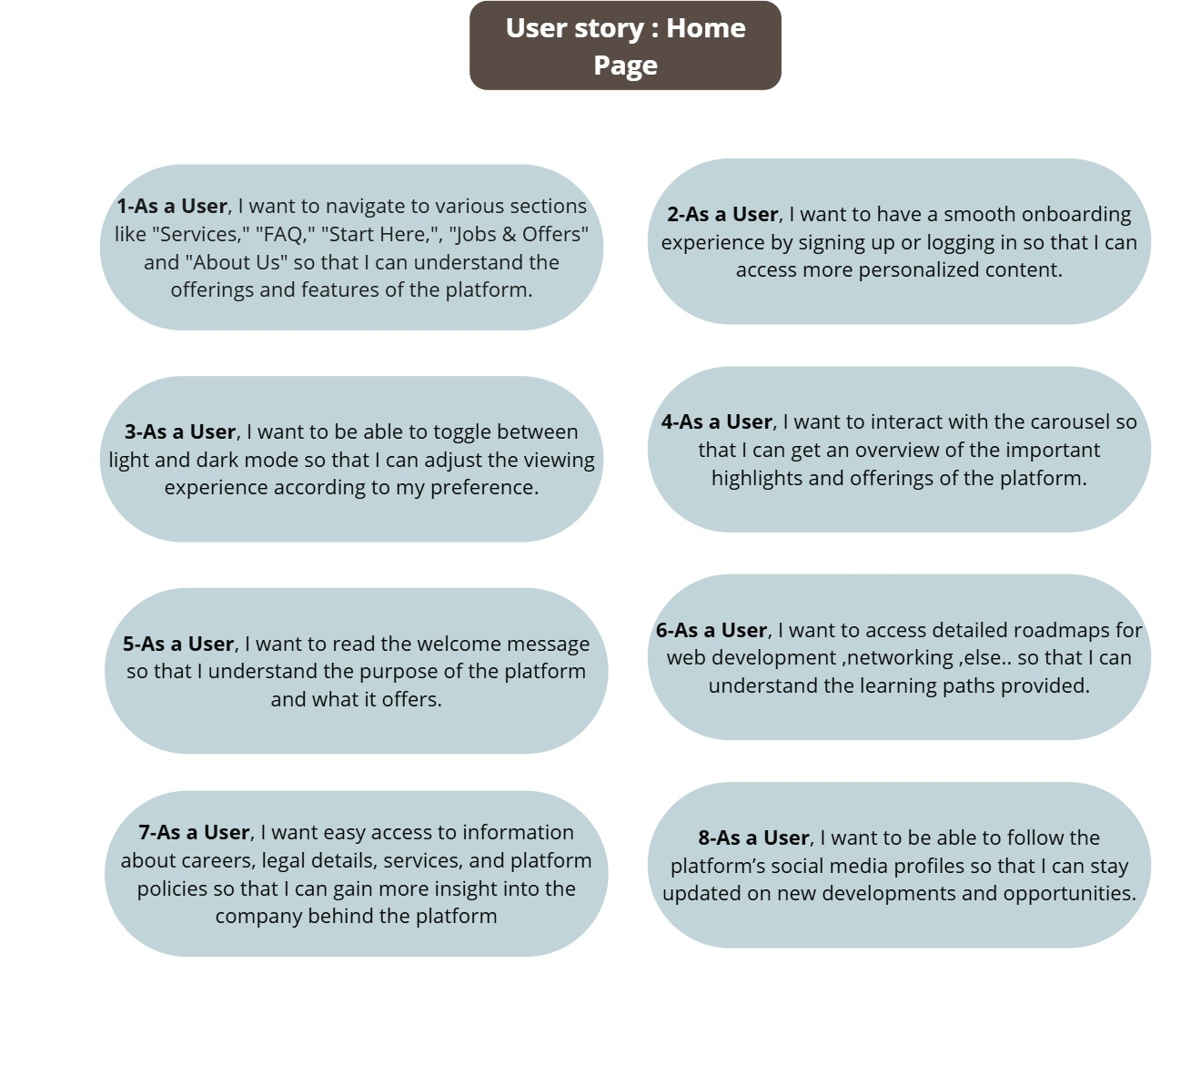Figure 3*‑‎0‑1* : Home Page

**Navigation & Onboarding**: Users can explore sections (Services, FAQ, Jobs, etc.), toggle light/dark mode, and sign up/login for personalized content.

**Content & Roadmaps**: Interactive carousels and welcome messages highlight platform offerings, while detailed roadmaps (e.g., web development) guide learning paths.

**Company Info & Social**: Access to careers, policies, and legal details, plus links to social media for updates.

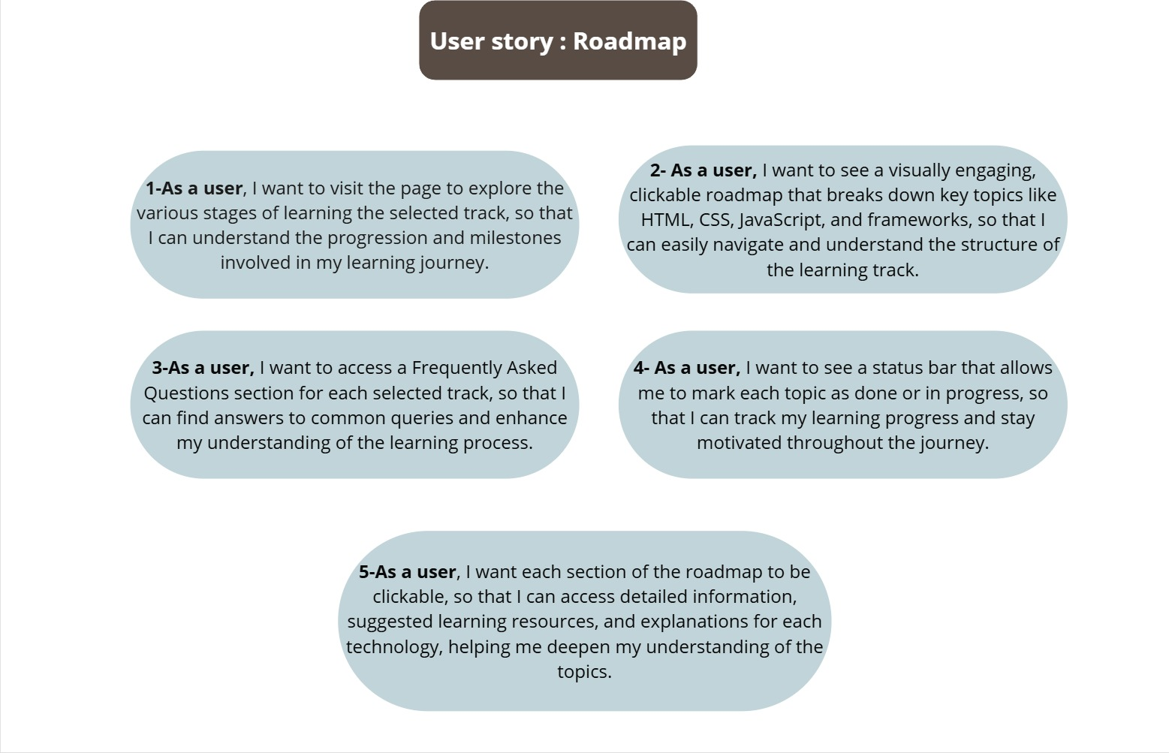

Figure 3‑‎0‑2 : Roadmap

**Interactive Learning Path**: Users can explore a clickable, visual roadmap (e.g., HTML, CSS, JS) with clear stages and milestones, including detailed resources for each topic.

**Progress Tracking**: A status bar lets users mark topics as "Done" or "In Progress" to track their learning journey and stay motivated.

**Quick Support**: Each track includes an FAQ section to answer common questions and help users understand the learning process better.

**Detailed Resources**: Clicking on any section provides extra materials, explanations, and recommended study tools for deeper understanding.

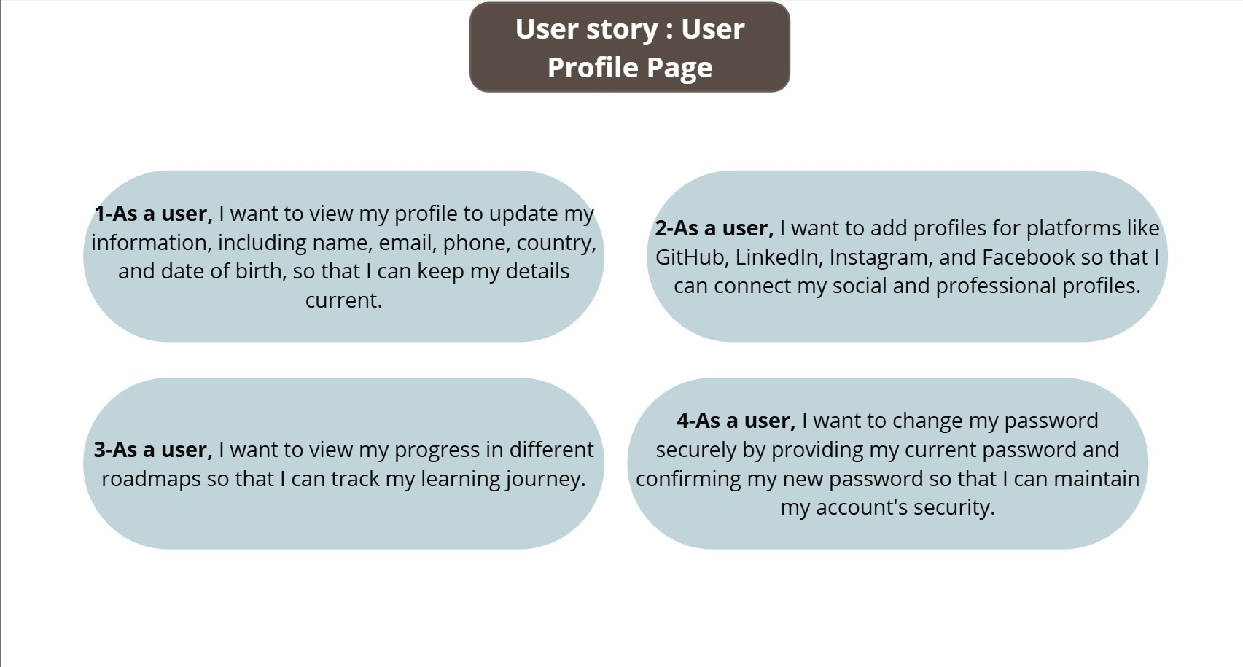Figure 3‑‎0‑3 : User Profile

**Profile Management:**Users can view and update their personal information (name, email, phone, country, date of birth) to ensure their profile is always up-to-date.

**Social & Professional Linking:**Users can connect external profiles such as GitHub, LinkedIn, Instagram, and Facebook to integrate their social and professional presence.

**Progress & Learning Tracking:**Users can track their progress in different learning roadmaps to monitor and manage their educational journey.

**Security:**Users can securely change their password by entering the current one and confirming a new one to protect their account.

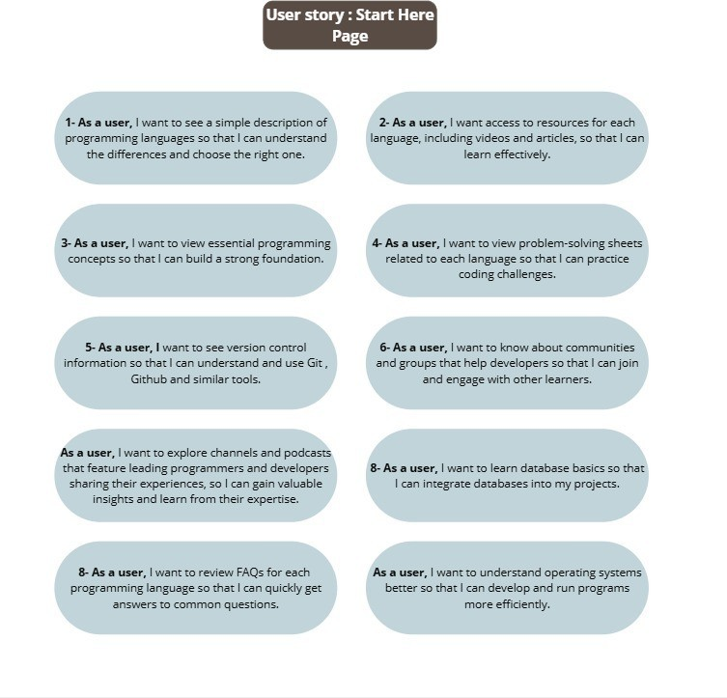

Figure 3‑‎0‑4: Start Here

**Language Selection & Learning**: Users can compare programming languages, access learning resources (videos/articles), and review FAQs to choose and master the right language.

**Core Skills Development**: Provides foundational concepts, problem-solving sheets, and version control (Git/GitHub) tutorials to build practical coding skills.

**Community & Advanced Topics**: Connects users with developer communities, podcasts, and covers databases/OS basics for project integration and efficiency.

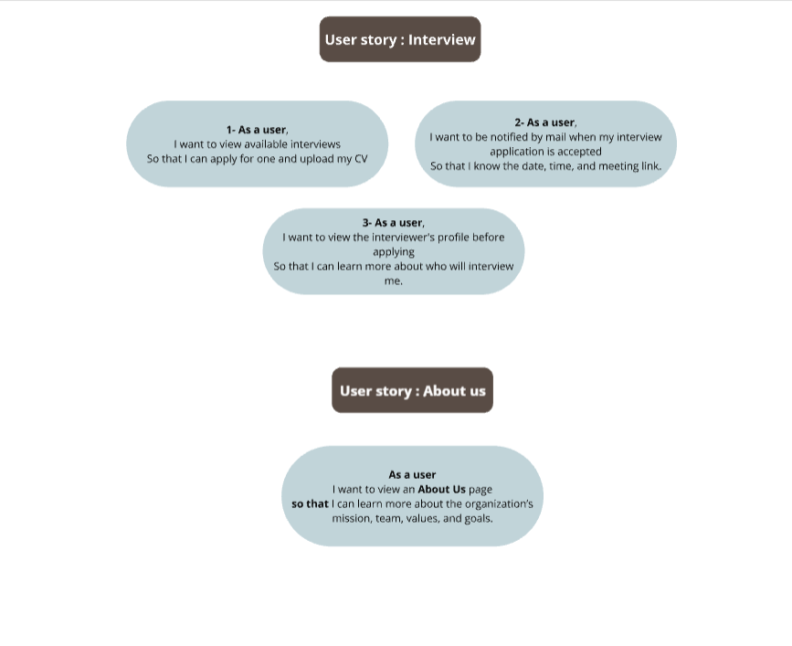

Figure 3‑‎0‑5 : Interview

**Interview Process**: Users can browse and apply for interviews, upload CVs, and receive email notifications with interview details (date/time/link) upon acceptance.

**Interviewer Insights**: Users can view interviewer profiles to understand their background before applying.

**About Us**: Users can explore the organization’s mission, team, values, and goals via a dedicated page.

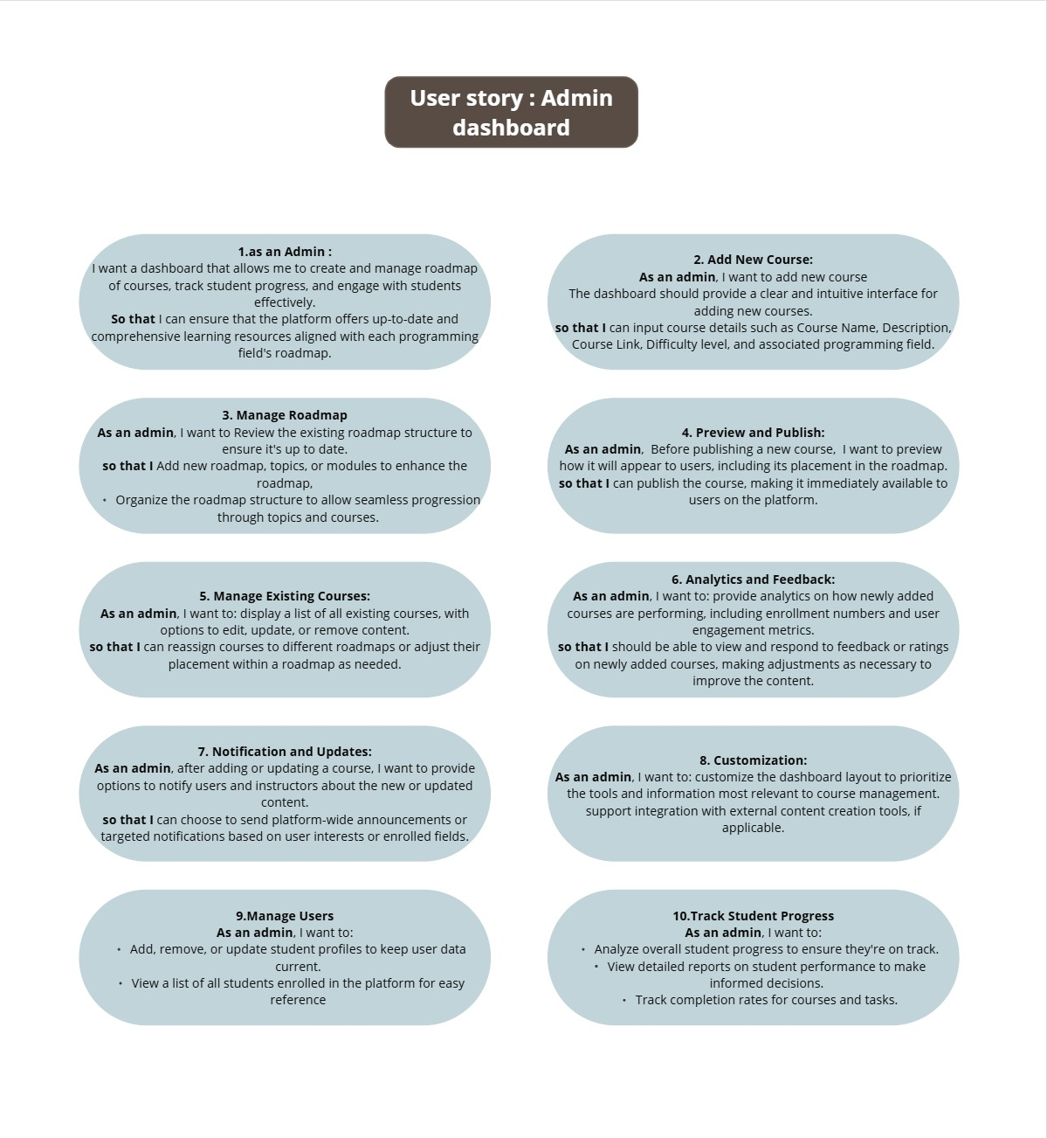

Figure 3‑‎0‑6 : Admin Dashboard

**Dashboard Overview:**Admins can create and manage course roadmaps, monitor student progress, and engage effectively with users to ensure content is aligned with learning goals.

**Add New Course:**Admins can add new courses through a user-friendly interface by entering course details like name, description, link, difficulty, and related programming field.

**Manage Roadmap:**Admins can review and update the roadmap structure by adding or modifying topics/modules to ensure seamless and updated content flow.

**Preview and Publish:**Before publishing, admins can preview how the course appears to users and adjust its placement in the roadmap, ensuring proper integration before making it live.

**Manage Existing Courses:**Admins can edit, update, or delete existing courses and reassign them within the roadmap to maintain content organization and relevance.

**Analytics and Feedback:**Admins can track course performance using analytics like enrollments and engagement, and use feedback to make content improvements.

**Notifications and Updates:**Admins can send platform-wide announcements or targeted notifications about course changes to users and instructors based on interests or enrollments.

**Customization:**Admins can customize the dashboard layout to prioritize important tools and enable integrations with external course creation tools if needed.

**Manage Users:**Admins can add, remove, or update student profiles, and view enrolled students for easier management and support.

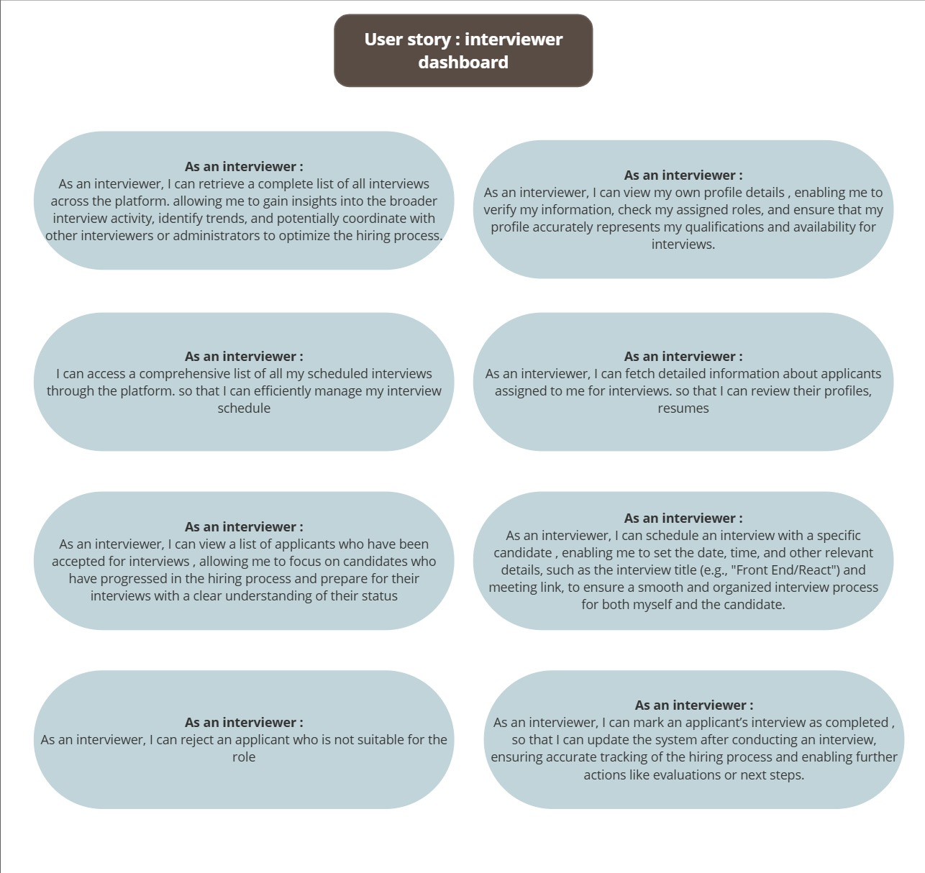

Figure 3‑‎0‑7 interviewer dashboard

**Dashboard Overview:**

**Interviewers can access a centralized dashboard to manage interviews, view applicant information, track progress, and coordinate with team members, ensuring a streamlined and data-informed hiring process.**

**View All Interviews:**

Interviewers can retrieve a complete list of all interviews conducted across the platform, allowing them to gain insights into trends, collaborate with others, and optimize hiring strategies.

**Manage Interviewer Profile:**

Interviewers can view and update their profile information, including assigned roles and availability, to ensure accurate representation for scheduling and communication.

**Scheduled Interviews:**

Interviewers can access a comprehensive schedule of their upcoming interviews, helping them manage their time and preparation more effectively.

**View Applicant Details:**

Interviewers can fetch and review detailed information about assigned applicants, such as resumes and profiles, to prepare thoroughly for interviews.

**Accepted Applicants:**

Interviewers can view a list of applicants who have been approved for interviews, focusing efforts on qualified candidates and understanding their status within the hiring pipeline.

**Schedule Interviews:**

Interviewers can set up interviews by selecting the candidate, date, time, meeting link, and title (e.g., "Front End/React") to ensure a smooth, organized interview process.

**Reject Applicants:**

Interviewers have the ability to reject candidates who are not suitable for the role, updating the system accordingly to reflect hiring decisions.

**Complete Interviews:**

Interviewers can mark interviews as completed, enabling accurate tracking of the hiring process and triggering follow-up actions such as evaluations or feedback.

**Track Student Progress:**Admins can monitor student progress through reports, track completion rates, and ensure users are on track with their learning.

### 3.1.2 Use Case

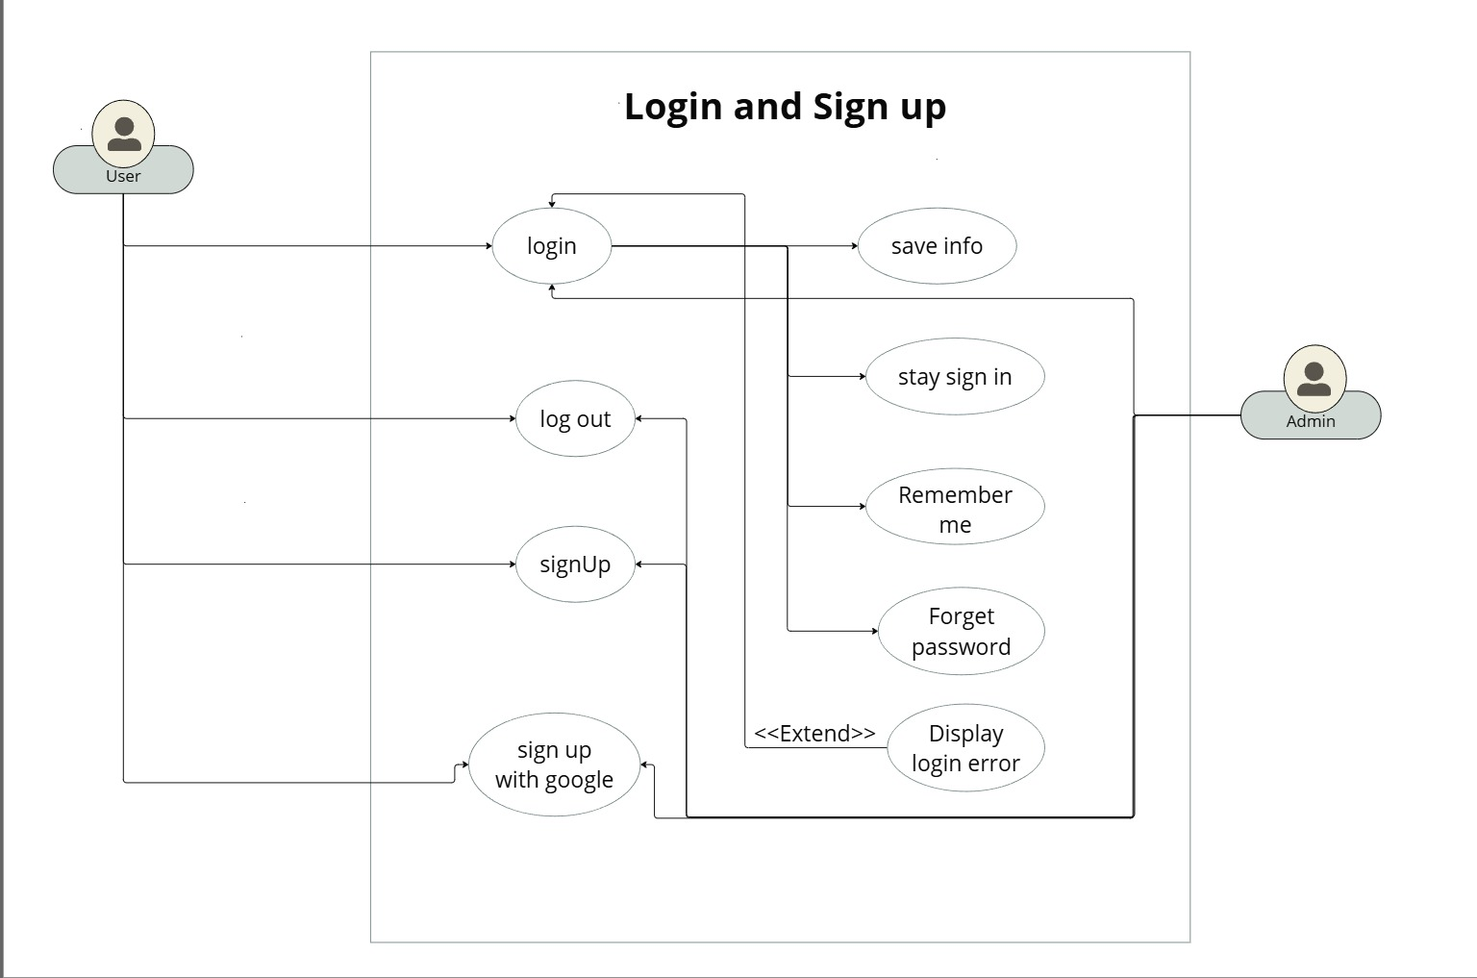

Figure 3‑‎0‑8: Login and Sign Up

**Authentication Options**:

* + Login with email/username & password
  + Sign up manually or via Google
  + "Remember Me" option to save credentials

**Security & Account Management**:

* + Password recovery ("Forgot Password")
  + Error messages for invalid login attempts
  + Secure logout functionality

**Extended Features**:

* + Session persistence ("Stay Signed In")
  + Form validation for signup fields
  + Social login integration (Google)

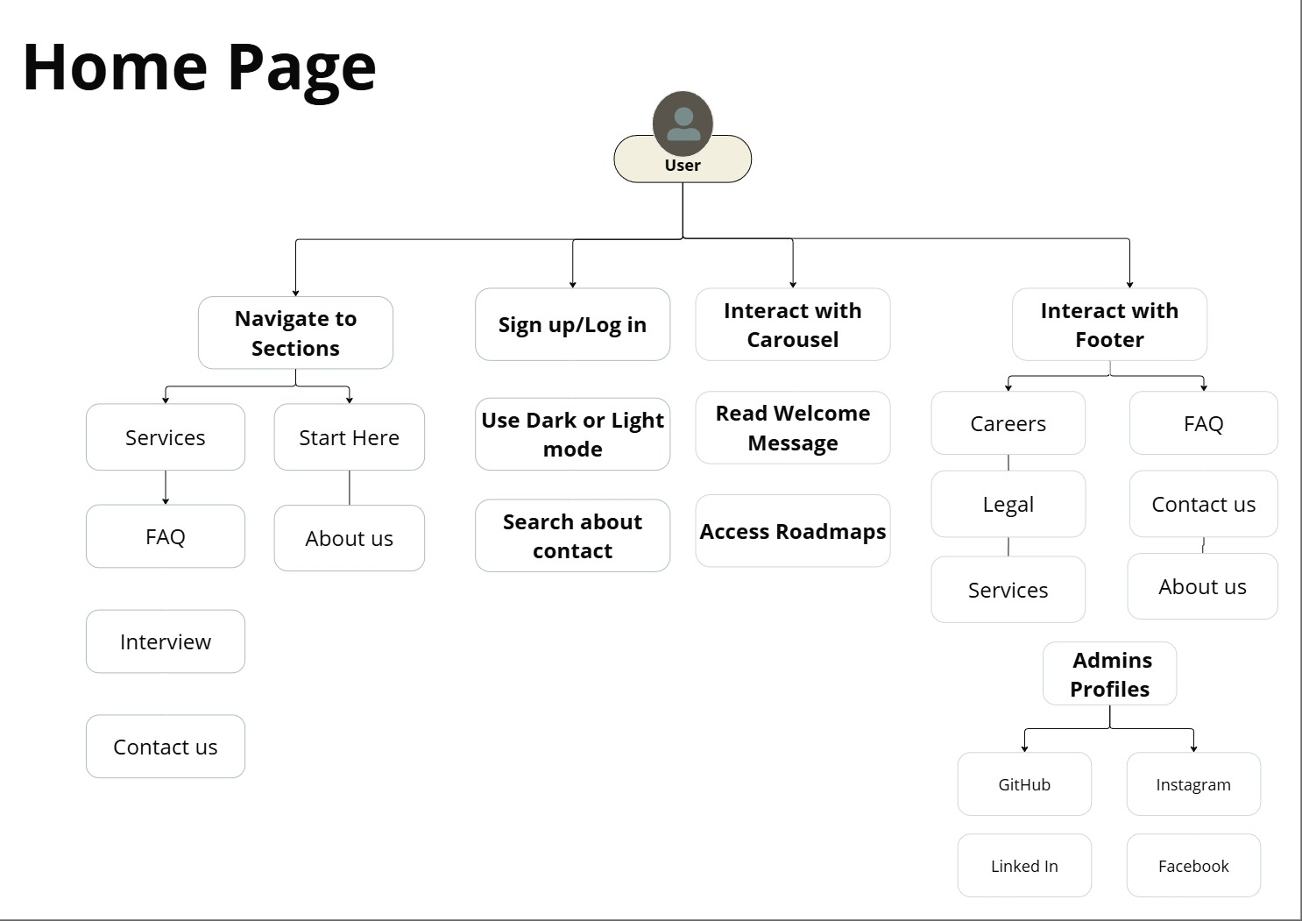

Figure 3‑‎0‑9 : Home Page

**Navigation & Personalization**:

* + Access key sections (Services, FAQ, Interviews, Contact)
  + Toggle between Dark/Light mode
  + Sign up/Log in for personalized content

**Content & Features**:

* + View welcome message and interactive carousel
  + Explore learning roadmaps
  + Search and contact options

**Company & Social Links**:

* + Careers, Legal info, and About Us
  + Footer with social media links (GitHub, LinkedIn, etc.)
  + Admin profile access

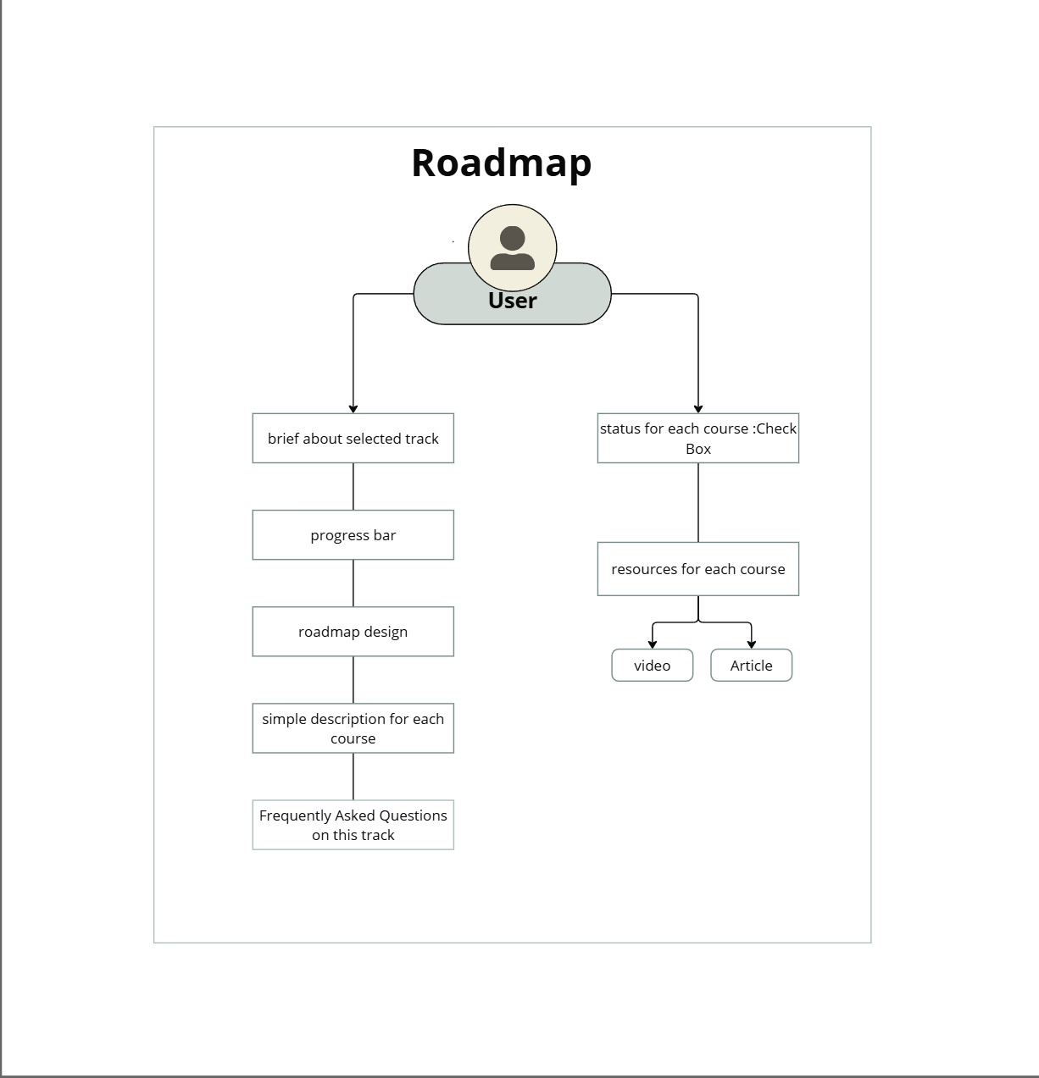

Figure 3‑‎0‑10 : Roadmap

**Track Overview**:

* + Brief introduction to the selected track
  + Clear visual roadmap design
  + Simple description for each course

**Progress Tracking**:

* + Visual progress bar
  + Checkbox to mark course status (Completed/In Progress)

**Resources & Support**:

* + Learning resources (videos, articles)
  + FAQ section for the track

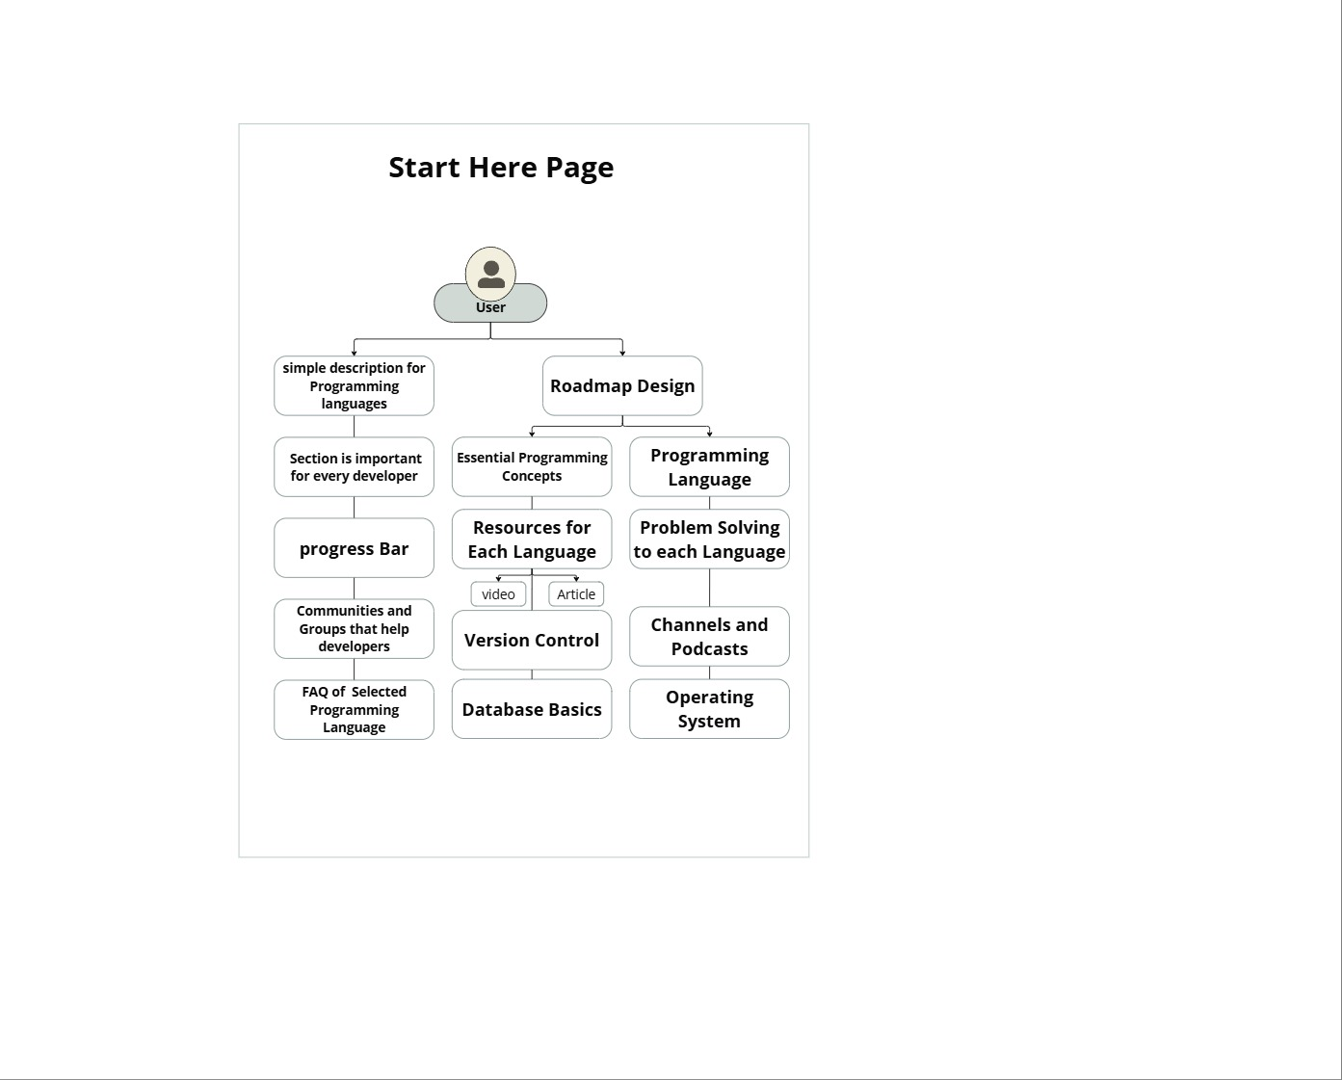

Figure 3‑‎0‑11 : Start Here Page

**Programming Introduction**

* + Simple descriptions of programming languages
  + Visually organized roadmap design

**Developer Essentials**

* + Key settings and tools for developers
  + Core programming concepts and problem-solving techniques

**Learning Resources**

* + Version control guidance (e.g., Git)
  + Community recommendations and FAQs
  + Operating system basics for development

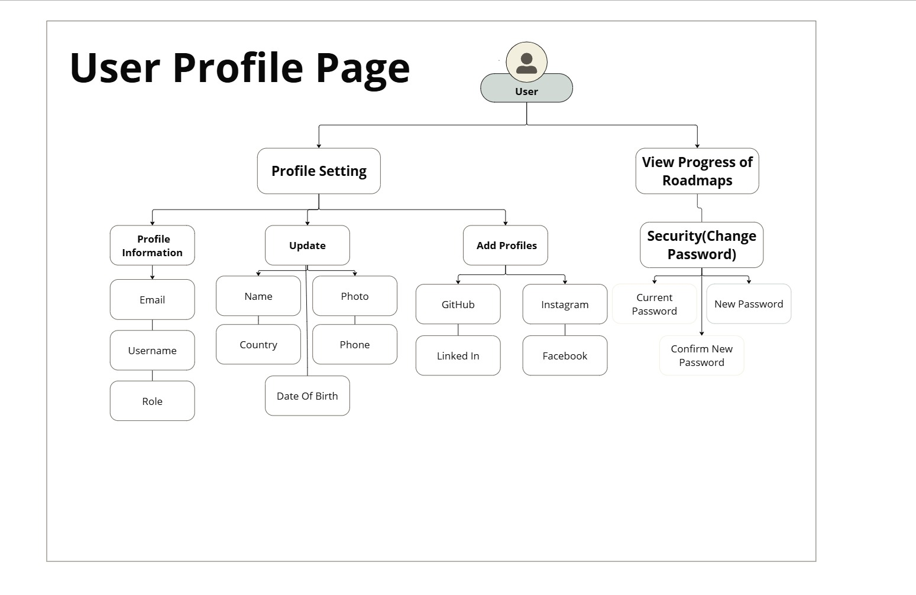

Figure 3‑‎0‑12 : User Profile Page

**1. Profile Management**

* View/edit personal info (name, email, phone, country, date of birth, role)
* Upload profile photo
* Link social accounts (GitHub, LinkedIn, Instagram, Facebook)

**2. Career Tracking**

* View progress across roadmaps to monitor learning journey

**3. Security**

* Change password securely (current password + new password confirmation)

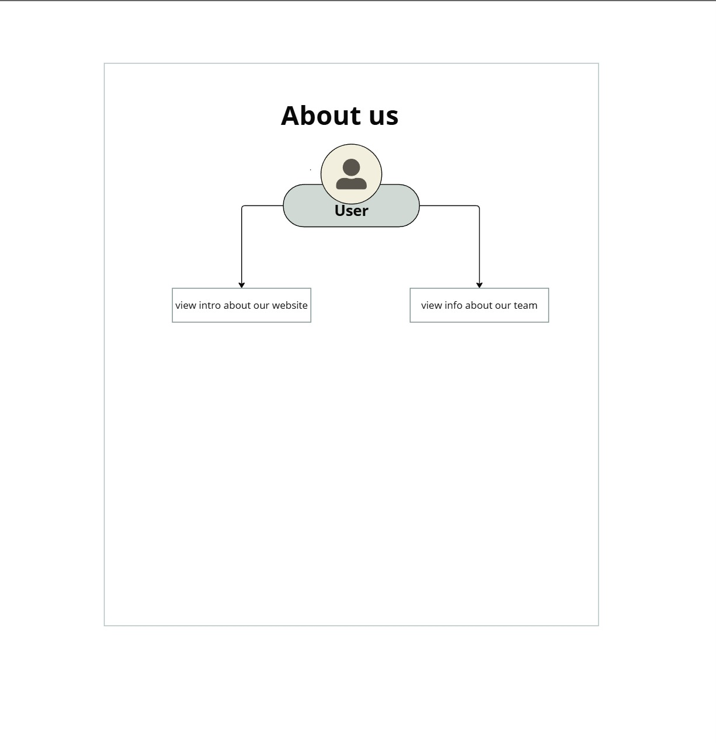Figure 3‑‎0‑13 : About Us

1. **Website Introduction**
   * Clear overview of the platform's purpose and mission
2. **Team Information**
   * Details about team members and their roles

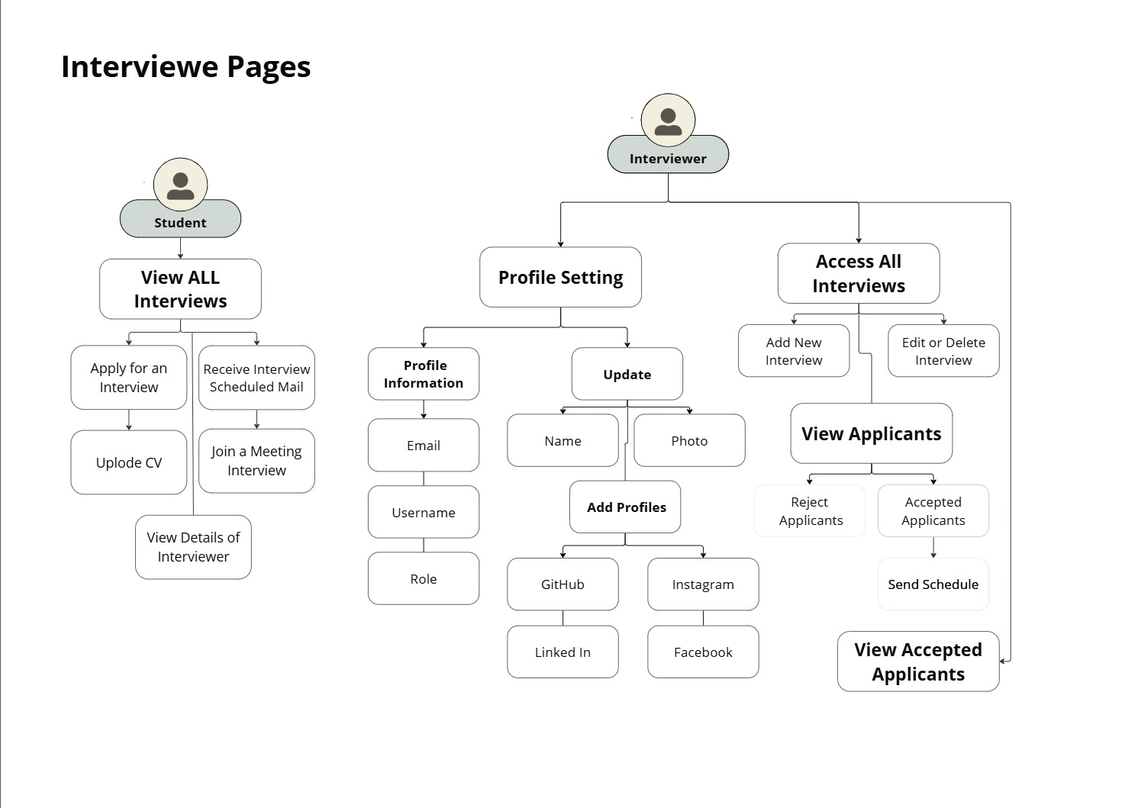Figure *3‑‎0‑14* : Interviews

1. **Student Features**

* **View All Interviews:**

Students can browse all available interviews on the platform, helping them stay informed about opportunities.

* **Apply for an Interview:**

Students can apply directly for interviews by uploading their CVs and viewing interviewer details to prepare in advance.

* **Receive Interview Scheduled Mail:**

Once scheduled, students receive an automated interview invitation email, including the interview time and meeting link.

* **Join a Meeting Interview:**

Students can access and join the scheduled interview meeting via a provided link, ensuring a smooth connection on time.

1. **Interviewer Features**

* **Profile Setting:**

Interviewers can manage their account and presence on the platform through profile settings.

* **Profile Information:**  
  Interviewers can view or edit their email, username, and role.
* **Update:**  
  Interviewers can update their name, photo, and social profiles to maintain a professional identity.
* **Add Profiles:**  
  Interviewers can link their GitHub, LinkedIn, Instagram, or Facebook accounts for better visibility.

1. **Access All Interviews:**

Interviewers can manage all interview-related activities from a single place.

* **Add New Interview:**  
  Interviewers can schedule new interviews, assigning applicants and setting relevant details.
* **Edit or Delete Interview:**  
  Interviews can be edited or removed based on updates in the hiring process.

1. **View Applicants:**

Interviewers can manage applicant status through filtering and reviewing features.

* **Reject Applicants:**  
  Interviewers can reject candidates who are not a fit, streamlining the hiring pipeline.
* **Accepted Applicants:**  
  Interviewers can view applicants who passed initial screening and are ready to be scheduled.
* **Send Schedule:**  
  For accepted applicants, interviewers can send interview schedules directly via the system.
* **View Accepted Applicants:**  
  A dedicated view allows interviewers to track only those who have been selected for interviews.

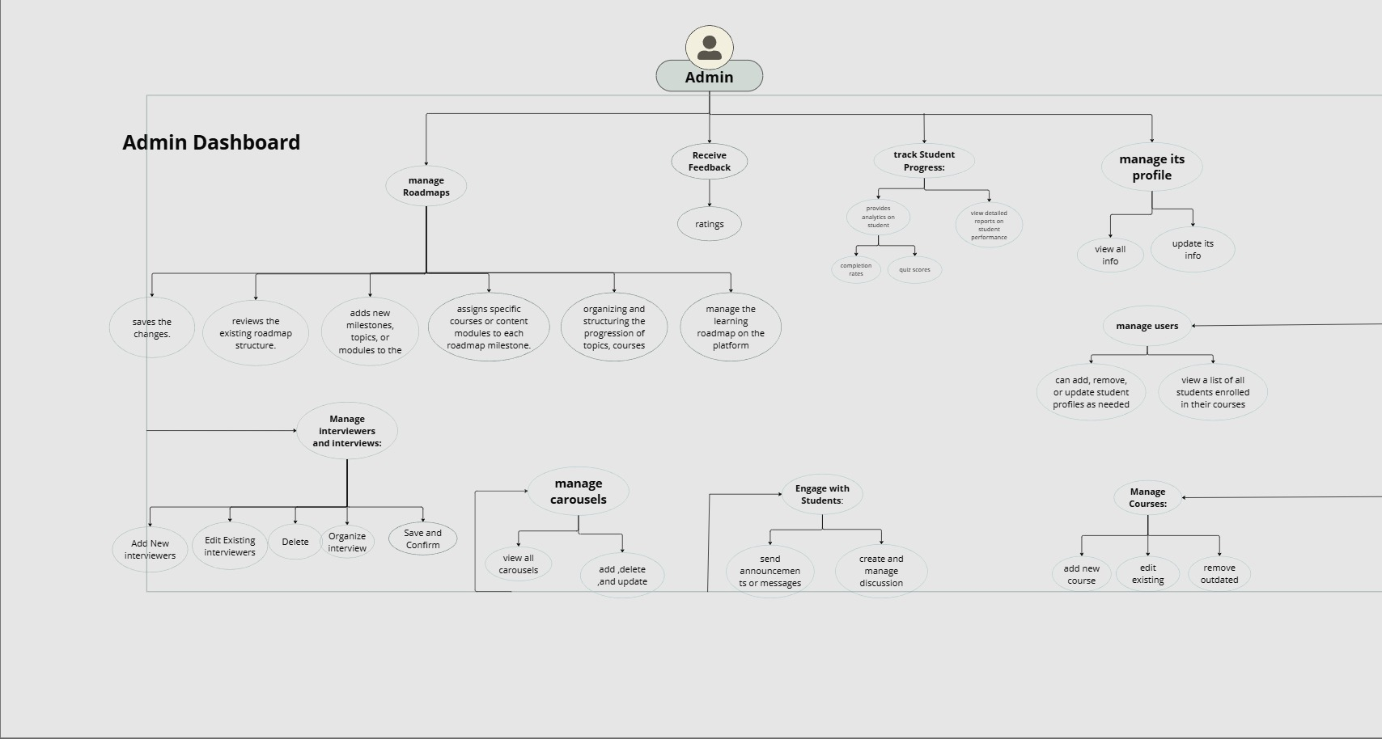

Figure 3‑‎0‑15: Admin Dashboard

1. **Roadmap Management**
   * Review/edit existing roadmaps
   * Add new modules/infrastructure
   * Organize topics and track progress
   * Analyze route-specific services
2. **Interview Coordination**
   * Add/delete interviewers
   * Schedule and organize interviews
   * Save interview configurations
3. **Content & Engagement**
   * Manage carousel resources
   * Send announcements/messages
   * Create discussion forums
   * Update/remove outdated content

### 3.1.3 ERD Diagram

The Entity Relationship Diagram (ERD) plays a vital role in illustrating the database structure of the system. It defines the entities, their attributes, and the relationships between them, serving as a blueprint for the overall data architecture.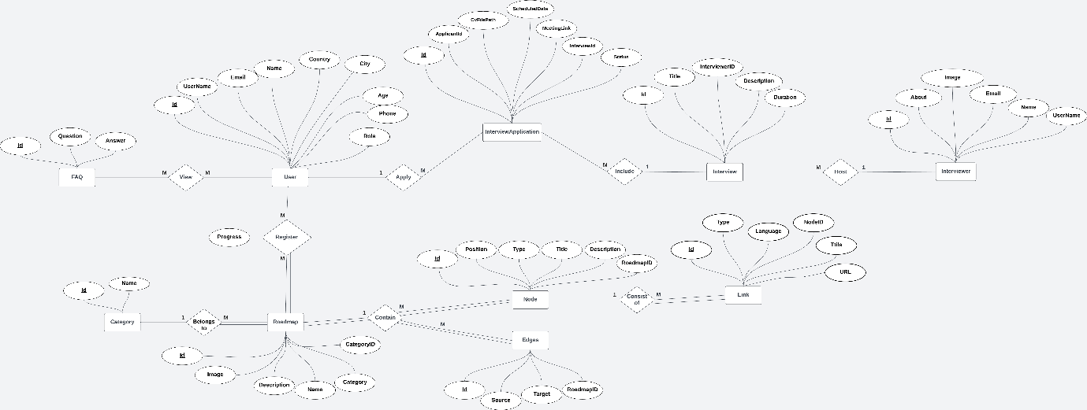

Figure 3‑‎0‑16:ERD Diagram

**1. User Entity**

**Attributes:** User ID, Name, Username, Email, Country, City, Age, Phone, Role (Student, Admin, Interviewer)

**Relationships:**

Can apply for jobs.

Can register for roadmaps (tracks).

Can view FAQs.

**2. FAQ Entity**

**Attributes:** FAQ ID, Question, Answer

**Relationships:** Users can view multiple FAQs

**3. InterviewApplication Entity**

**Attributes:**

* + - * Id: Unique application identifier
      * ApplicantId: ID of the user who applied
      * CvFilePath: Path to uploaded CV
      * ScheduledDate: Scheduled date of interview
      * MeetingLink: Link to the interview meeting
      * MeetingId: Meeting identifier
      * InterviewId: Associated interview ID
      * Status: Application status ( Pending, Accepted)

**Relationships:**

Linked to a user through the application process

Linked to a specific interview

**4. Interview Entity**

**Attributes:**

* Id: Unique interview identifier
* Title: Title of the interview
* Description: Brief description
* Duration: Duration of the interview
* InterviewerId: ID of the person conducting the interview

**Relationships:**

* Can include multiple interview applications
* Hosted by an interviewer

**5. Interviewer Entity**

**Attributes:**

* Id: Unique identifier
* Name: Full name
* UserName: Interviewer's username
* Email: Contact email
* Image: Profile picture
* About: Bio or description

**6. Roadmap Entity**

**Attributes:**

**Id:** Unique roadmap identifier

**Name:** Roadmap title

**Description:** Description of the roadmap

**Image:** Associated image

**CategoryId:** ID of the category belongs to

**Relationships:**

Users can register to follow a roadmap

A roadmap belongs to a specific category

A roadmap contains multiple nodes

**7. Category Entity**

**Attributes:**

* **Id:** Unique category identifier
* **Name:** Name of the category

**Relationships:**

* A category can have multiple roadmaps

8**. Node Entity**

**Attributes:**

**Id:** Unique node identifier

**Position:** Order or sequence in the roadmap

**Type:** Type of the node (e.g., lesson, task)

**Title:** Title of the node

**Description:** Description or content

**RoadmapID:** ID of the parent roadmap

**Relationships:**

A roadmap contains multiple nodes

Nodes are connected to each other via edges

Each node can have multiple associated links

**9. Edges Entity**

**Attributes:**

**Id:** Unique edge identifier

**Source:** Source node ID

**Target:** Target node ID

**RoadmapID:** Roadmap the edge belongs to

**Relationships:**

Represents the logical flow between nodes in a roadmap

**9. Link Entity**

**Attributes:**

* **Id:** Unique link identifier
* **Type:** Type of content (e.g., Video, Article, PDF)
* **Language:** Content language
* **NodeID:** The node it belongs to
* **Title:** Title of the content
* **URL:** Direct URL to the resource

**Relationships:**

* A node can consist of multiple links

### 4. Class Diagram

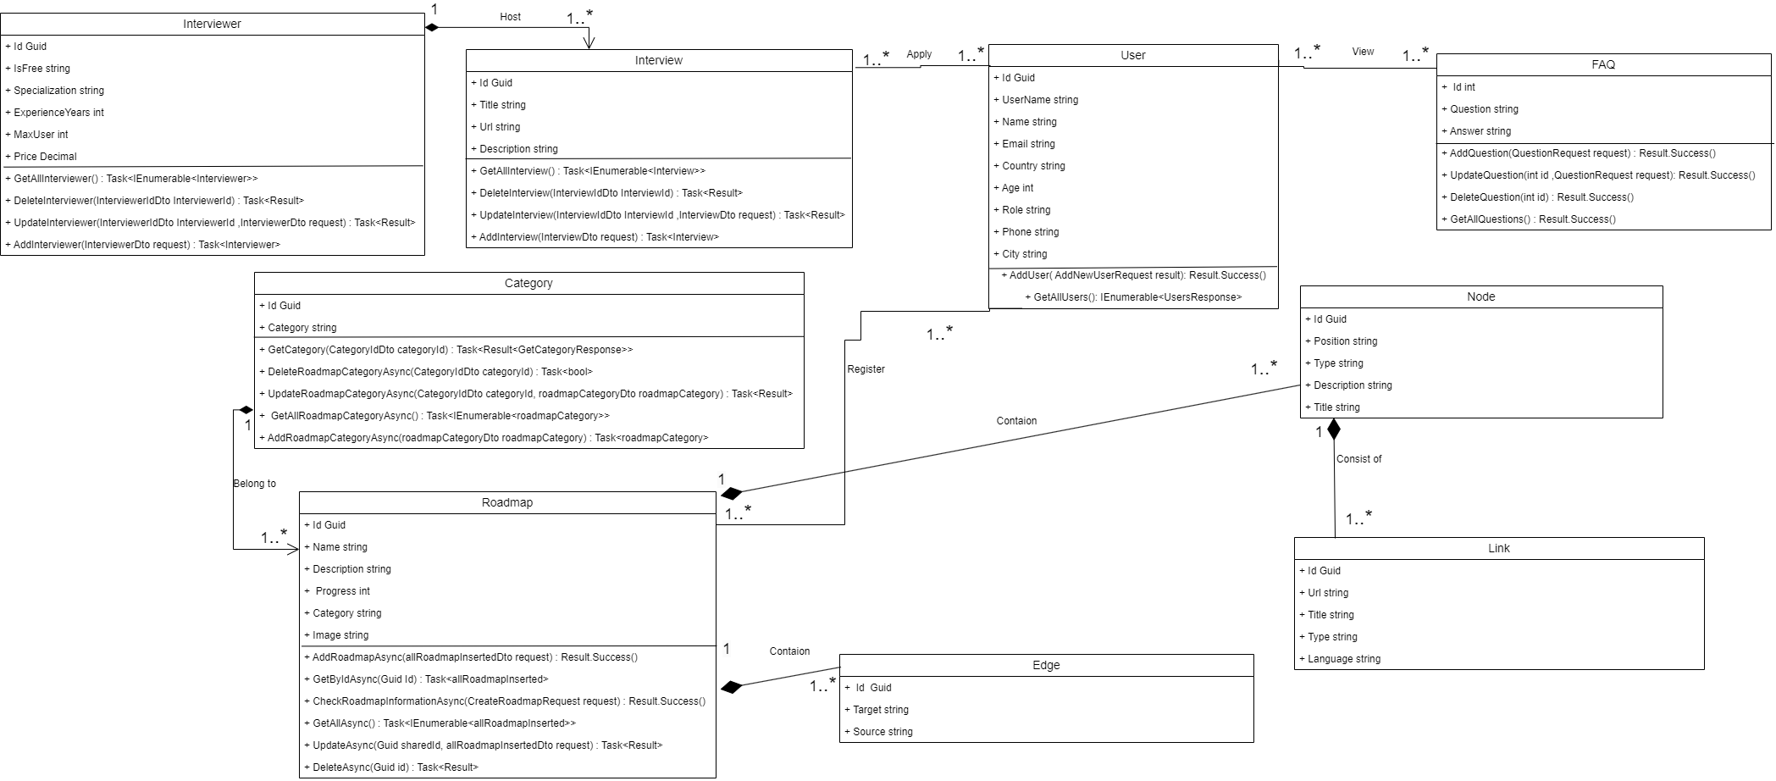

Figure 3‑‎0‑17:Class Diagram

**2.1 Roadmap Entity**

**Attributes**  ID, Name, Description, Progress , Category , Image

**Relationships:** Defines connections between nodes , link and edge in a roadmap and

The relationship between Roadmap and Node is Composition and it is One-to-Many.

relationship between Roadmap and Edge is Association and it is One-to-Many.

**2.2 Interview Entity**

**Attributes:** ID, Url , Title , Description

**Relationships:** Defines connections between user and Interviewer.

**2.3 Interviewer Entity**

**Attributes:** ID,IsFree ,Specialization ,ExperienceYears ,MaxUser , Price

**Relationships:** Defines connections between interviews and

relationship between Interviewer and Interview is Association and it is One-to-Many.

**2.4 Category Entity**

**Attributes:** ID, Category

**Relationships:** Defines connections between roadmaps and

relationship between Category and Roadmap is Aggregation and it is One-to-Many.

**2.5 Node Entity**

**Attributes:** Edge ID, Source Node, Target Node

**Relationships:** Defines connections between roadmaps

relationship between Node and Link is Association and it is One-to-Many.

**2.6 Link Entity**

**Attributes:** ID , Url , Title , Type , Language

**Relationships:** Defines connections between nodes in a roadmap

**2.7 User Entity**

**Attributes:** ID, UserName, Name,Role,Phone,City,Email,Country,Age

**Relationships:** Defines connections between FAQ , User ,Roadmap, and Interview and

relationship between User and Interview is Aggregation and it is Many-to-Many.

and relationship between User and FAQ is Association and it is Many-to-Many.

The relationship between User and Roadmap is Association and it is One-to-Many.

**2.8 FAQ Entity**

**Attributes:** ID, Answer , Question

**Relationships:** Defines connections between FAQ and User

**2.9 Edge Entity**

**Attributes:** ID, Source, Target, Roadmap ID

**Relationships:** Defines connections between roadmaps and Edge

### 5. Sequence Diagram

**3.1 User Login Process:**

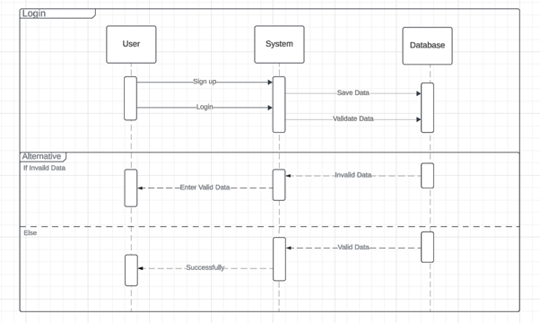

Figure 3‑‎0‑18:User Login Process

The following sequence diagram illustrates the login workflow within the Career Guidance platform. It describes how a user interacts with the system and how the system communicates with the database to authenticate users.

**Components:**

* **User:** The person interacting with the platform (student, instructor, etc.)
* **System:** The backend logic (RESTful API running on .NET Core)
* **Database:** The SQL Server database where user data is stored and validated

**Main Flow:**

SignUp:  
If a user is new, they can register an account.

* The user submits signup information to the System.
* The System stores this information in the Database.

**Login:**

* The user submits login credentials (username/email and password).
* The System sends a validation request to the Database.
* The Database checks if the credentials match existing records.

**Alternative Flow:**

* If the submitted data is **invalid**:
  + The System sends an "Invalid Data" response.
  + The User is prompted to "Enter Valid Data" and try again.
* If the submitted data is **valid**:
  + The System sends a "Valid Data" response.
  + The User is logged in **successfully** and granted access to the platform.

**Purpose of the Diagram:**

This sequence diagram helps visualize the interaction between **frontend (User)**, **backend (System)**, and **database**, making the **login process** clear and easy to understand.  
It also shows how **error handling** (invalid login) is managed through an **alternative flow**.

**3.2 Add User Process**

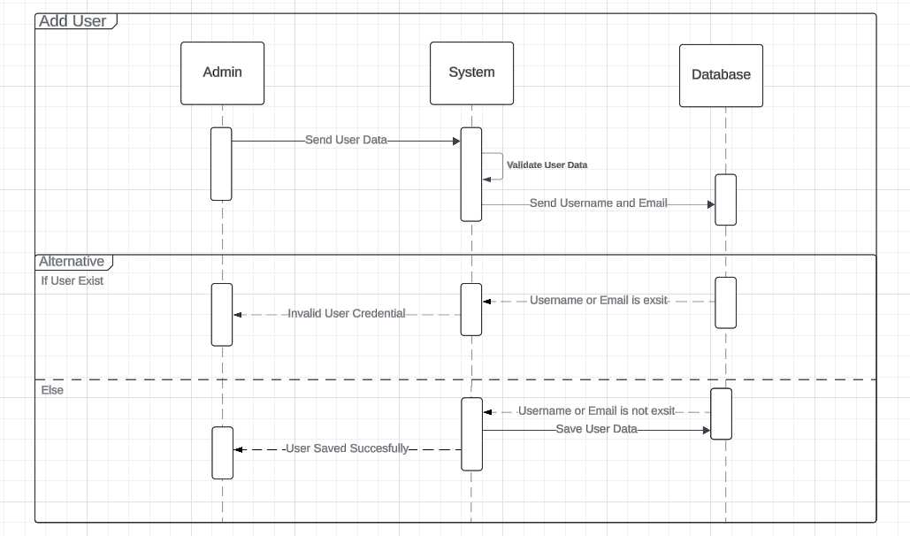

Figure 3‑‎0‑19: Add User Process

The following sequence diagram illustrates the process of **adding a new user** to the system by an **administrator**. It shows the interaction between the Admin, the System (backend), and the Database during this operation.

**Components:**

* **Admin:** The administrator user responsible for managing users on the platform.
* **System:** The backend logic handling business processes and data validation.
* **Database:** The data layer where user information is stored and validated.

**Main Flow:**

The Admin initiates the process by submitting **new user data** (typically username, email, and other credentials) to the System.

The System sends the provided **username and email** to the Database to check whether they already exist.

The Database performs a lookup:

* If **username or email already exists** → returns validation result to System.
* If **username or email is unique** → accepts the new user data for storage.

**Alternative Flow:**

* **If User Exists:**
  + The Database notifies the System that "Username or Email already exists".
  + The System responds to the Admin with an **"Invalid User Credential"** message, prompting correction.
* **Else (User Does Not Exist):**
  + The Database saves the new user data.
  + The System confirms to the Admin that the **"User Saved Successfully"**.

**Purpose of the Diagram:**

This sequence diagram helps visualize how the platform ensures **data integrity and uniqueness** when adding new users. It shows how the System prevents duplicate accounts and ensures that user records remain consistent and valid.

**3.3 Add Category Process**

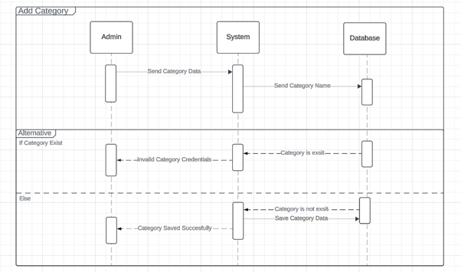

Figure 3‑‎0‑20: Add Category Process

The following sequence diagram illustrates the process of adding a new category to the system by an administrator. It shows the interaction between the Admin, the System (backend logic), and the Database during this operation.

**Components:**

* **Admin**: The platform administrator responsible for managing categories.
* **System**: The backend service that processes the category request and validates data.
* **Database**: The persistent storage layer that contains existing categories and stores new ones.

**Main Flow:**

The **Admin** initiates the process by sending the new category data (such as category name) to the **System**.

The **System** extracts the category name and sends it to the **Database** to check whether it already exists.

**Alternative Flow:**

**If the Category Already Exists**:

* The **Database** returns a message to the **System** indicating that the category name is already present.
* The **System** informs the **Admin** that the category credentials are invalid, prompting them to choose a different name.

**Else (Category Does Not Exist)**:

* The **Database** proceeds to save the new category data.
* The **System** sends a confirmation message to the **Admin** stating that the category was saved successfully.

**Purpose of the Diagram:**

This sequence diagram visualizes the logic behind preventing duplicate category entries. It ensures that all categories added to the system are unique, maintaining data integrity and improving user experience during category management operations.

**3.4 Forget Password Process**

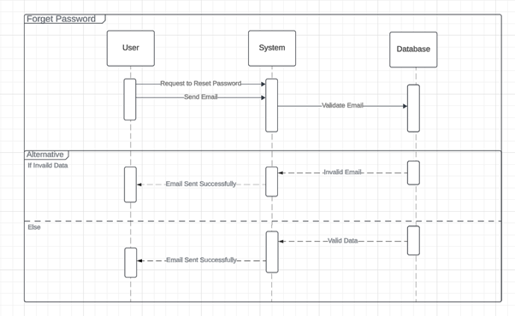

Figure 3‑‎0‑21:Forget Password Process

The sequence diagram illustrates the process a user follows to reset their password using the "Forget Password" functionality. It outlines the interaction between the User, the System, and the Database throughout the operation.

Components:

* User: An existing platform user who wants to reset their password.
* System: The backend service responsible for handling the password reset logic and communication.
* Database: The data source that stores and verifies user email addresses.

**Main Flow:**

The User initiates a password reset request by entering their registered email address.

The System receives the request and sends the provided email to the Database to validate whether it exists in the system.

**Alternative Flow:**

If the email is invalid:

The Database responds with a validation failure indicating that the email address does not exist.

The System still responds to the User with a generic message such as "Email Sent Successfully" to avoid revealing whether the email is registered, maintaining security and privacy.

Else (the email is valid):

The Database confirms that the email is valid.

The System proceeds to send a password reset email and confirms to the User that the message was sent successfully.

**Purpose of the Diagram:**

This sequence diagram demonstrates how the system handles password reset requests securely and efficiently. It ensures that valid users can initiate a password recovery process, while invalid or malicious requests are handled in a way that preserves the confidentiality of user data and account existence.

**3.5 Create Roadmap Process**

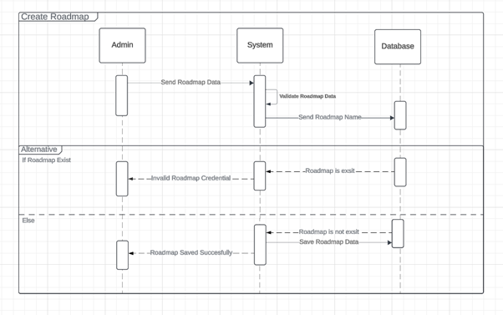

Figure 3‑‎0‑22: Create Roadmap Process

The following sequence diagram illustrates the process of creating a new roadmap in the system by an administrator. It outlines the communication between the Admin, the System (backend logic), and the Database when attempting to add a new roadmap entry.

**Components**

* **Admin**: The administrator responsible for creating and managing roadmaps on the platform.
* **System**: The backend application logic that handles validation and communication with the database.
* **Database**: The persistent storage layer where roadmap records are checked and saved.

**Main Flow**

The **Admin** initiates the process by submitting roadmap data (e.g., roadmap name and other attributes) to the **System**.

The **System** begins by validating the submitted data and specifically sends the roadmap name to the **Database** to check for existing records.

The **Database** searches for the given roadmap name and returns whether it exists or not.

**Alternative Flow**

**If Roadmap Exists:**

* The **Database** returns a response indicating that the "Roadmap already exists".
* The **System** notifies the **Admin** with an **"Invalid Roadmap Credential"** message, prompting the admin to enter a unique name or revise the submission.

**Else (Roadmap Does Not Exist):**

* The **Database** saves the new roadmap data.
* The **System** confirms to the **Admin** that the **"Roadmap Saved Successfully"**.

**Purpose of the Diagram**

This sequence diagram serves to visualize the logic behind creating a new roadmap while ensuring name uniqueness. It safeguards against duplication by validating data before saving it and ensures that each roadmap entry is distinct and correctly handled by the backend system. This promotes consistency, data integrity, and user feedback throughout the creation process.

**3.6 Add FAQ Question Process**

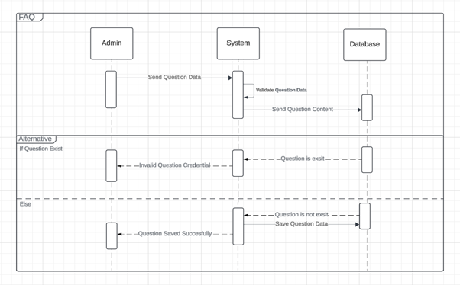

Figure 3‑‎0‑23 : Add FAQ Question Process

The following sequence diagram illustrates the process of adding a new FAQ question to the system by an administrator. It details the interactions between the **Admin**, the **System**, and the **Database** during this operation.

**Components**

* **Admin**: The administrator user responsible for managing the FAQ content on the platform.
* **System**: The backend component that handles request validation and interaction with the database.
* **Database**: The storage layer responsible for checking and storing FAQ question records.

**Main Flow**

The **Admin** submits new FAQ question data (such as the question text and its answer) to the **System**.

The **System** validates the received content and sends the question text to the **Database** to verify uniqueness.

The **Database** checks if the same question already exists in the records and returns the result to the **System**.

**Alternative Flow**

**If Question Exists:**

* The **Database** responds that the "Question already exists".
* The **System** notifies the **Admin** with an **"Invalid Question Credential"** message, requesting a change or update to the input.

**Else (Question Does Not Exist):**

* The **Database** saves the new question and its associated answer.
* The **System** returns a success message to the **Admin** stating that the **"Question Saved Successfully"**.

**Purpose of the Diagram**

This diagram illustrates the FAQ content management flow in the admin panel. It emphasizes the importance of validating the uniqueness of each question before storing it, ensuring that the knowledge base remains concise, non-redundant, and helpful to users. It also helps stakeholders understand the underlying logic that preserves data quality and prevents duplicates in the FAQ section.

**3.7 User Cycle In interview Sequence Diagram**

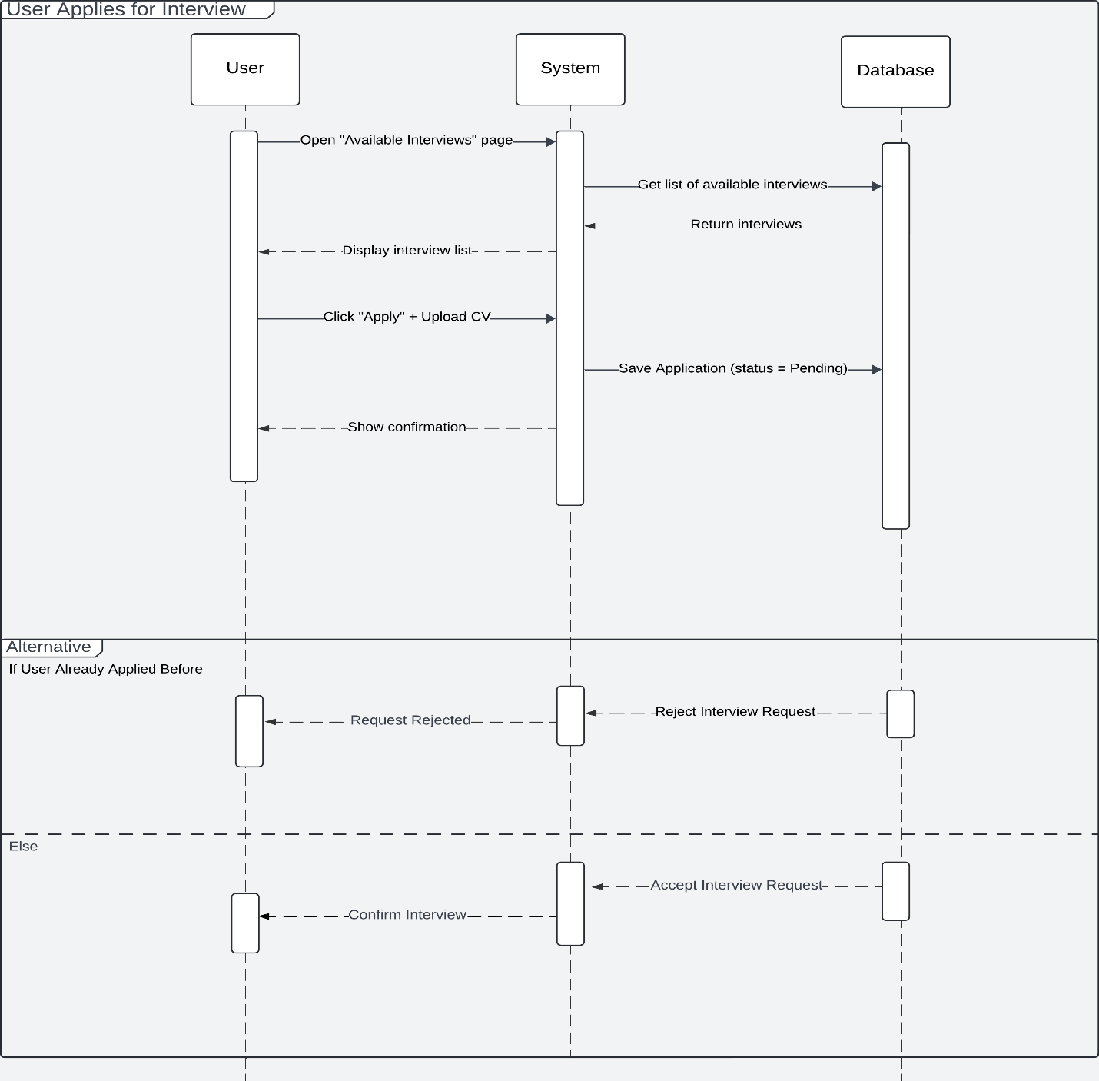

Figure 3‑‎0‑24 : User Cycle In Interview Sequence Diagram

The following sequence diagram illustrates the workflow for how a user applies for an interview within the Career Guidance platform. It outlines the interaction between the user and the system, along with the system’s communication with the database to manage interview applications.

**Components:**

* **User:** The applicant accessing the platform to apply for interviews.
* **System:** The backend service (e.g., RESTful API) responsible for processing interview requests.
* **Database:** The storage system (e.g., SQL Server) where interview information and application statuses are managed.

**Main Flow:**

**1. Viewing Available Interviews:**

* The **User** opens the “Available Interviews” page from the platform.
* The **System** sends a request to the **Database** to retrieve all upcoming and available interviews.
* The **Database** returns the list of interviews.
* The **System** displays the available interviews to the **User**.

**2. Applying for an Interview:**

* The **User** selects an interview and clicks “Apply,” then uploads their CV.
* The **System** saves the application to the **Database** with a status set to Pending.
* A confirmation message is displayed to the **User**.

**Alternative Flow:**

**If the User Has Already Applied Before:**

* The **System** checks for existing applications by the same **User** for the selected interview.
* If an application exists, the **System** rejects the new request.
* The **User** receives a "Request Rejected" message.

**If This Is a New Application:**

* The **System** accepts the interview request and updates the status accordingly.
* The **User** receives a "Confirm Interview" message.

**Purpose of the Diagram:**

This sequence diagram helps visualize the process of applying for interviews on the platform. It clearly outlines how:

* Interviews are fetched and displayed,
* Applications are submitted and stored,
* Duplicates are checked,
* Users are notified of the outcome.

**3.8 interviewer Mangement Cycle Sequence Diagram**

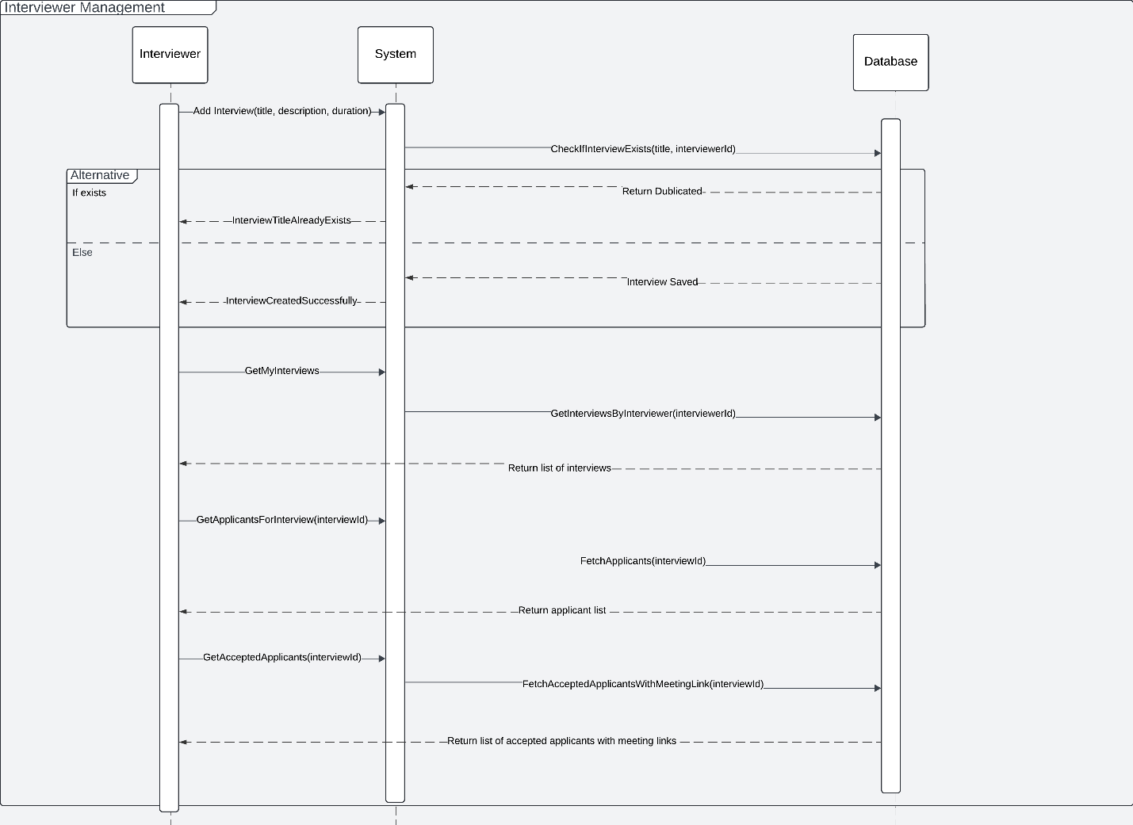

Figure 3‑‎0‑25 : interviewer Management Cycle Sequence Diagram

The following sequence diagram illustrates the interviewer management workflow within the Career Guidance platform. It explains how an interviewer interacts with the system to manage interviews and how the system retrieves or stores data via the database.

**Components:**

* **Interviewer:** The person responsible for managing and conducting interviews.
* **System:** The backend logic (RESTful API implemented in .NET Core).
* **Database:** The SQL Server database where interview-related data is stored and retrieved.

**Main Flow:**

**1. Add Interview:**

If the interviewer wants to create a new interview:

* The Interviewer submits interview details (title, description, duration) to the System.
* The System checks in the Database whether an interview with the same title already exists for the same interviewer (CheckIfInterviewExists).

**If a duplicate is found:**

* The Database returns a "Duplicated" response.
* The System informs the Interviewer that the interview title already exists (InterviewTitleAlreadyExists).

**Else (No duplication):**

* The System stores the new interview in the Database.
* The System returns a success message (InterviewCreatedSuccessfully).

**2. Get My Interviews:**

To view all interviews created by the interviewer:

* The Interviewer requests their list of interviews (GetMyInterviews).
* The System queries the Database (GetInterviewsByInterviewer).
* The Database returns a list of interviews.
* The System forwards the list back to the Interviewer.

**3. Get Applicants for a Specific Interview:**

To view applicants who applied for a particular interview:

* The Interviewer provides an InterviewId.
* The System fetches the list of applicants from the Database (FetchApplicants).
* The Database returns the applicant list.
* The System delivers the list to the Interviewer.

**4. Get Accepted Applicants with Meeting Links:**

To get only accepted applicants along with their meeting links:

* The Interviewer sends a request specifying the InterviewId.
* The System queries the Database for accepted applicants with meeting links (FetchAcceptedApplicantsWithMeetingLink).
* The Database returns the required list.
* The System forwards the data to the Interviewer.

**Purpose of the Diagram:**

This sequence diagram visualizes the end-to-end workflow for managing interviews, including creating, retrieving, and filtering interviews and applicants. It highlights the flow of requests from the user to the backend and then to the database, emphasizing error handling (such as duplicate titles) and filtering logic (such as accepted applicants only). This makes the system behavior more transparent and easier to understand for developers and stakeholders.

**3.9 Interviewer Accept Applicants Cycle Sequence Diagram**

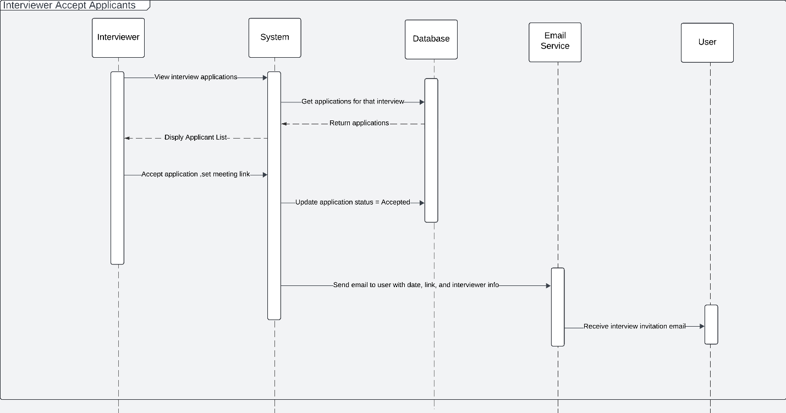

Figure 3‑‎0‑26 : Interviewer Accept Applicants Cycle Sequence Diagram

The following sequence diagram illustrates the workflow for how a user applies for an interview within the Career Guidance platform. It outlines the interaction between the user and the system, along with the system’s communication with the database to manage interview applications.

**Components:**

* **User:** The applicant accessing the platform to apply for interviews.
* **System:** The backend service ( RESTful API) responsible for processing interview requests.
* **Database:** The storage system (SQL Server) where interview information and application statuses are managed.

**Main Flow:**

**1. Viewing Available Interviews:**

* The **User** opens the “Available Interviews” page from the platform.
* The **System** sends a request to the **Database** to retrieve all upcoming and available interviews.
* The **Database** returns the list of interviews.
* The **System** displays the available interviews to the **User**.

**2. Applying for an Interview:**

* The **User** selects an interview and clicks “Apply,” then uploads their CV.
* The **System** saves the application to the **Database** with a status set to Pending.
* A confirmation message is displayed to the **User**.

**Alternative Flow:**

**If the User Has Already Applied Before:**

* The **System** checks existing applications by the same **User** for the selected interview.
* If an application exists, the **System** rejects the new request.
* The **User** receives a "Request Rejected" message.

**If This Is a New Application:**

* The **System** accepts the interview request and updates the status accordingly.
* The **User** receives a "Confirm Interview" message.

**Purpose of the Diagram:**

This sequence diagram helps visualize the process of applying for interviews on the platform. It clearly outlines how:

* Interviews are fetched and displayed,
* Applications are submitted and stored,
* Duplicates are checked,
* Users are notified of the outcome.

### 4. Data Flow Diagram

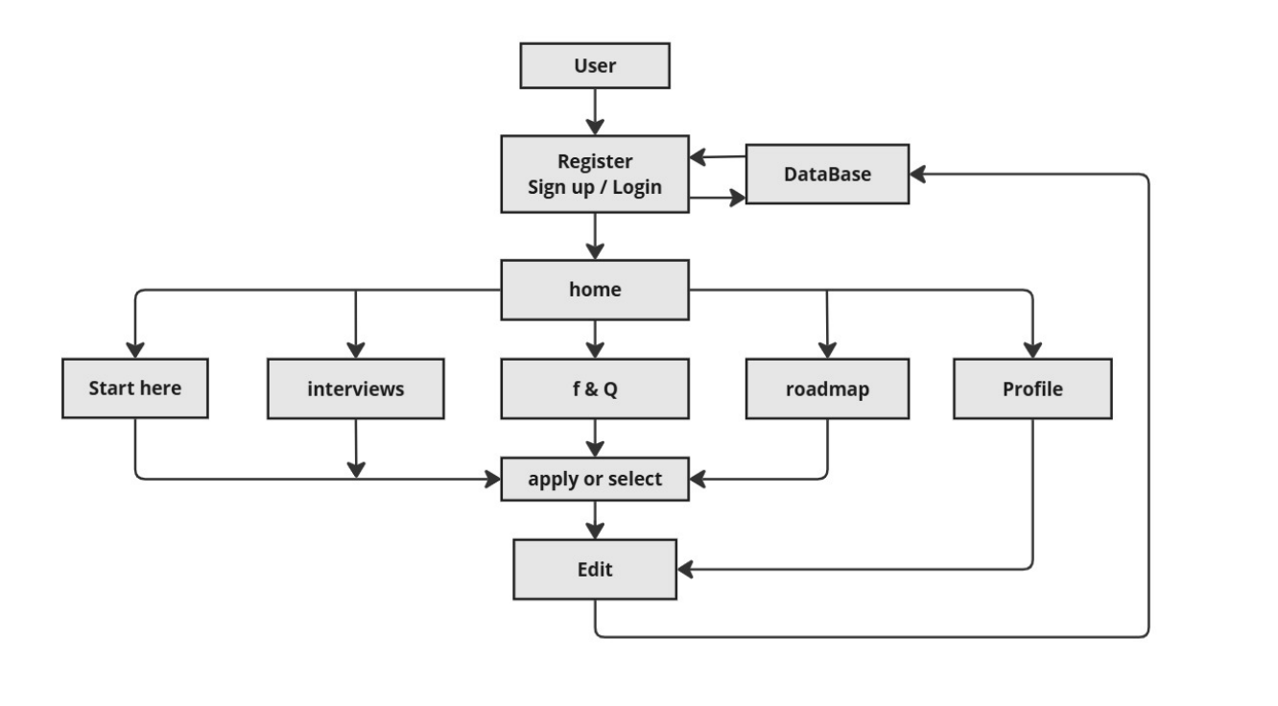

Figure 3‑‎0‑27: User Navigation Flow in the Platform

The following flowchart illustrates the navigation flow for a user interacting with the platform. It covers the typical user journey from registration or login, through various system modules such as FAQ, interviews, roadmaps, and profile management.

**Components**

* **User**: The end-user who accesses the platform's features.
* **Register / Sign up / Login**: Entry point where a user creates an account or authenticates an existing one.
* **Database**: Responsible for verifying login credentials and storing user-related data.
* **Home**: The central dashboard or landing page after successful login.
* **Start Here**: An optional guidance or onboarding section for first-time users.
* **Interviews**: A section that provides interview questions or practice content.
* **F&Q**: The Frequently Asked Questions module that offers common user inquiries and answers.
* **Roadmap**: A section outlining learning or career progress paths.
* **Profile**: Where users can manage personal information and preferences.
* **Apply or Select**: An action point where users make a decision or application within a section (e.g., apply for a roadmap, select a question).
* **Edit**: Interface where users can modify entries (e.g., answers, roadmap progress, or profile details).

**Flow Description**

The **User** starts by navigating to the platform and either **Registers** or **Logs in**.

Authentication is handled through the **Database**, which then redirects the user to the **Home** page upon success.

From the **Home** page, users can choose to:

* Access **Start Here** for introductory content.
* Navigate to **Interviews** to view or practice questions.
* Visit **F&Q** for common questions.
* Explore **Roadmap** to view learning paths.
* Go to their **Profile**.

From either **F&Q** or **Interviews**, the user may reach an **Apply or Select** screen.

Upon selection, the user can proceed to the **Edit** screen to make changes or provide input.

From the **Edit** screen, navigation can loop back to **Profile**, **F&Q**, or other modules, forming a full interaction cycle.

**Purpose of the Diagram**

This flowchart visually represents the user journey and system structure in a simplified, high-level manner. It helps developers and stakeholders understand how different modules are interconnected, and how users interact with the platform. It also clarifies the central role of the home page as a navigation hub and highlights key touchpoints for user input and customization.

## 3.3 Algorithms or frameworks used.

The **Career Guidance Platform** is designed using a modern, scalable, and secure technology stack that prioritizes performance, maintainability, and user experience. While the system does not rely on advanced algorithmic models such as AI or machine learning, it incorporates essential algorithms, business logic flows, and robust frameworks to deliver intelligent and efficient behavior across its modules.

**Frameworks and Technologies**

**Frontend Framework: React.js**

* Built using **React.js**, a component-based JavaScript library for creating dynamic and reusable UI components.
* Utilizes **Virtual DOM** for high-performance rendering and **React Router** for smooth in-app navigation.
* Integrated with **Material UI (MUI)** and **Bootstrap** to ensure a responsive and consistent user interface across devices.

**Backend Framework: ASP.NET Core**

* Core business logic and RESTful APIs are developed using **ASP.NET Core**, a high-performance, cross-platform framework.
* Implements a clean, layered architecture (Controllers → Services → Repositories) for scalability and testability.
* Handles user management, content delivery, and integrations securely and efficiently.

**Database Access: Entity Framework Core (EF Core)**

* Uses **EF Core** as the Object-Relational Mapping (ORM) layer between the backend and SQL Server database.
* Supports **LINQ queries**, **automatic migrations**, and entity relationship management using strongly typed C# models.
* Simplifies CRUD operations and ensures secure, efficient data access.

**Authentication and Authorization: JWT + RBAC**

* Implements **JSON Web Tokens (JWT)** for stateless, encrypted authentication across sessions.
* Combines **Role-Based Access Control (RBAC)** to manage permissions for various user roles such as Admins, Users, and Interviewers.
* Secures APIs and restricts access to sensitive operations through backend role checks.

**API Communication: RESTful APIs + Axios**

* All client-server communications follow RESTful architecture.
* On the frontend, the **Axios** library manages asynchronous API calls and error handling, supporting a responsive user experience.

**Algorithms and Logical Workflows**

**User Progress Tracking Logic**

* Tracks user progress across **roadmaps**, **lessons**, and **quizzes**.
* Updates progress status upon completion of tasks and content nodes.
* Provides **personalized recommendations** for next steps based on progress data.

**Duplicate Validation Algorithm**

* Prevents the creation of duplicate entries at multiple levels:
  + Roadmap names
  + Node titles within roadmaps
  + Resource links within nodes
* Ensures **data integrity** and eliminates redundancy, enhancing the learning experience.

**Quiz Evaluation Algorithm**

* Automatically evaluates quiz submissions by:
  + Comparing answers against predefined correct solutions
  + Calculating and returning scores in real-time
  + Providing instant **feedback** for continuous learner improvement

**Job Application Workflow Logic**

* Handles the end-to-end process of job application submissions within the platform.
* Tracks **application status**, user history, and employer responses.
* Ensures seamless user-employer interactions within the **Jobs Module**.

**Mock Interview Flow Logic**

* Manages the **mock interview simulation** experience:
  + Presents interview questions in a timed, sequential manner
  + Captures and stores user responses
  + Generate **feedback and recommendations** for user enhancement

**Roadmap Navigation Logic**

* Ensures logical progression through roadmap content:
  + Unlocks new content based on previous node completion
  + Tracks learning behavior to adjust recommendations dynamically

# Chapter 4

# Implementation

## 4.1 Technologies, Tools, and Programming Languages Used

The Career Guidance platform is developed using a robust, scalable, and modern full-stack technology ecosystem designed to deliver seamless, secure, and efficient user experience. The system architecture integrates responsive frontend components, a reliable backend, secure authentication, and powerful development tools. Below is an overview of the key technologies, tools, and programming languages used:

**Frontend Technologies**

* **React.js**: A powerful JavaScript library used to build dynamic, component-based user interfaces. It enables efficient rendering, modular development, and real-time interactivity.
* **HTML5 & CSS3**: Standard markup and styling languages for structuring and designing the user interface.
* **Bootstrap & Material UI (MUI)**: Responsive UI frameworks used to ensure consistency across different screen sizes and enhance the visual design of the platform.
* **JavaScript (ES6+)**: The core scripting language used for frontend logic, user interactions, and API communication.

**Backend Technologies**

* **ASP.NET Core**: A high-performance, open-source, cross-platform framework used to build RESTful APIs, manage business logic, and handle server-side operations efficiently.
* **C#**: The primary programming language used to implement backend controllers, services, and database logic.

**Database & Data Access**

* **SQL Server**: A reliable relational database system used to store structured data such as user profiles, roadmaps, interview records, tasks, and progress tracking.
* **Entity Framework Core (EF Core)**: An object-relational mapper (ORM) that simplifies data manipulation using LINQ and C# objects, ensuring strong typing and reduced boilerplate code.

**Security & Authentication**

* **JWT (JSON Web Tokens)**: Implements stateless and secure authentication mechanisms for API access.
* **Role-Based Access Control (RBAC)**: Used to manage user permissions based on roles such as administrator, learner, or interviewer.
* **HTTPS & SSL**: Ensure all user data is securely transmitted and protected from external threats.

**Development Tools & Utilities**

* **Visual Studio / Visual Studio Code**: Integrated development environments (IDEs) used for backend (.NET Core) and frontend (React) development.
* **Postman**: A testing tool for simulating and verifying RESTful API requests and responses during development.
* **Swagger (OpenAPI)**: Used for automatic documentation and interactive testing of APIs.
* **Git & GitHub**: Employed for version control, team collaboration, and source code management throughout the development lifecycle.

## 4.2 Key Components/Modules of the System

The Career Guidance platform is composed of several core components and modules that work together to deliver an integrated and career-focused learning experience. Each module is designed with a specific purpose to support the user journey from onboarding and learning to job readiness and application. The following outlines the key components of the system:

**User Management Module**

This module handles user registration, login, role-based access, and profile management. Users are assigned specific roles such as learner, admin, or interviewer, which control access to different platform functionalities.

**Roadmap Module**

The core of the learning experience, this module delivers structured educational paths across various programming fields. Each roadmap consists of ordered **nodes**, representing lessons, challenges, or tasks. It allows learners to progress step-by-step while tracking completion status.

**Node and Content Module**

Each node within a roadmap represents a learning unit. This module manages node content such as titles, descriptions, types (video, article, task), and external **links** to resources. It ensures learners have access to quality educational material at each step.

**Progress Tracking Module**

This module monitors learners’ progress through roadmaps and updates their status in real-time. It includes completion indicators, progress bars, and conditional unlocking of subsequent tasks to maintain a guided experience.

**Interview Preparation Module**

A unique feature of the system, this module enables learners to schedule and attend **mock interviews** with professional interviewers. It includes interview listings, scheduling functionality, feedback submission, and behavioral/technical evaluation criteria.

**Job Opportunities Module**

This module connects learners to real-world career opportunities. It allows users to browse, filter, and apply to job postings or internships from partner companies directly through the platform.

**FAQ & Support Module**

Manages a knowledge base of frequently asked questions and answers to assist users. It helps reduce support overhead and enhances user self-service.

**Admin Dashboard Module**

A powerful backend interface that allows administrators to manage users, update roadmap content, monitor system activity, and maintain the quality and relevance of learning materials. It includes CRUD operations for all major entities in the system.

**Security & Authentication Module**

This module handles secure access to the system using JWT-based authentication and enforces role-based access control (RBAC). It also includes protections like encrypted communication via HTTPS and session management.

## 4.3 Database Implementation

4.2.1 Introduction

The database implementation serves as the backbone of the **Career Guidance** platform, enabling efficient storage, organization, and retrieval of all critical system data. Due to the platform’s wide array of features including user interaction, structured learning paths, task tracking, interview preparation, and job listings—a scalable and dependable database architecture was essential.

**Microsoft SQL Server** was selected as the core relational database management system (RDBMS) due to its robustness and enterprise-level performance. The design process began with modeling the logical data structure using **Entity Relationship Diagrams (ERDs)**, which clarified how different entities relate to one another. This logical model was then transformed into a physical schema using **Entity Framework Core (EF Core)**, an object-relational mapping (ORM) framework integrated with ASP.NET Core.

The database design prioritizes **data integrity**, **referential consistency**, and **performance optimization**. Carefully defined one-to-many and many-to-many relationships were established, supported by appropriate constraints and indexing strategies to ensure structural coherence and query efficiency. Mechanisms were also implemented to prevent data duplication and enforce validation rules, promoting a clean and reliable data environment.

**4.2.2 All Tables in Database**

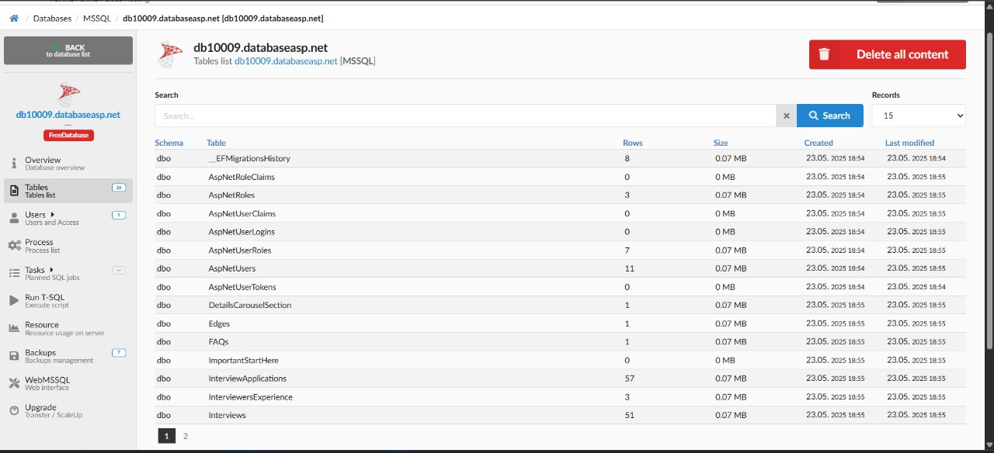

Figure ‎4‑27 : Overview of database tables (Part 1)

This screenshot shows the first set of tables implemented in the Career Guidance database using SQL Server. These tables manage content-related data such as roadmaps, links, carousel sections, and social media components, forming the foundation of the platform’s structured learning system.

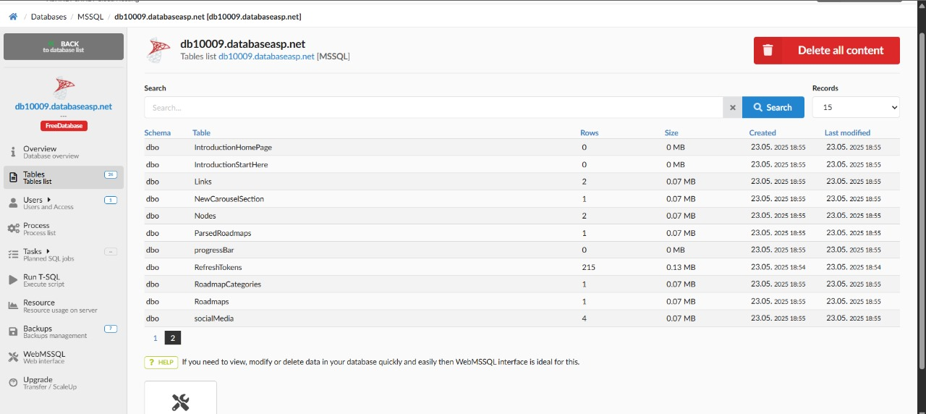

Figure 4‑‎0‑18: Overview of database tables (Part 2 )

this screenshot displays the second set of tables focused on user authentication, interview management, and entity relationships. these tables handle user tokens, interview simulations, and system tracking operations.

**4.2.3 Tables**

**4.2.3.1 Users**

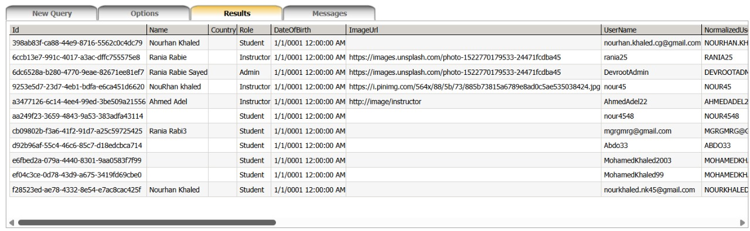

Table 4-1: Structure and sample data from the Users table

This table stores information related to registered users on the platform. It includes key fields such as user ID, name, country, role (e.g., Student, Instructor, Admin), date of birth, profile image URL, and login credentials (username and normalized username).

**4.2.3.2 Roadmaps**

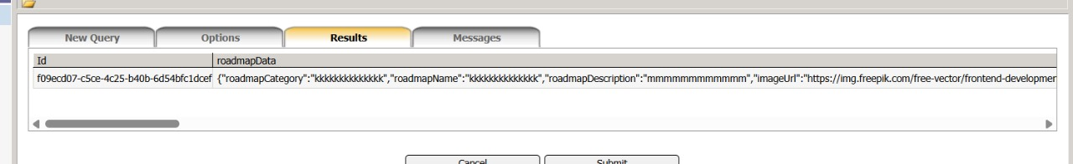

Table 4-2: Structure and sample data from the Roadmap table

This table stores raw roadmap data in a JSON format under the roadmapData column. Each record includes structured information such as the roadmap category, name, description, and image URL. The Id column holds a unique identifier used to link or parse the roadmap when needed. This structure allows for flexible storage before the data is processed and split into more detailed entities.

**4.2.3.3 Interviews**

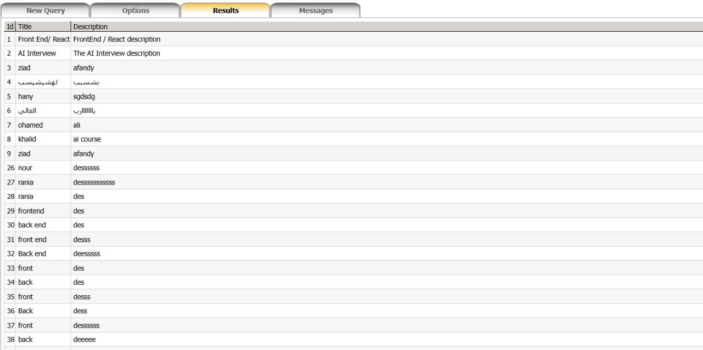

Table 4-3: Structure and sample data from the Interviews table

This table stores interview topics and their descriptions to help learners prepare for various technical and non-technical interviews. Each entry includes an Id as a primary key, a Title field that specifies the interview subject, and a Description field that provides additional context or details about the interview. This structure supports organizing diverse interview types and ensuring learners have easy access to relevant preparation material.

**4.2.3.4 Social Media**

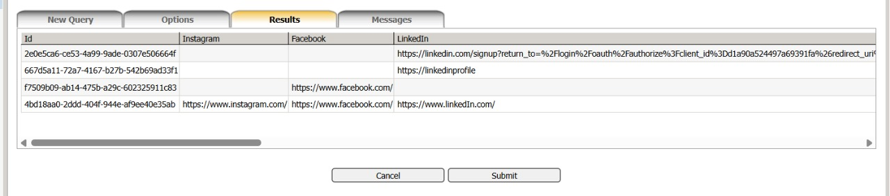

Table 4-4: Structure and sample data from the Social Mediatable

This table stores external social media links associated with users on the platform. It includes fields for Instagram, Facebook, and LinkedIn URLs, enabling the system to display or link users' profiles on external networks as part of their public or instructor-facing profiles.

**4.2.3.5 Parsed Roadmap**



Table 4-5: Structure and sample data from the Parsed Roadmap table

This table represents the parsed version of the main learning roadmaps used in the Career Guidance platform. It includes essential metadata such as the roadmap’s unique identifier (Id), its title (RoadmapName), a brief description (RoadmapDescription), and the category it belongs to (Category). Additionally, the ImageUrl field stores a link to a visual representation of the roadmap, which helps users quickly identify and relate to the learning path.

**4.2.3.6 FAQs**

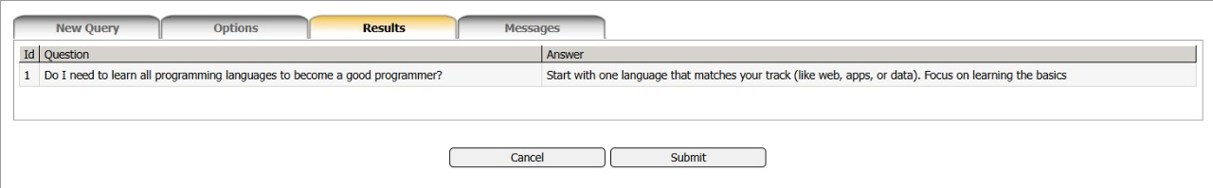

Table 4-6: Structure and sample data from the FAQs table

This table stores frequently asked questions along with their corresponding answers to support learners during their journey. Each entry contains an Id as a primary key, a Question field with a common inquiry from users, and an Answer field that provides a clear, helpful response. This feature helps clarify key concepts and addresses common concerns new learners might have.

**4.2.3.7 Interview Applications**

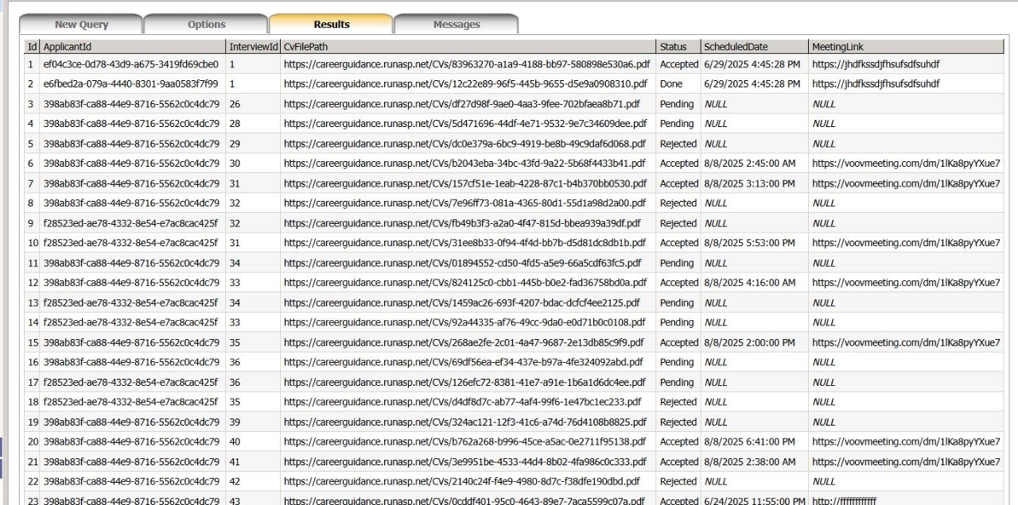

Table 4-7: Structure and sample data from the Interview Applications table

This table manages the application process for interviews, tracking each applicant’s progress and status. It includes an Id as a primary key, an ApplicantId to identify the applicant, an InterviewId to link to the specific interview, and a CVFilePath to store the location of the applicant’s CV. The table also records the current Status of the application (e.g., Pending, Accepted, Rejected), the ScheduledDate for interviews if applicable, and a MeetingLink for virtual interview sessions. This setup helps efficiently organize and monitor the entire interview workflow.

## 4.4 GUI Implementation Design

**4.3.1 dashboard**

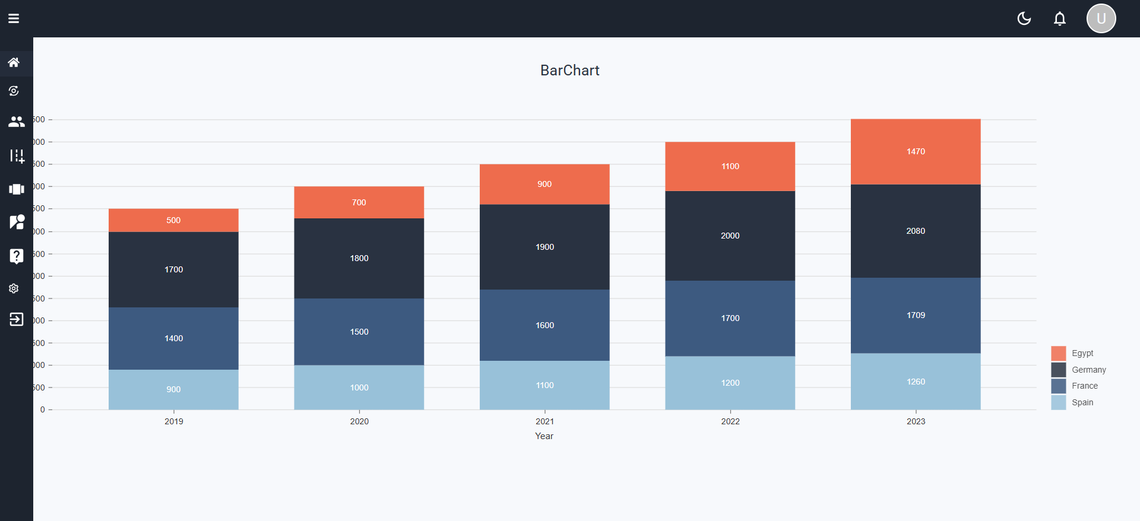

Figure4-1: This page displays analytical data about the site.

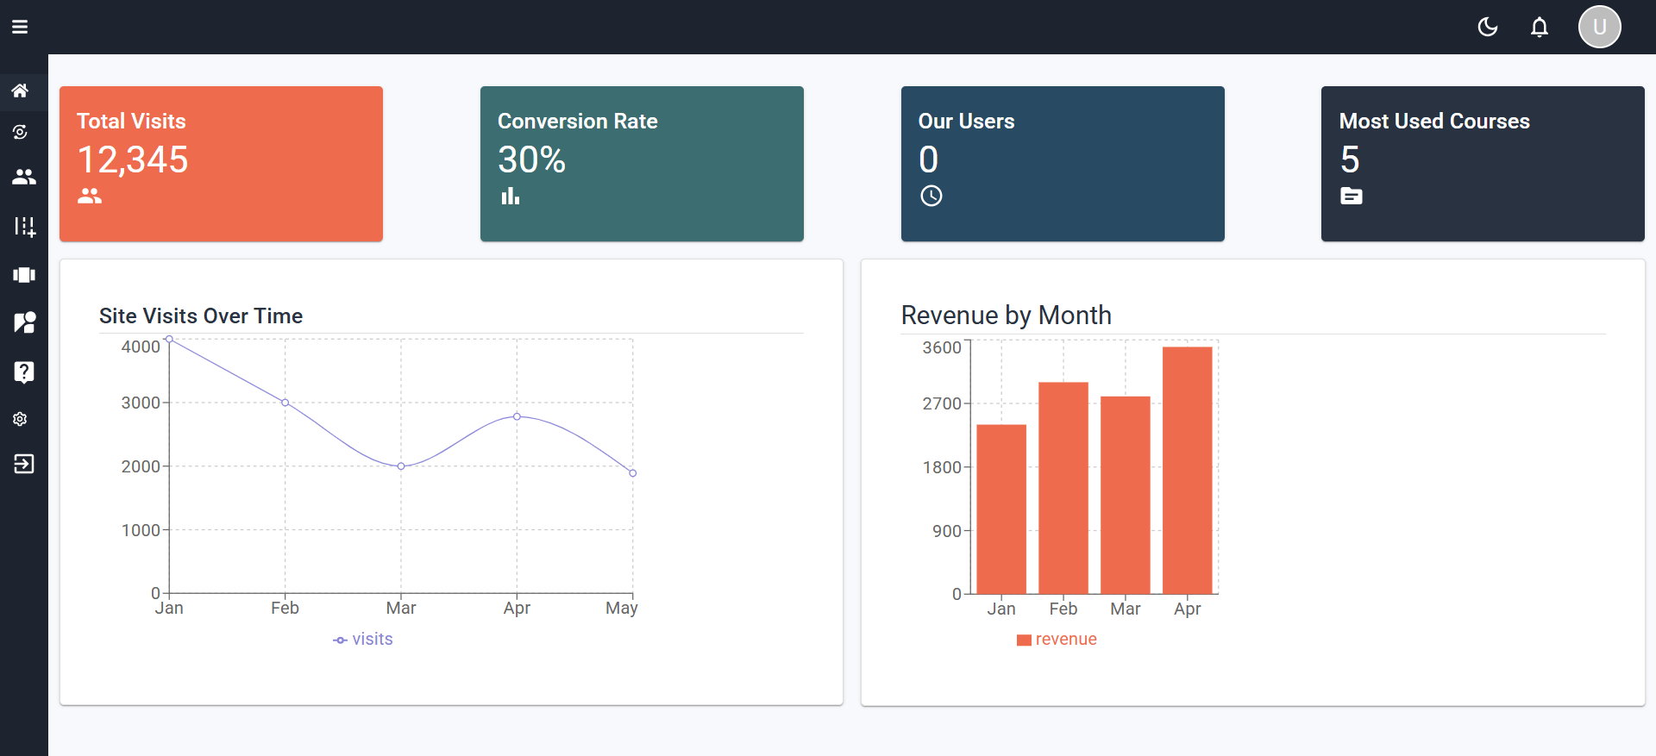

Figure 4‑2: This page displays analytical data about the site.

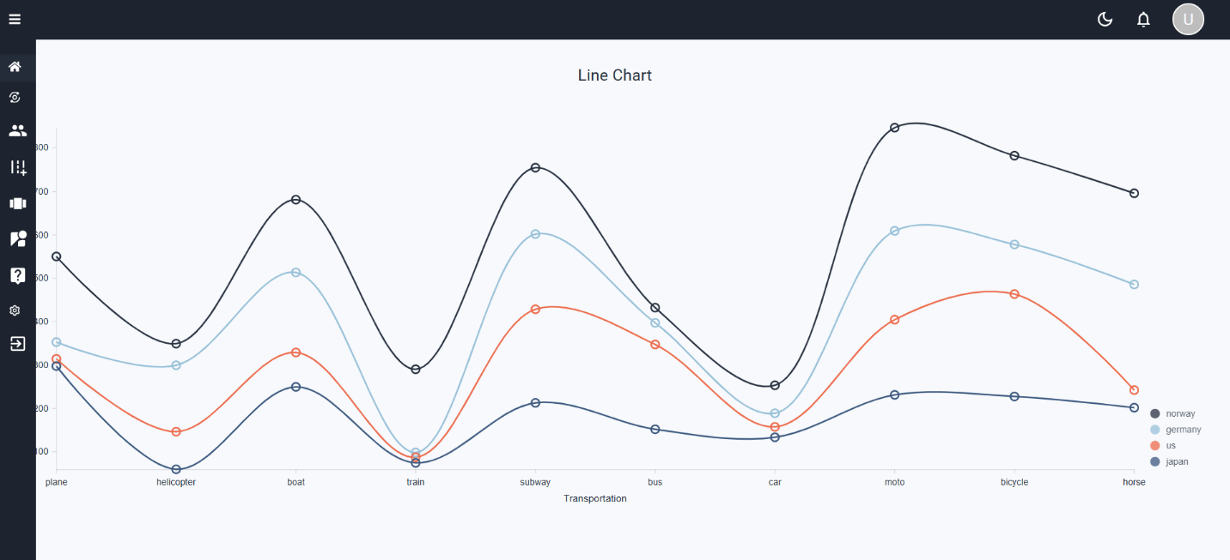

Figure 4‑3: This page displays analytical data about the site.

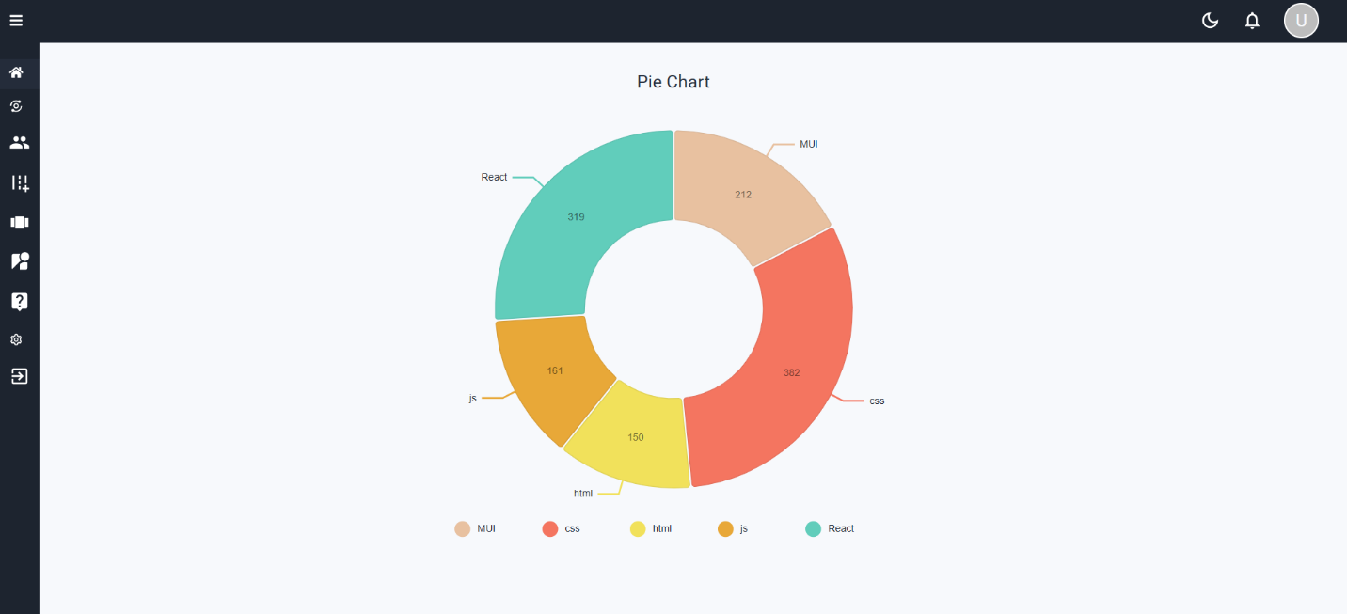

Figure 4‑4: This page displays analytical data about the site.

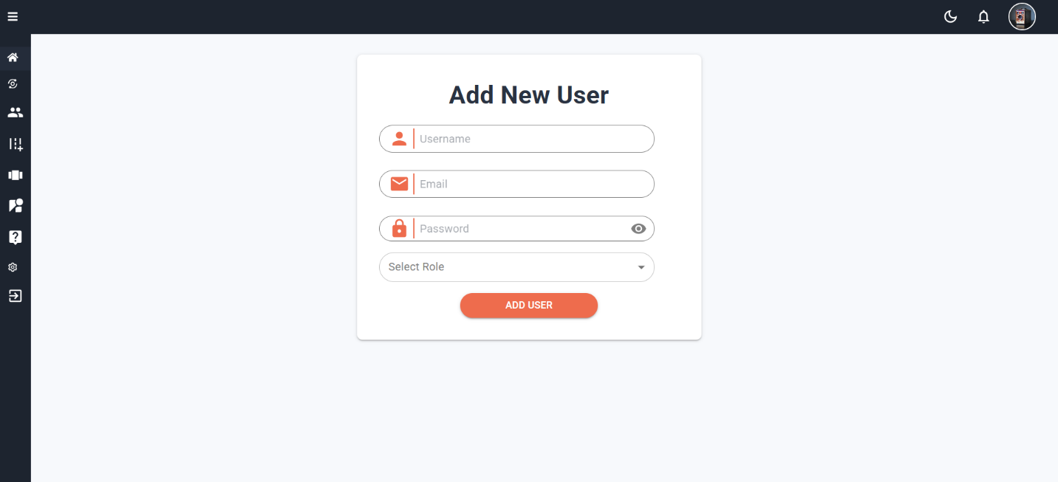

Figure 4‑5: This page creates an account for either the admin or the instructor.

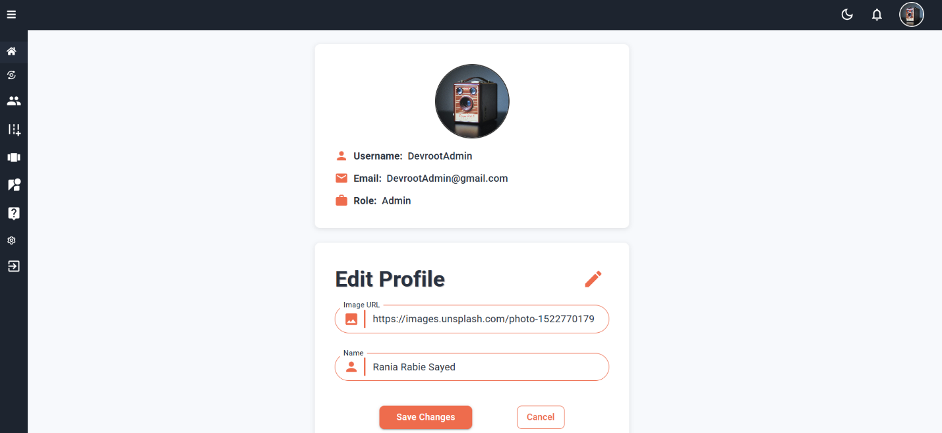

Figure 4‑6: This page allows you to edit your personal page, whether it's the photo or the name.

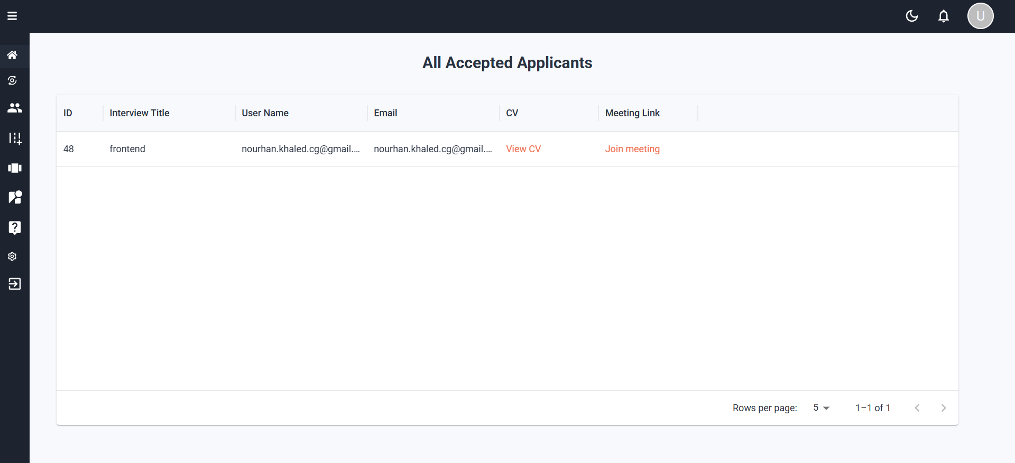

Figure 4‑7: This page displays those accepted for the interview by the instructor and allows him to view their CV or set a meeting date for the interview.

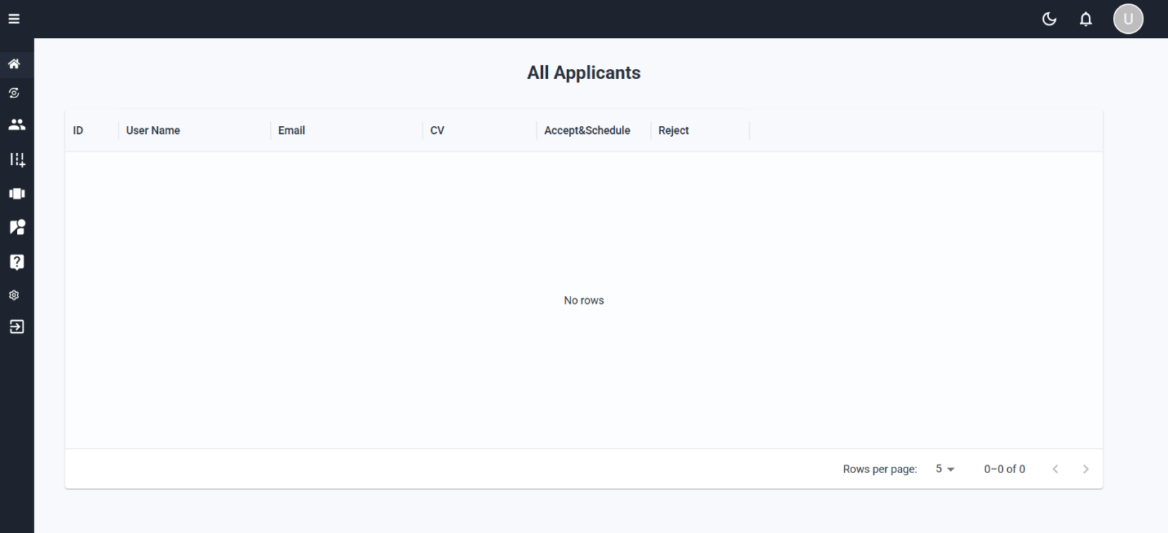

Figure 4‑8: This page displays the applicants who were interviewed by the instructor and the ability to view their CVs and accept or reject them.

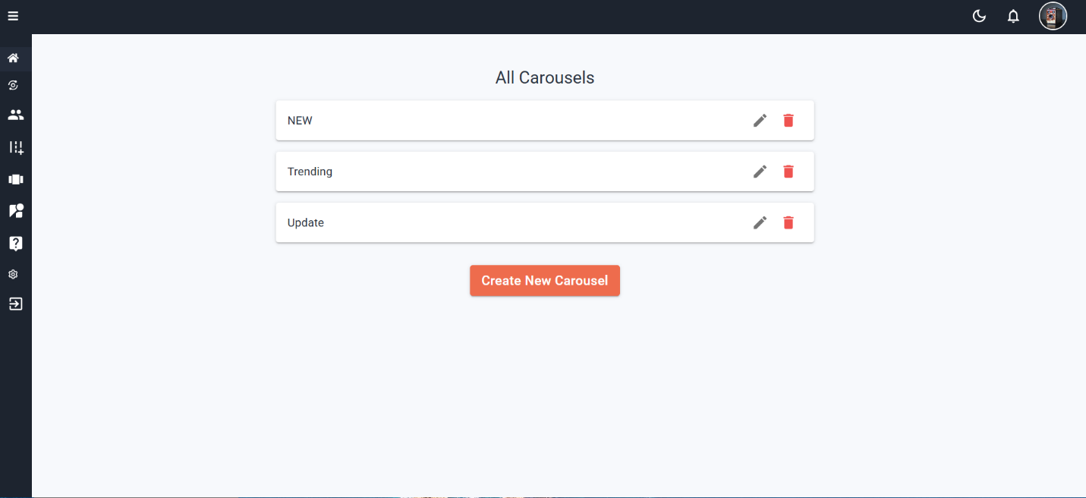

Figure 4‑9: This page displays all the carousel and the ability to edit or delete it.

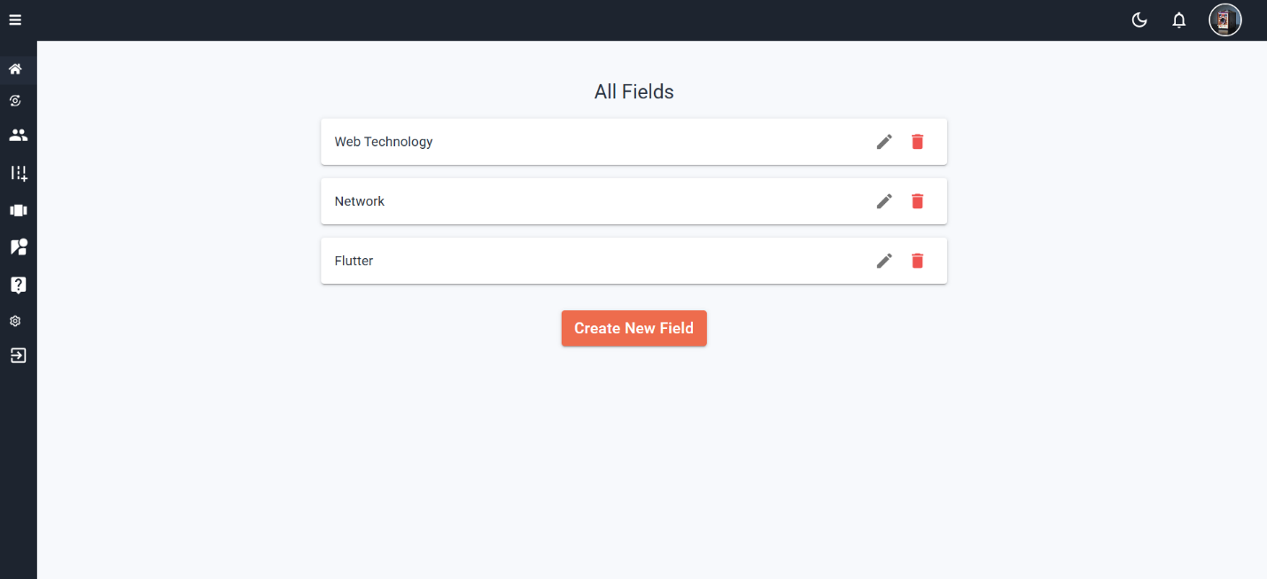

Figure 4‑10 :This page displays all the fields available on the site that can be learned, and the possibility of adding other fields or deleting a field.

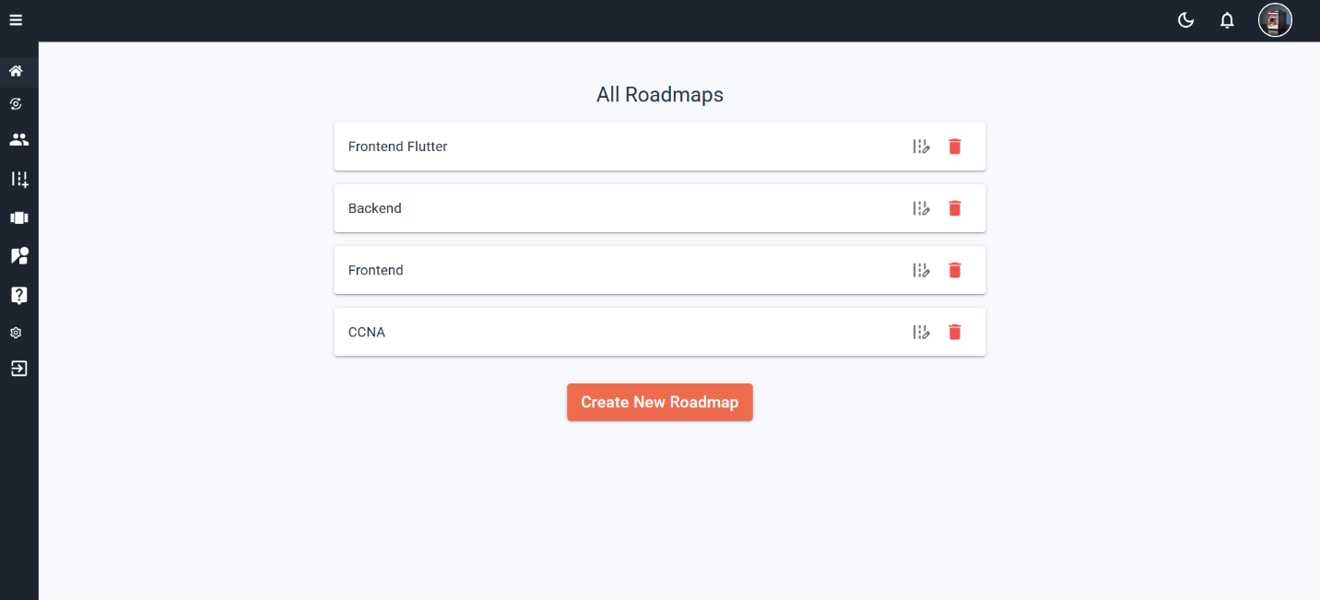

Figure 4‑11 :All different maps in all fields and the ability to modify them or create another one

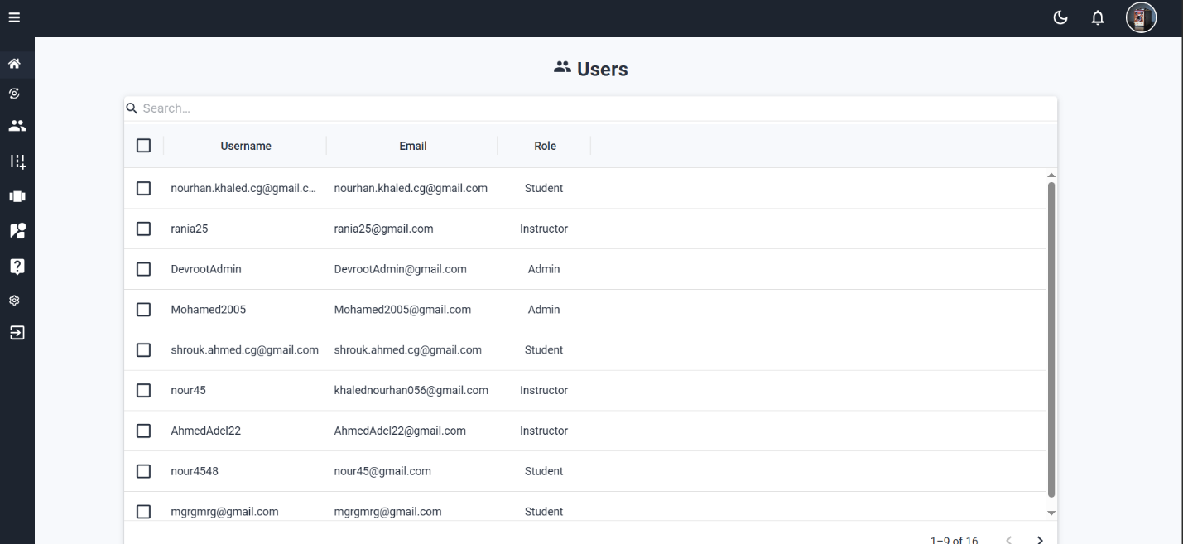

Figure 4‑12 : This page displays the users registered on the website with their information and the possibility of deleting them.

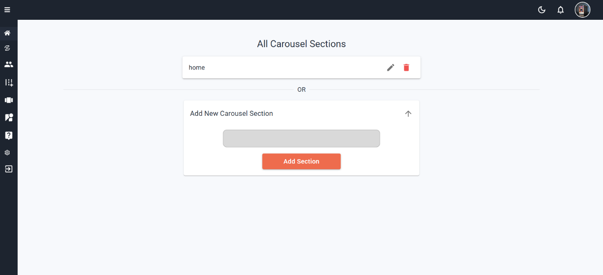

Figure 4‑13: This page displays the different areas of the carousel and the possibility of adding a new carousel.

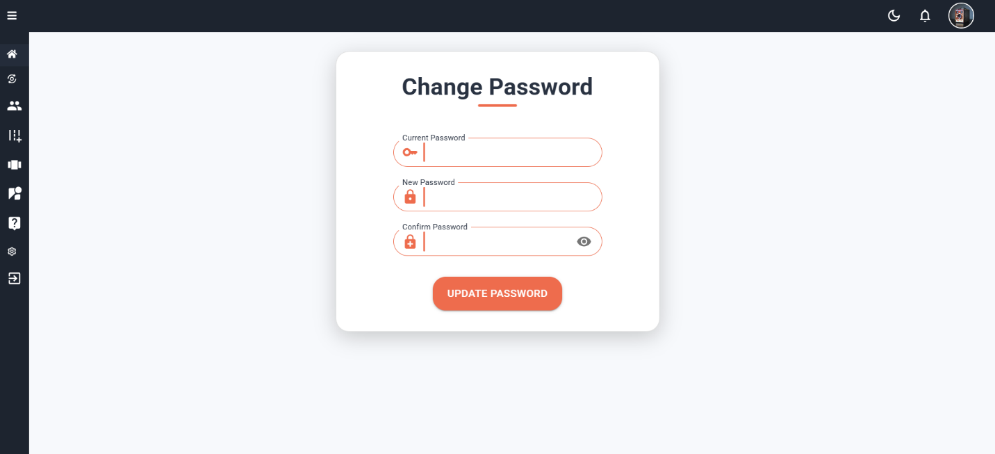

Figure 4‑14: This page allows the admin to change the password by entering the old and new password and confirming the new one.

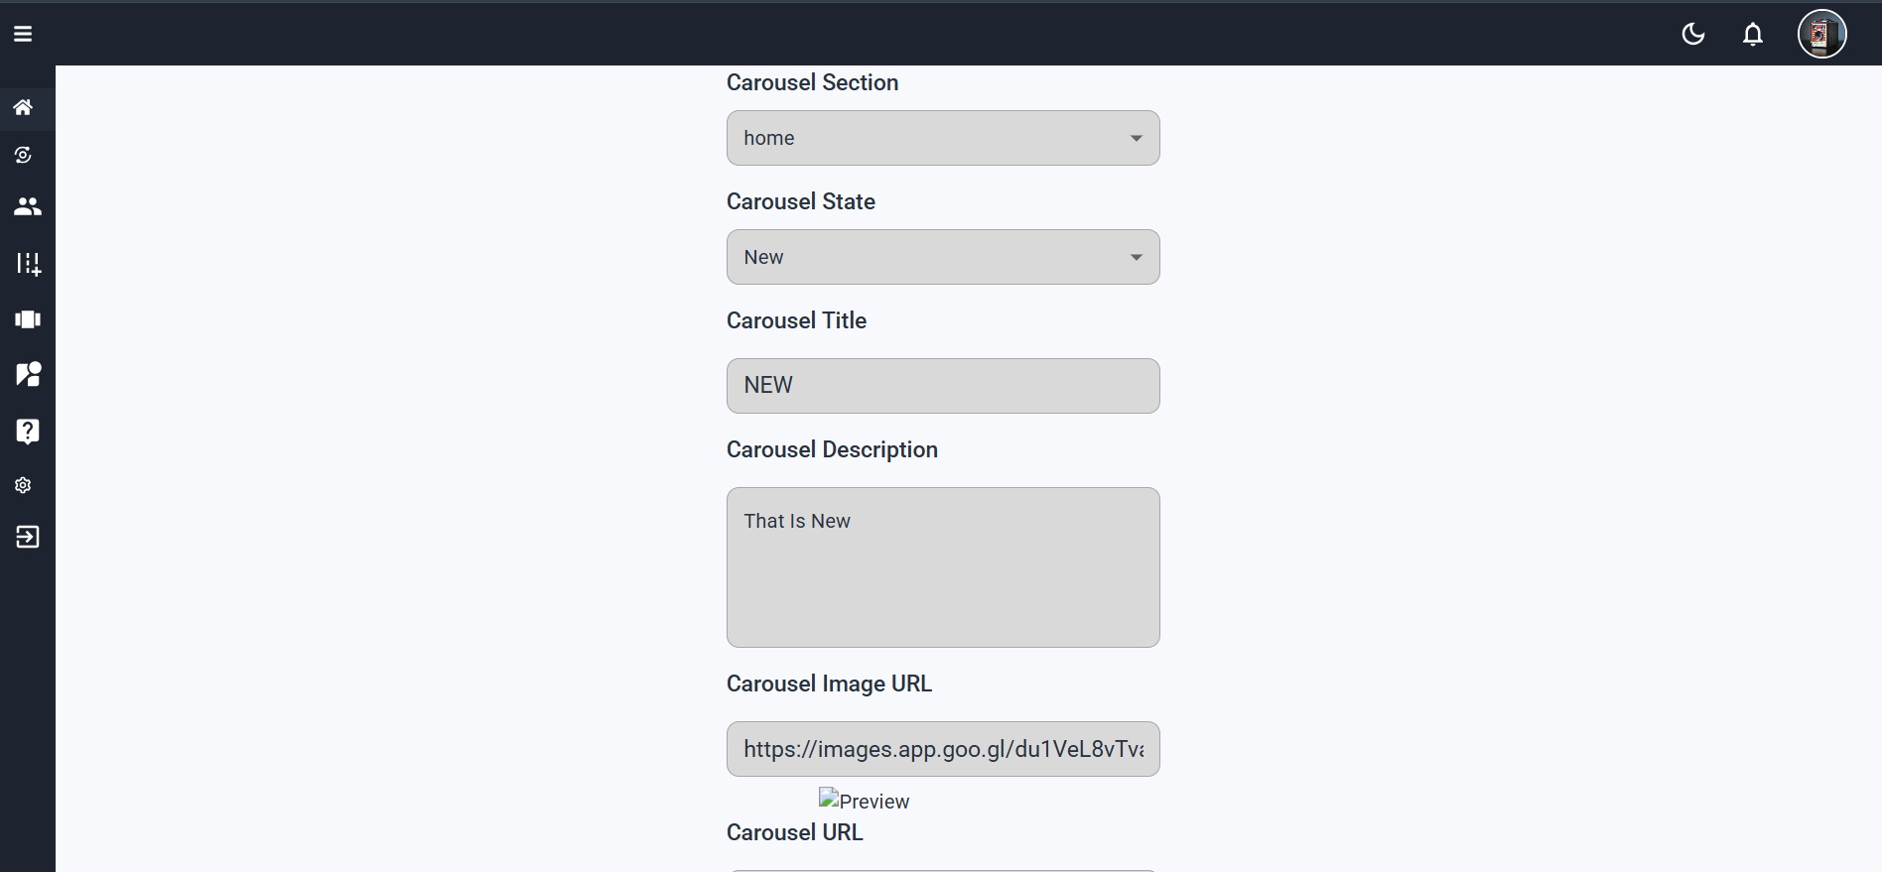

Figure 4‑15: This page adds a picture of the carousel, specifies which field you will join, and specifies the link to the picture.

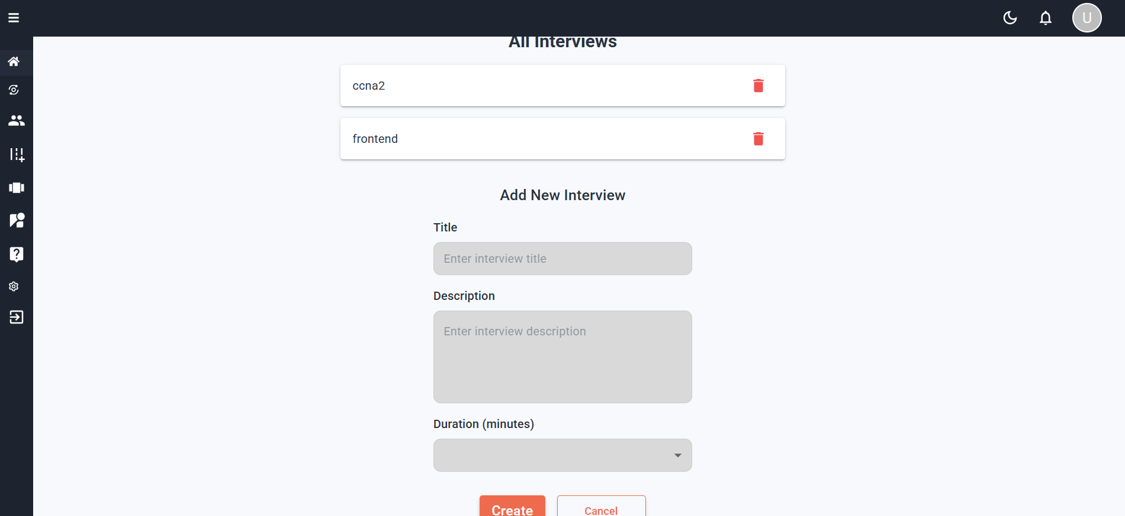

Figure 4‑16: This page allows the instructor to modify the interview, whether by adding a new field or modifying an old field.

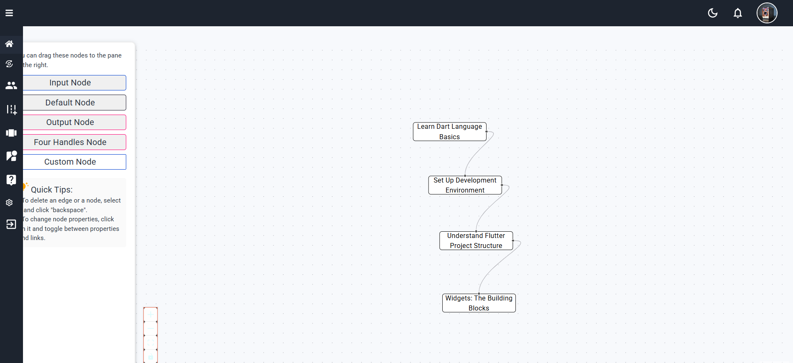

Figure 4‑17: This page adds a roadmap by the admin and chooses the form in which it will appear to the user.

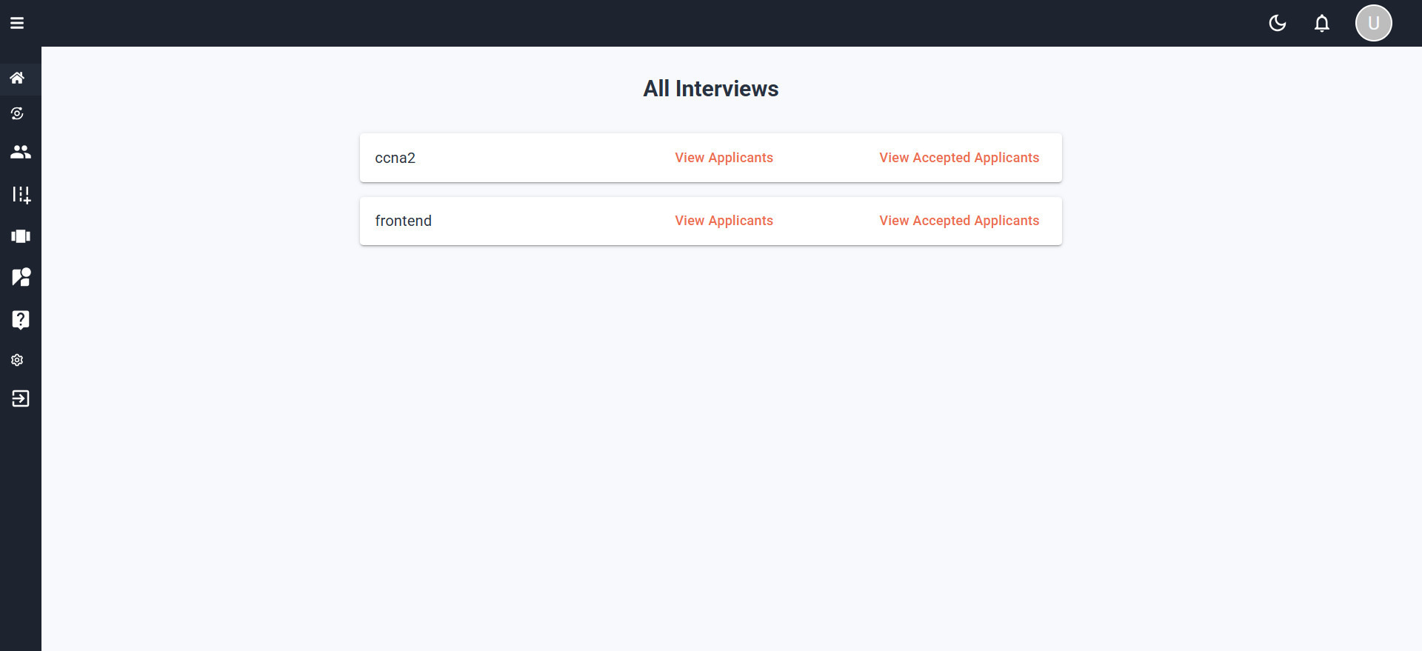

Figure 4‑18: This page displays the interview fields and allows the instructor to see the applicants and those accepted.

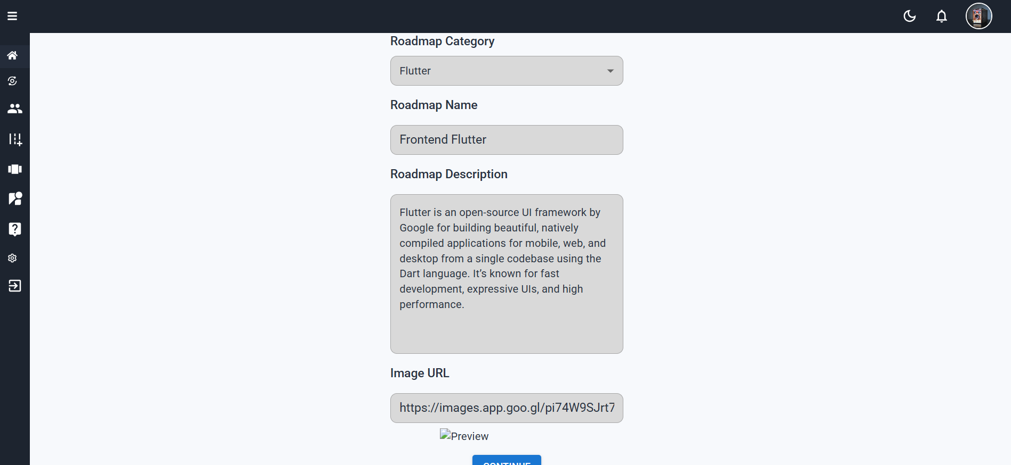

Figure 4‑19: This page adds the external form of the road map by putting a description and a picture representing it and adding its name

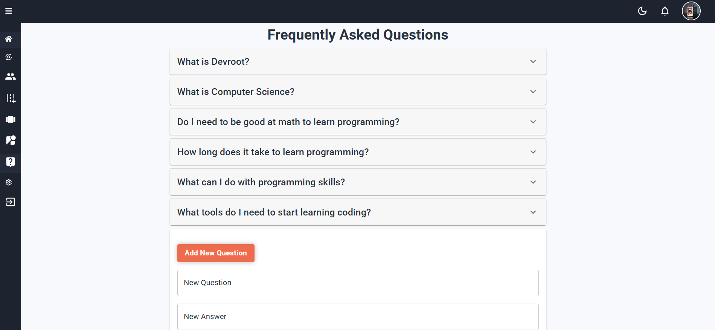

Figure 4‑20: Through this page, we add the most frequently asked questions from the user and answer them.

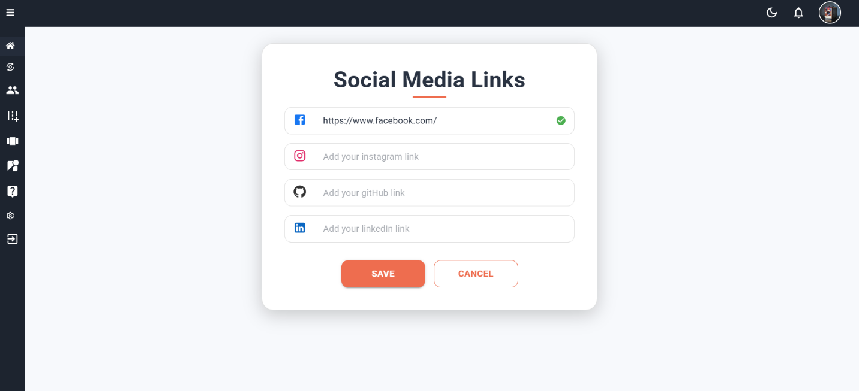

Figure 4‑21: Through this page, the admin can add social media links if he likes.

**4.3.2 user**

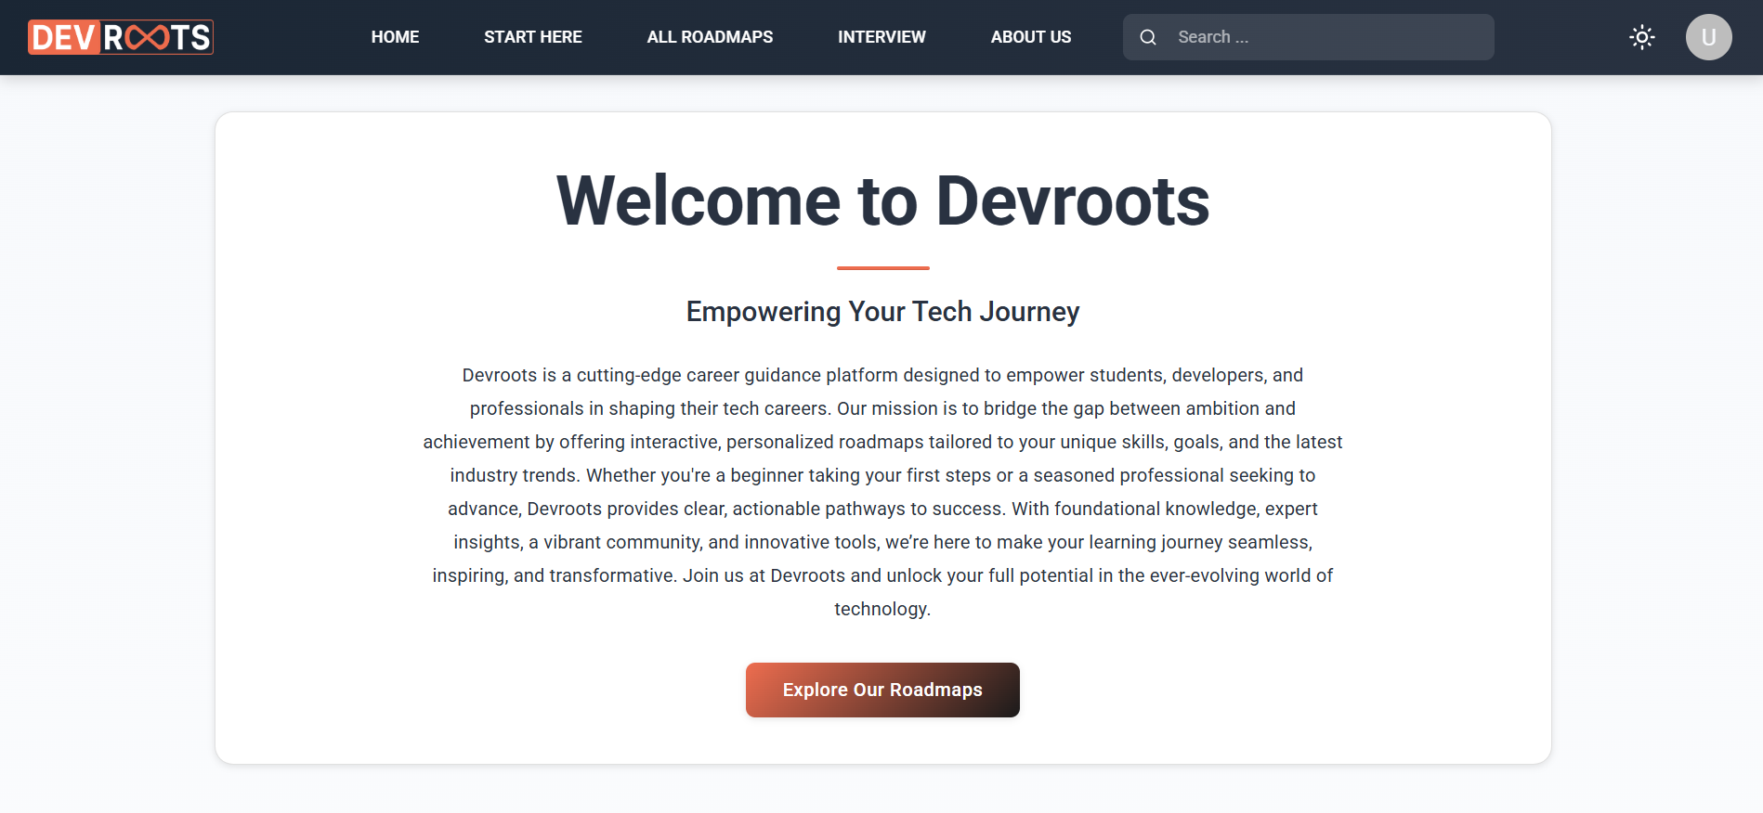

Figure 4‑22: This page provides a brief overview of the team and what it offers.

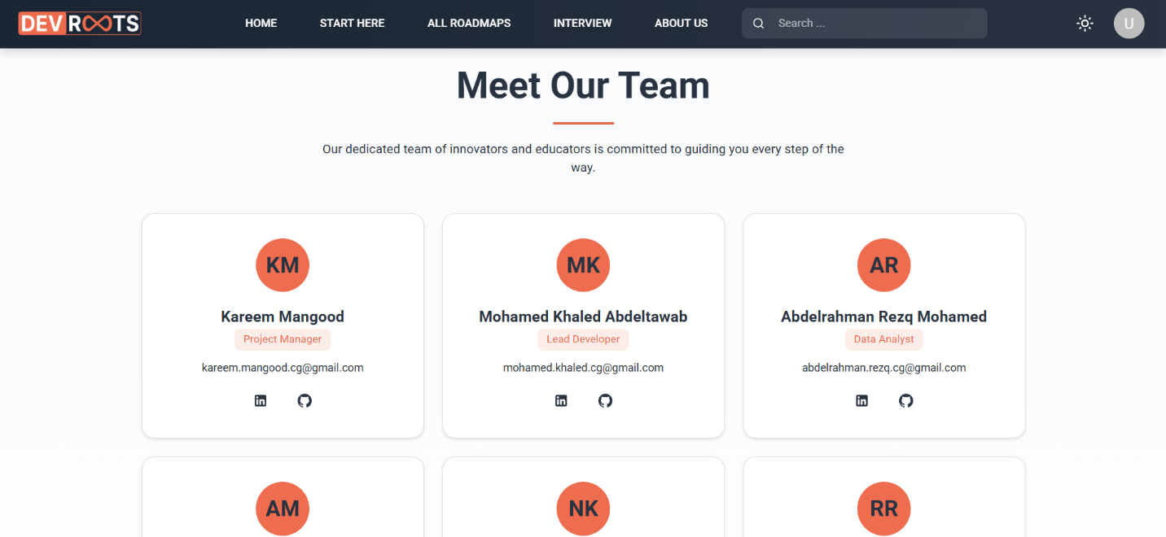

Figure 4‑23: This page provides a brief overview of the team and what it offers.

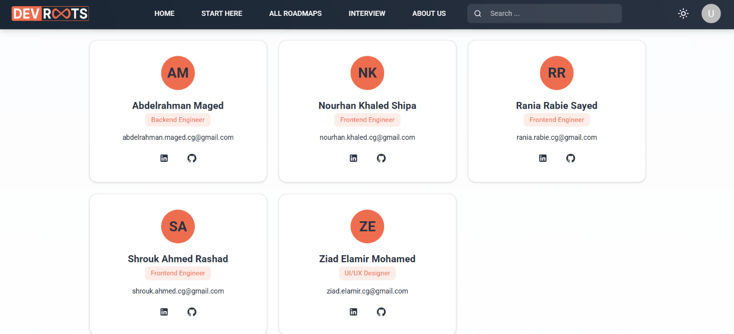

Figure 4‑24: This page provides a brief overview of the team and what it offers.

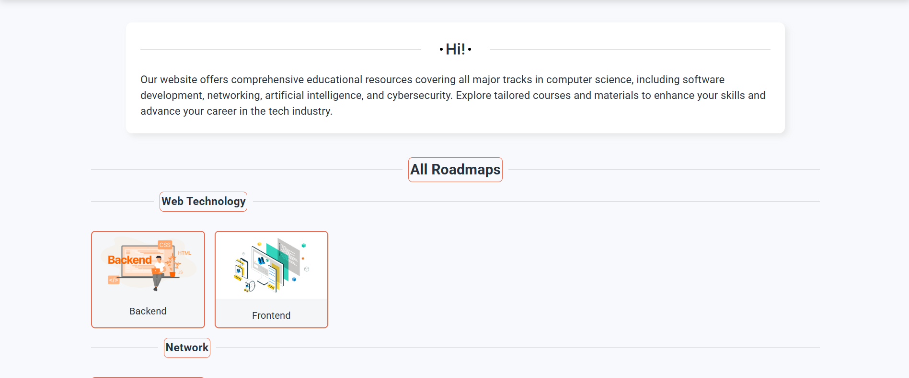

Figure 4‑25: This page displays the different user areas and tracks within them.

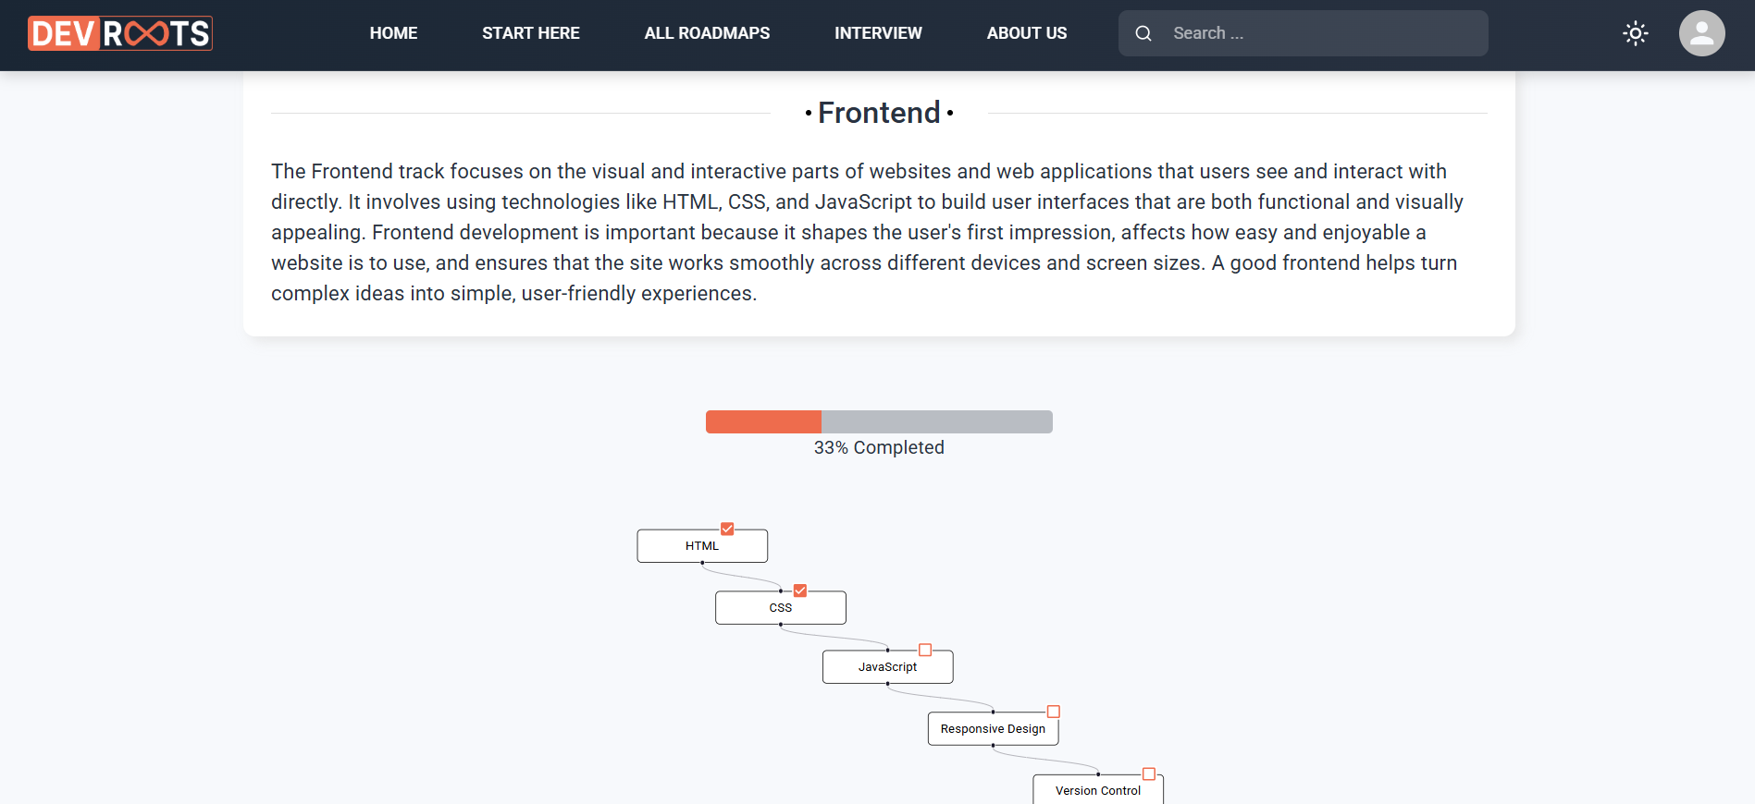

Figure 4‑26: This page displays an overview of the track and a roadmap to learn the track and a bar that measures your progress.

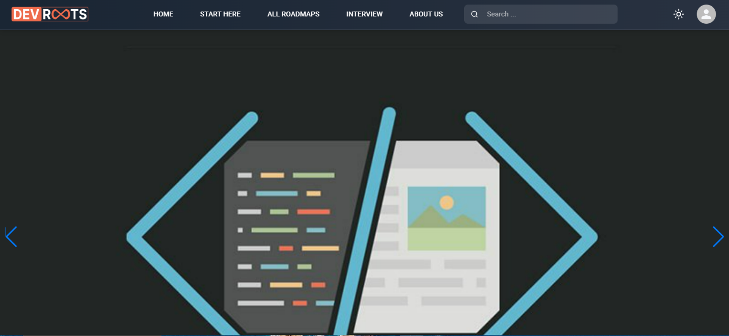

Figure 4‑27: Home page and display the carousel

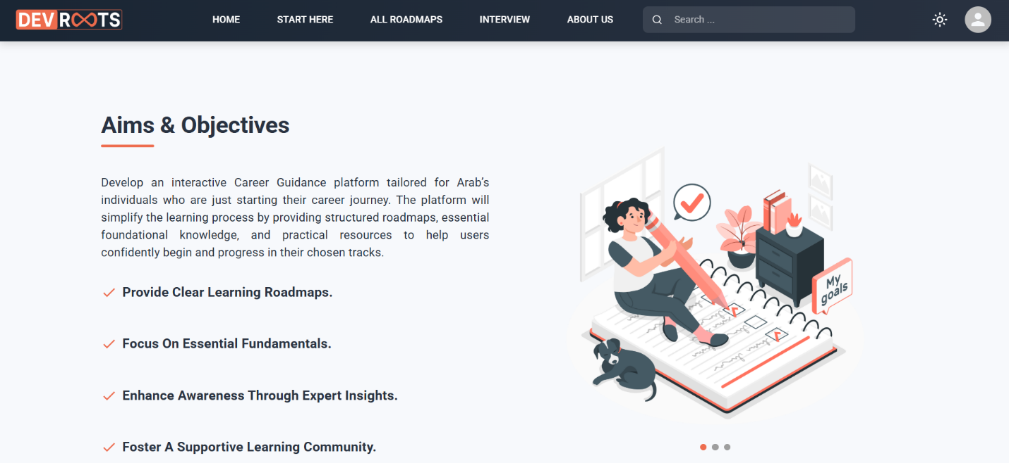

Figure 4‑28: The home page displays a brief overview of our goals.

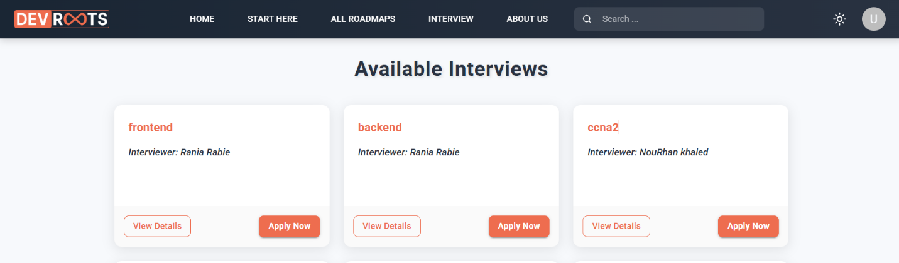

Figure 4‑29: This page displays the interviews available for the user to apply for and also allows him to display a summary of the interviewer who will conduct the interview or upload his CV.

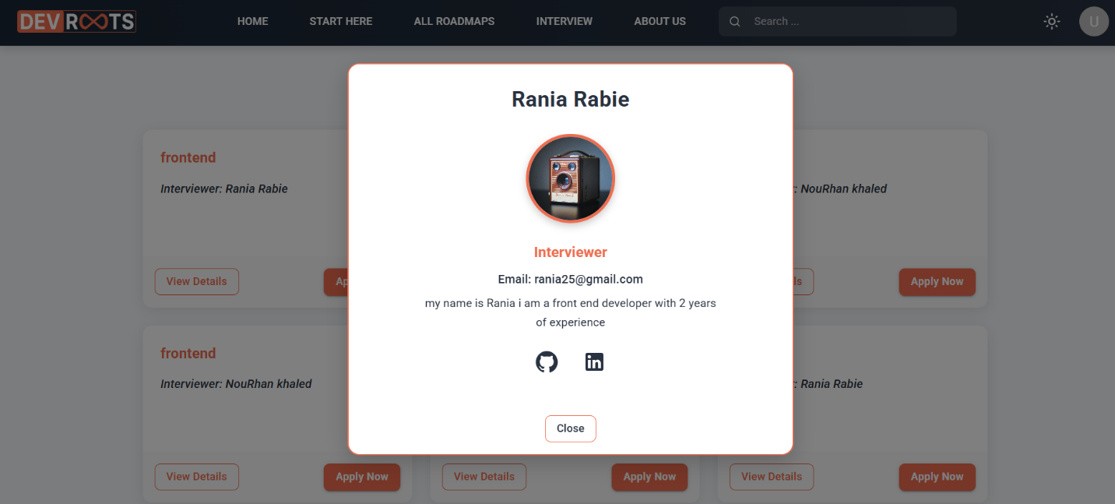

Figure 4‑30: You will be providing an overview of the interview and its social media links.

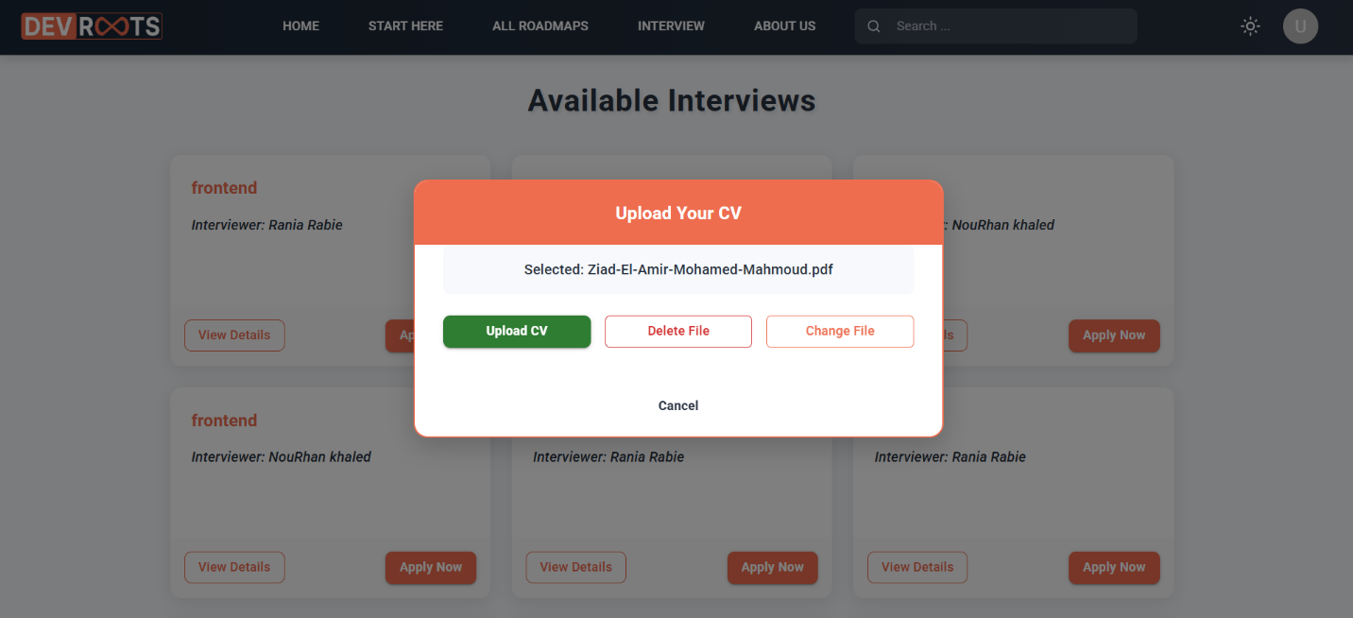

Figure 4‑31: It allows the user to add or edit his CV after uploading or deleting it.

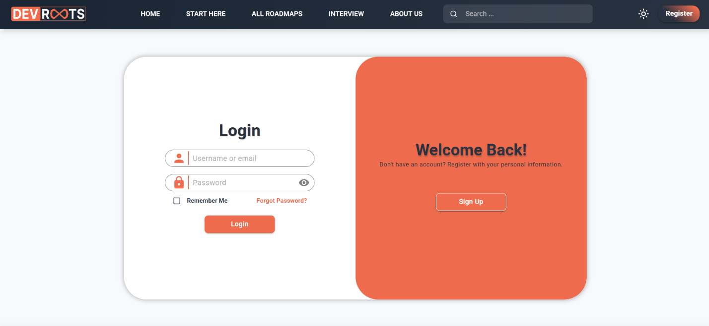

Figure 4‑32: If the user has an account, he can log in.

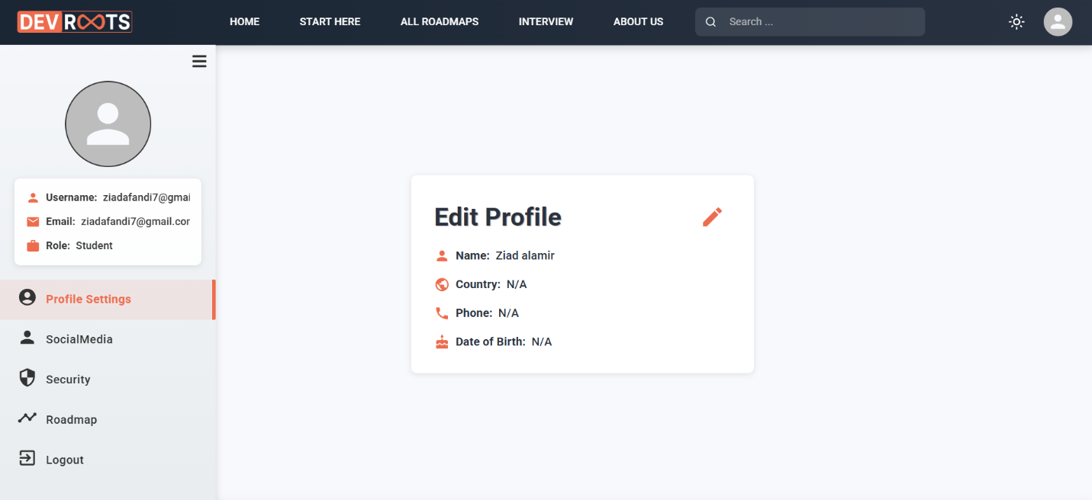

Figure 4‑33: It allows the user to modify his personal page, whether it is his name, the city he lives in, his phone number, or his date of birth.

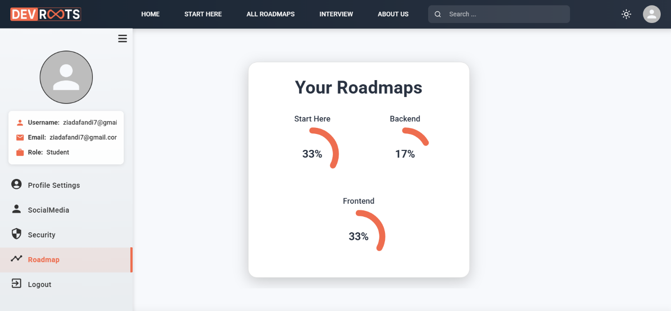

Figure 4‑34: This page displays the user's progress in the roadmap he is learning in.

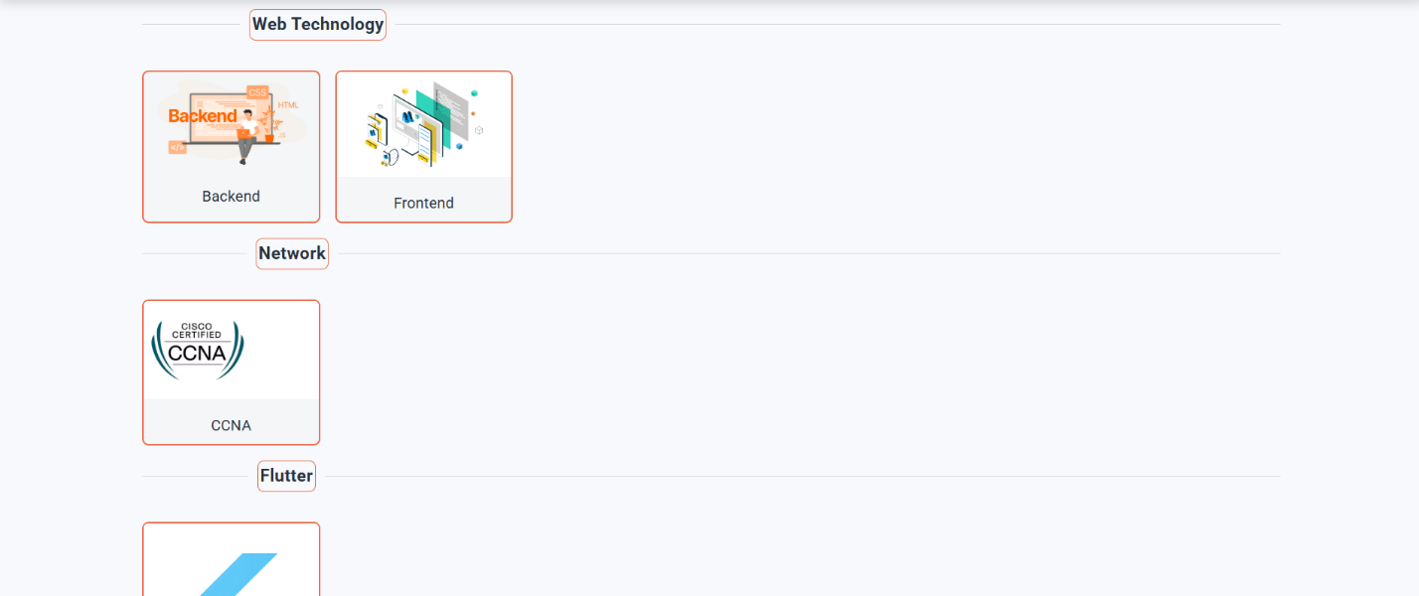

Figure 4‑35: Displays different fields and tracks that can be learned.

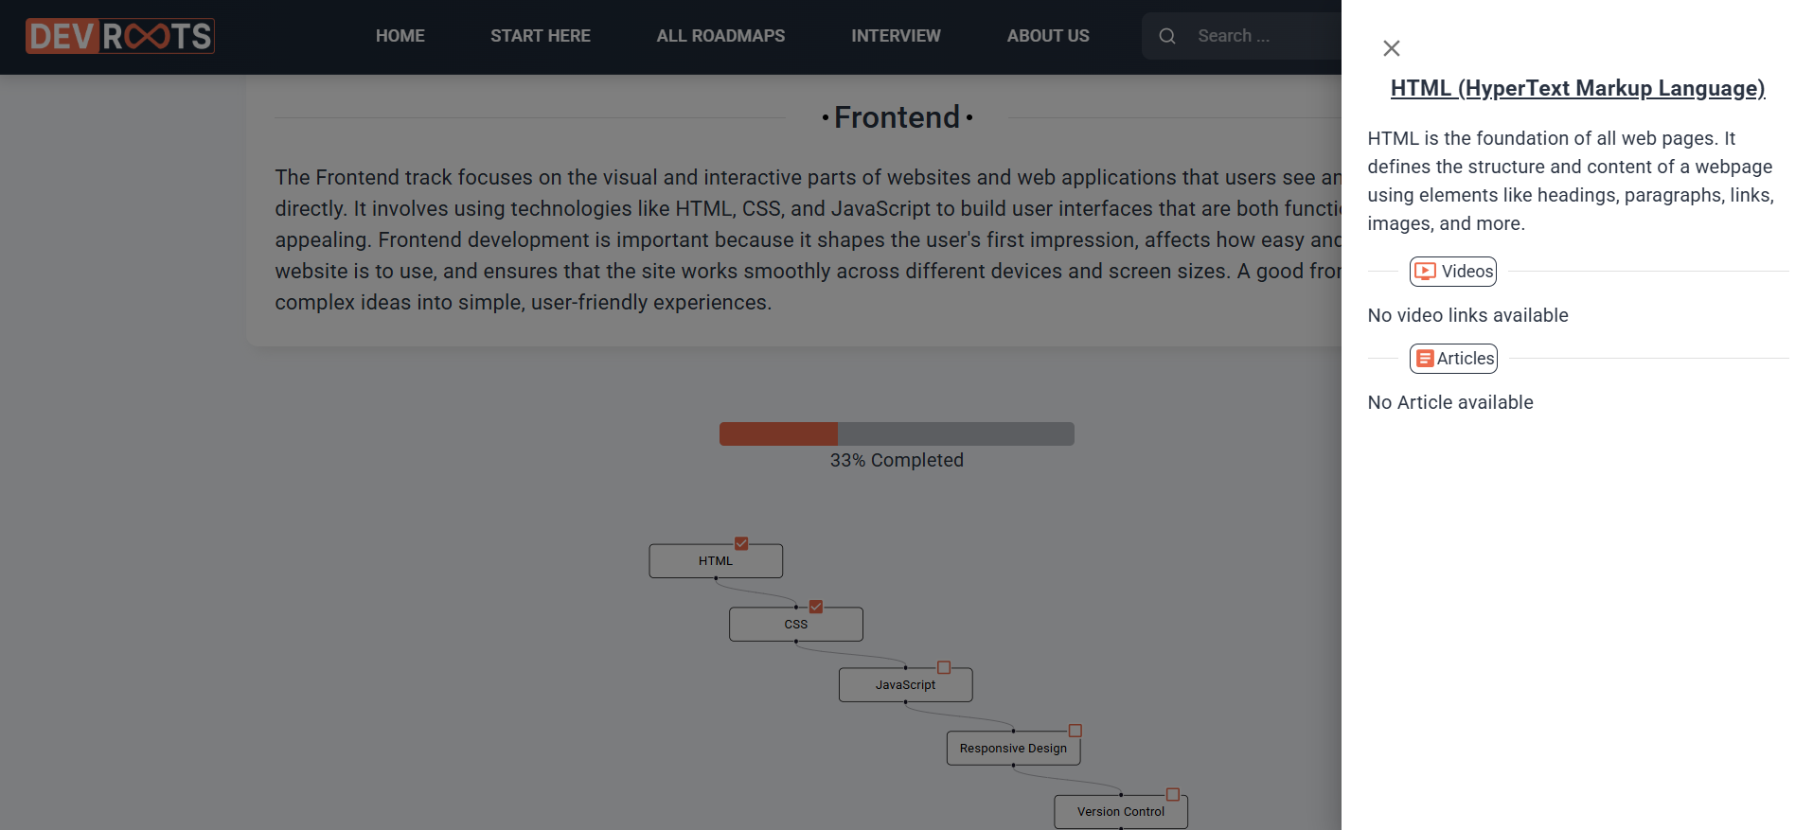

Figure 4‑36: This page displays a brief overview and the areas that can be learned, whether they are vids or articles, and whether they are in Arabic or English.

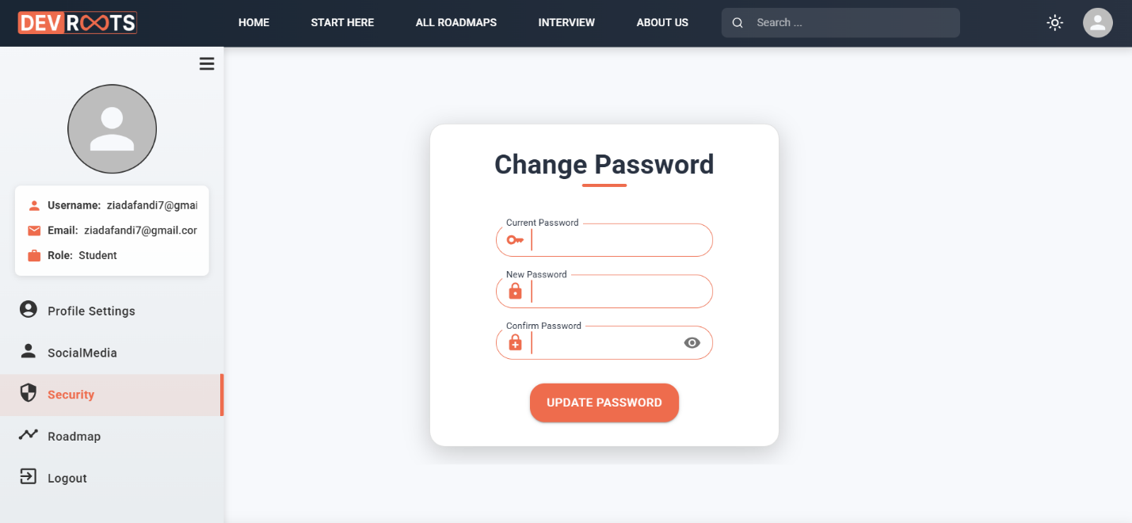

Figure 4‑37:Allows the user to modify his password

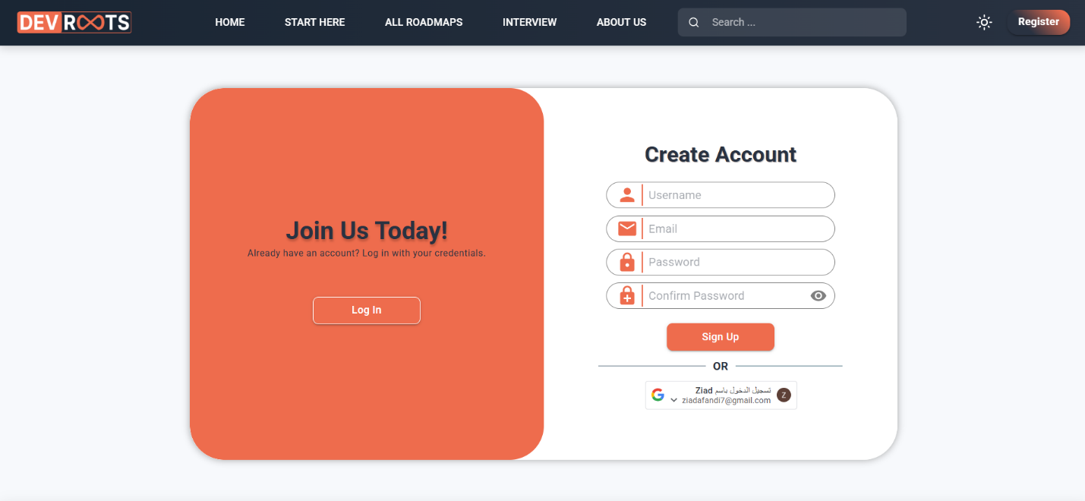

Figure 4‑38: If the user does not have an account, we allow him to create an account or log in using a Google account.

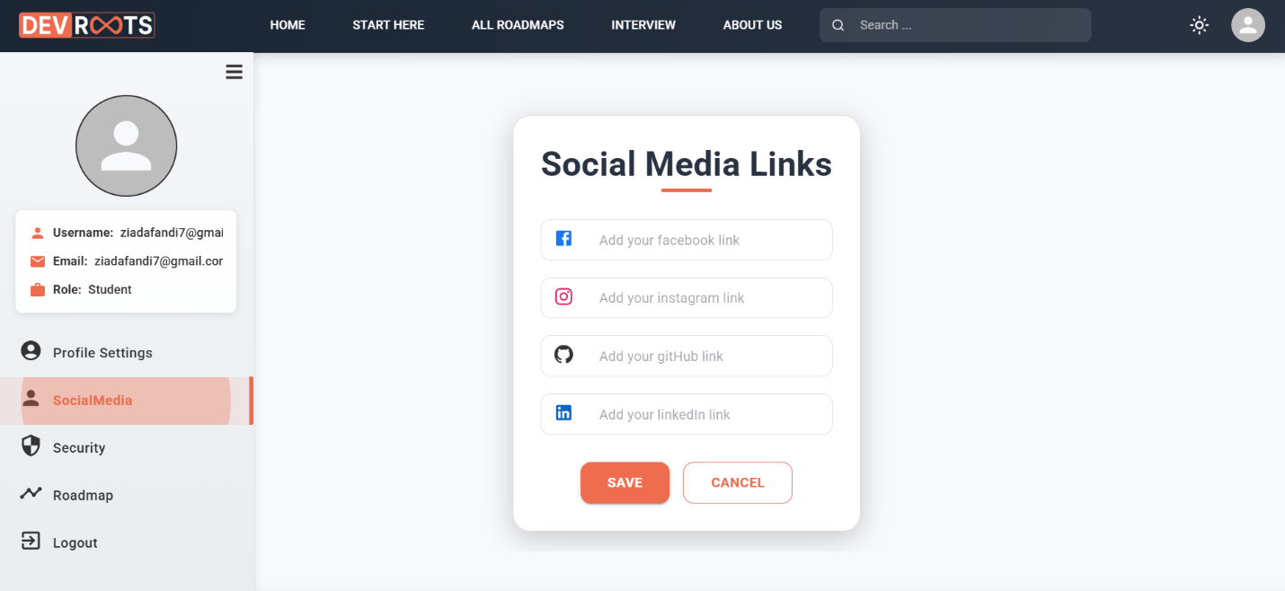

Figure 4‑39: It allows the user to add his own communication links if he wants.

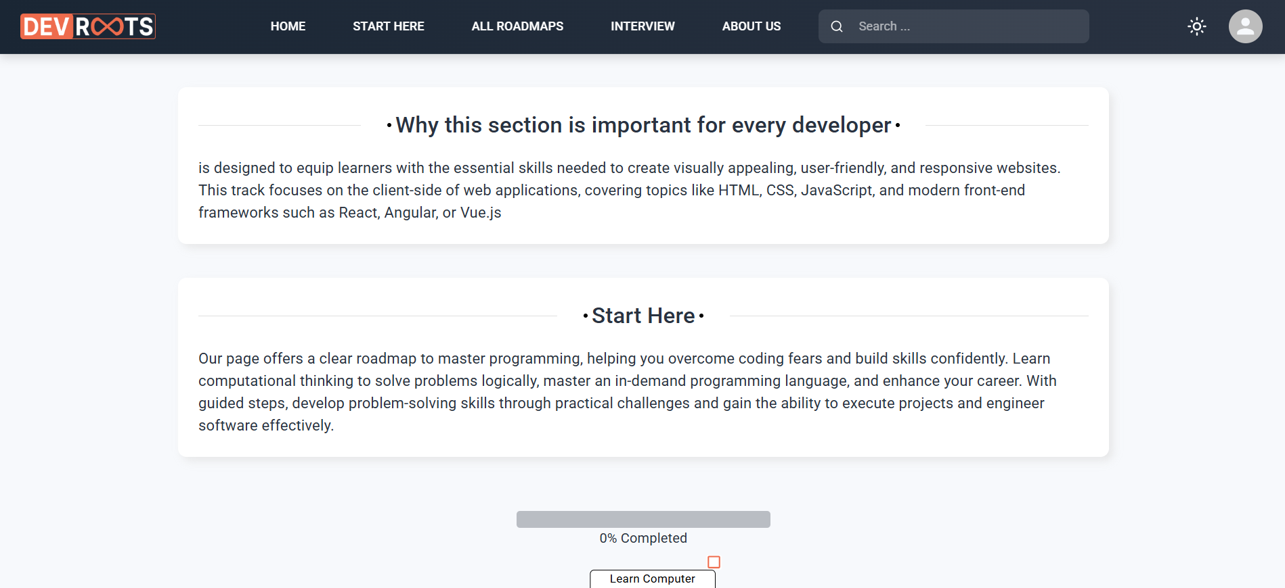

Figure 4‑40: This page displays basic information that the user must learn before starting any track because it will make it easier for him later. We provide a brief overview of Word Map for learning.

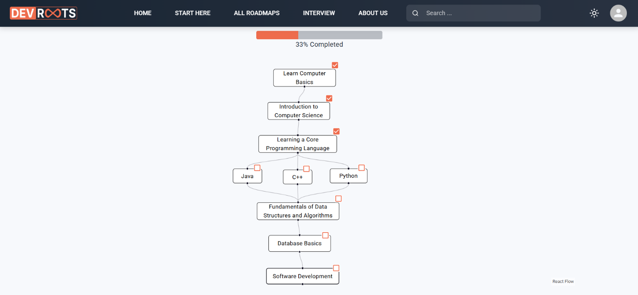

Figure 4‑41: This page displays basic information that the user must learn before starting any track because it will make it easier for him later. We provide a brief overview of Word Map for learning.

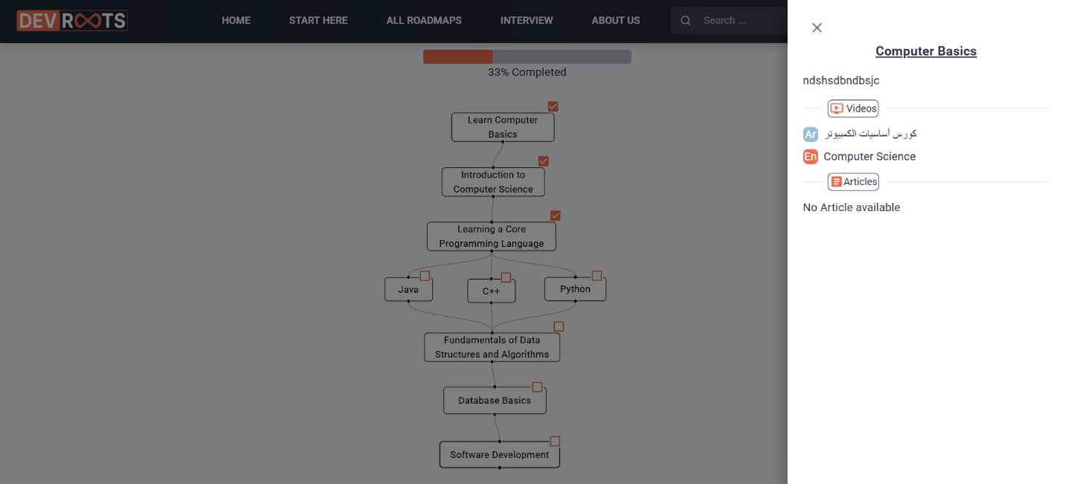

Figure 4‑42: This page displays basic information that the user must learn before starting any track because it will make it easier for him later. We provide a brief overview of Word Map for learning.

**4.4 Challenges Faced and How They Were Resolved**

During the implementation of the DevRoot platform, the team encountered several challenges that tested both technical and organizational capabilities. Despite these obstacles, practical strategies and team collaboration helped in effectively resolving the issues. Below is a detailed account of the main challenges faced and how they were addressed:

* **Time Constraints**

The second academic term, during which the majority of the project was developed, was notably shorter than the first term. This limited the available time for completing all planned features and conducting thorough testing.

To manage this, the team adopted a focused development strategy. Core and essential features were prioritized, while less critical ones were postponed for future versions. Tasks were distributed efficiently among team members, and progress was closely monitored to ensure the timely completion of each stage.

* **API Integration Difficulties**

At the beginning of the backend development, the team faced difficulties in structuring and integrating APIs. These included managing data flow between the frontend and backend, handling asynchronous requests, and designing RESTful endpoints.

These challenges were gradually overcome through consistent practice, research, and team collaboration. Members actively sought guidance from online resources and tutorials and eventually developed a working understanding of the required backend technologies using Node.js and Express.

* **Lack of Automated Testing**

Although some testing was done using SuperTest, the project lacked a complete automated testing framework. This made it difficult to catch potential bugs early or ensure long-term stability.

To mitigate this issue, the team relied heavily on manual testing. Repeated tests were conducted after each feature implementation to verify frontend-backend communication and user interactions. While this was sufficient for the current scope, future iterations of the project will benefit from the implementation of formal automated testing tools.

* **UI/UX Simplicity vs. Feature Complexity**

One of the design challenges was finding a balance between a user-friendly interface and the inclusion of multiple advanced features. The platform needed to be simple enough for beginners, yet powerful enough to offer real value to more experienced users.

The team addressed this by using React and Material UI to build a clean, structured, and responsive user interface. Consistent feedback from early users helped refine the design to be both functional and easy to navigate.

* **Knowledge Gaps in Technologies**

Some team members were not initially familiar with the technology stack used in the project, which created a learning curve and slowed down progress in the early stages.

To address this, each member took ownership of specific parts of the project, allowing them to specialize and gain confidence in those areas. The team also shared knowledge regularly, which helped everyone stay on the same page and improved overall productivity.

# Chapter 5

# Testing & Evaluation

## 5.1 Testing Strategies

To ensure the reliability and functionality of the DevRoot platform, multiple testing strategies were adopted throughout the development process:

* **Unit Testing**

Although dedicated test files were not fully implemented in the current version of the project, **SuperTest** was selected as the testing tool for backend endpoints. This tool allows automated verification of RESTful API responses and ensures endpoints return the expected data and handle edge cases effectively. While formal unit tests were not written, manual endpoint checks were frequently carried out during development.

* **Integration Testing**

The interaction between the frontend (React) and backend (Express.js) was tested extensively to verify proper data flow. For example, forms that collect user input (such as interview entries or course suggestions) were connected to backend routes, and multiple tests confirmed that requests from the frontend were successfully received, processed, and responded to by the backend, and vice versa. This ensures that the integration between modules is seamless and robust.

* **User Testing**

Usability testing was conducted with real users, primarily fellow developers and peers. They interacted with the platform and provided feedback based on their experience. The general feedback was positive, emphasizing that the platform brings together many scattered tools and resources into one accessible location. Users appreciated the simplicity, clarity, and usefulness of the content, stating that it saved them significant time and effort in preparing for interviews or selecting learning resources.

## 5.2 Performance Metrics

The performance of the DevRoot platform was considered during both development and deployment stages. Although formal benchmarking was not performed, several performance-related aspects were considered:

* **Scalability:**

The platform's backend was developed using Node.js and Express, ensuring a scalable architecture capable of efficiently supporting growing user demand. The system is designed for horizontal scaling, allowing seamless expansion as needed.

* **Performance & Speed:**

API endpoints were optimized for low latency, delivering fast response times during all testing phases. While exact metrics weren't logged, user interactions consistently received instant feedback, ensuring a smooth experience.

* **Optimization** **Techniques:**

To enhance efficiency, the platform implements:

* Pagination for large datasets (e.g., interviews, courses) to reduce load times.
* Vite for frontend builds, improving client-side performance with faster rendering and optimized asset delivery.

## 5.3 Comparison with Existing Solutions

During the research and planning phases, several existing platforms were analyzed for comparison, including well-known platforms such as **LinkedIn**, **Glassdoor**, and **Coursera**. While these platforms offer specialized services (e.g., job listings, course recommendations, or interview experiences), DevRoot stands out by combining multiple features in one unified interface.

**Unique Advantages of DevRoot:**

* **All-in-OnePlatform:**  
  Unlike other tools that focus on a single aspect (like interviews or courses), DevRoot provides a complete ecosystem including interview preparation, learning recommendations, and career guidance in one website.
* **Simplicity and Accessibility:**

The platform is designed with a focus on clarity and ease of use, ensuring it remains accessible even for beginners. The language and structure are kept simple to minimize barriers to entry.

* **Opportunities for Future Improvements:**

Partnerships with Companies:

A key planned enhancement is to integrate real-world job opportunities by collaborating with hiring companies and embedding direct job links into the platform.

* **Expert Contributions:**

Another proposed improvement involves partnering with experienced professionals from leading companies to provide high-quality interview content, advice, or mentorship directly on the platform.

# Chapter 6

# Results & Discussion

## 6.1 Introduction

This chapter presents a comprehensive overview of the outcomes derived from the DevRoot project. It reflects on how the platform performed in practical scenarios, the insights gathered during testing and implementation, and how these findings relate to the original goals of the project. Furthermore, the section explores the broader implications of the results, the extent to which the solution succeeded, and the limitations encountered during development.

## 6.2 Summary of Findings

The project produced remarkable and encouraging results. One of the standout achievements was the successful integration of multiple core functionalities into a single, cohesive web platform. DevRoot proved capable of guiding users from having no prior knowledge in tech domains to becoming well-informed and job-ready individuals through structured learning paths and simulated interview environments.

Additionally, the content strategy implemented in the platform was effective in addressing diverse user preferences. By offering both Arabic and English content in the form of articles, videos, and curated feeds, DevRoot was able to cater to a broader audience. This multilingual, multimedia approach ensured accessibility and inclusivity, making the platform appealing to beginners and advanced users alike.

Another critical achievement was the simplicity and engagement level of the user interface. The presentation of complex topics in a simplified and engaging manner helped users stay motivated and increased knowledge retention. Feedback collected during user testing confirmed that the unified approach of DevRoot saved time and made learning and career planning more intuitive.

## 6.3 Interpretation of Results

In terms of meeting its objectives, DevRoot achieved approximately **90%** of the original project goals, which is a strong indicator of success, especially considering time constraints and technical challenges. The platform accomplished several of its primary aims, including:

* Educating users about various tech fields in a structured and beginner-friendly way.
* Providing foundational knowledge and learning paths for different areas.
* Enabling users to simulate interview experiences to prepare them for real-world job markets.
* Delivering content in a clear, engaging, and bilingual format.

However, a few goals were only partially met or postponed for future development. For example, one of the original ambitions was to integrate **job opportunities** directly into the platform, allowing users to apply through DevRoot itself. Although this functionality was not implemented in the current version, it remains a viable and important enhancement for future iterations of the project.

Overall, the results indicate that DevRoot is not only functional but also highly aligned with its core mission: empowering learners and job seekers through simplified, effective, and centralized guidance.

## 6.4 Limitations of the Proposed Solution

Despite the project’s overall success, several limitations were identified during development:

Time Constraints

The second academic term, during which most of the project was built, was shorter than the first, which limited the time available for implementation, refinement, and testing. As a result, some features had to be deprioritized or left for future development.

API Integration Challenges

Backend development and API integration posed significant challenges during the early phases of the project. Team members initially faced difficulties in structuring routes, handling requests, and managing server-side logic. However, through persistent effort, practice, and knowledge sharing, these challenges were overcome to a large extent.

Partial Testing Coverage

While manual and integration testing were conducted, the lack of automated testing limited the ability to detect regressions or edge case failures in a scalable way. Future versions of DevRoot would benefit from formal unit and integration tests using tools like Jest and SuperTest.

User Interface Simplicity

Interestingly, the **UI did not pose any major difficulties** during the development process. The use of modern frontend tools and frameworks (React + Vite + MUI) made UI creation smooth and intuitive. However, continuous user feedback and UX refinement would still be essential as more features are added.

# Chapter 7

# Conclusion & Future Work

## 7.1 Summary of Contributions

The DevRoot project was envisioned as a centralized platform for educational and career guidance, aiming to simplify the journey for learners and job seekers in the tech field. Over the course of development, the project delivered significant contributions, both technically and conceptually.

* **Centralized Platform for Career Development:**

DevRoot effectively consolidates various career development resources—such as learning paths, technical content (articles, videos), and interview simulations—into a single, streamlined web application.

* **End-to-End Learning Support:**

The platform supports users from the beginner stage to job readiness, offering foundational knowledge, guided exploration of different fields, and mock interviews to build both skills and confidence.

* **Multilingual and Multi-format Content:**

DevRoot enhances accessibility and engagement by providing content in both Arabic and English, along with multiple formats (articles and videos) to cater to different learning preferences.

* **User-Centered Design and Accessibility:**

Featuring an intuitive interface and simplified content delivery, DevRoot ensures ease of use—even for those with no technical background—making learning more approachable and engaging.

* **Community Feedback and Validation:**

User testing and peer feedback confirmed the platform’s effectiveness, with users appreciating the convenience of having diverse resources in one place and the clarity of its content delivery.

Overall, DevRoot represents a strong foundation for a scalable and impactful educational solution in the tech career domain.

## 7.2 Possible Improvements or Extensions for Future Work

While the project achieved the majority of its objectives, there remains significant potential for expansion and enhancement. Future iterations of DevRoot can benefit from the following improvements:

* **Integration with Job Opportunities**

One of the major extensions planned is to partner with companies and job platforms to allow users to view and apply for real-world job openings directly through DevRoot. This would elevate the platform from a learning tool to a full-fledged career launchpad.

* **Expert Contributions and Mentorship**

Collaborating with seasoned professionals from top companies can add significant value. These experts can contribute to the interview simulation module, provide industry-relevant content, or even offer mentorship sessions within the platform.

* **Automated Testing and CI/CD**

Introducing formal unit, integration, and end-to-end testing using tools like **Jest**, **Cypress**, and **SuperTest** will enhance system reliability and scalability. Setting up continuous integration pipelines can also ensure that updates are safely deployed.

* **Mobile Responsiveness and App Version**

Expanding the platform to mobile users through responsive design or a dedicated mobile app can increase reach and accessibility.

* **Analytics and Personalization**

Incorporating analytics to track user behavior and progress can allow for personalized content recommendations, helping users learn more efficiently and stay engaged.

* **Community-Driven Content**

Introducing a feature that allows users to contribute content (articles, videos, tips) can help grow the platform’s knowledge base and promote community engagement.

# References

[1] W3Schools, “W3Schools Online Web Tutorials,” *W3Schools.com*. [Online]. Available: <https://www.w3schools.com/>. [Accessed: Jun. 7, 2025].

[2] YouTube, “YouTube - Learn to Code,” *YouTube.com*. [Online]. Available: <https://www.youtube.com/>. [Accessed: Jun. 7, 2025].

[3] Roadmap.sh, “Developer Roadmaps,” *Roadmap.sh*. [Online]. Available: <https://roadmap.sh/>. [Accessed: Jun. 7, 2025].

[4] React Documentation, “React – A JavaScript library for building user interfaces,” *Reactjs.org*. [Online]. Available: <https://reactjs.org/>. [Accessed: Jun. 7, 2025].

[5] Express Documentation, “Express - Node.js web application framework,” *Expressjs.com*. [Online]. Available: <https://expressjs.com/>. [Accessed: Jun. 7, 2025].

[6] Stack Overflow, “Stack Overflow - Where Developers Learn, Share, & Build Careers,” *Stackoverflow.com*. [Online]. Available: <https://stackoverflow.com/>. [Accessed: Jun. 7, 2025].

[7] MongoDB Docs, “MongoDB Manual,” *MongoDB.com*. [Online]. Available: <https://www.mongodb.com/docs/>. [Accessed: Jun. 7, 2025].

[8] Microsoft Docs, “.NET documentation,” *Microsoft.com*. [Online]. Available: <https://learn.microsoft.com/en-us/dotnet/>. [Accessed: Jun. 7, 2025].